**Project Name :** AmAccessBiz PC2  
**Test Script ID :** AABAA_IFT_CCRepayment_05  
**Platform :** Windows 10  
**App Version :** chrome 122.0.6261.69  
**Run Date :** 02/27/2024  
**Run Started :** 13:31:51  
**Run Ended :** 13:39:19  
**Execution Time :** 00hrs 07mins 28secs   
**Execution Status :** Failed  
  
  
**Test Step 1(PASS) :** [CFO] Input [User ID]  
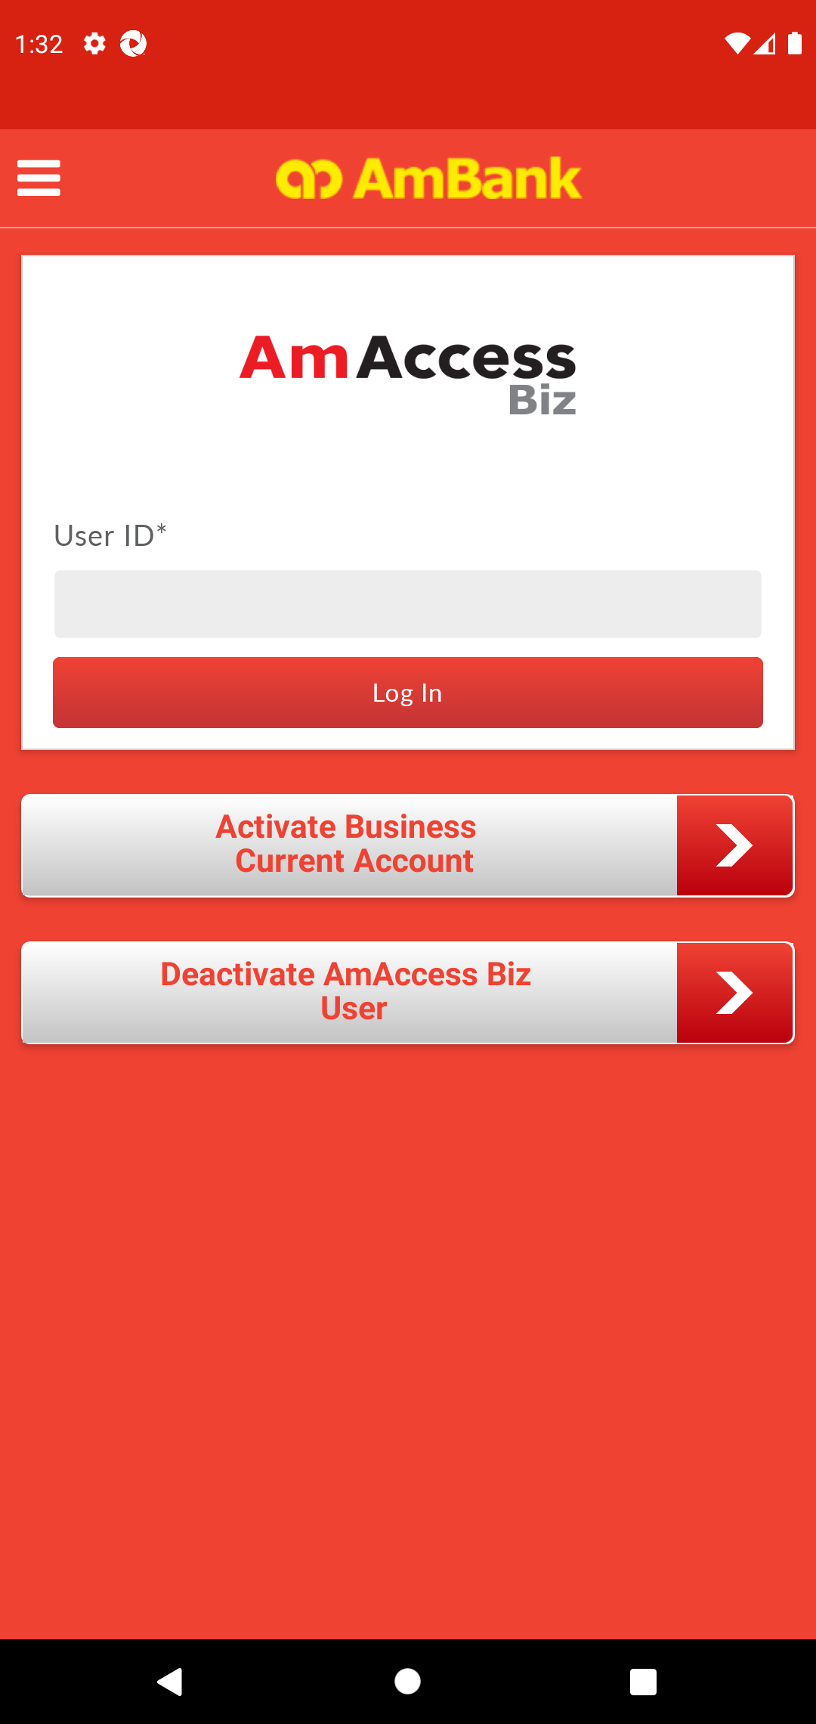  
  
**Test Step 2(PASS) :** [CFO] Click [Log In]  
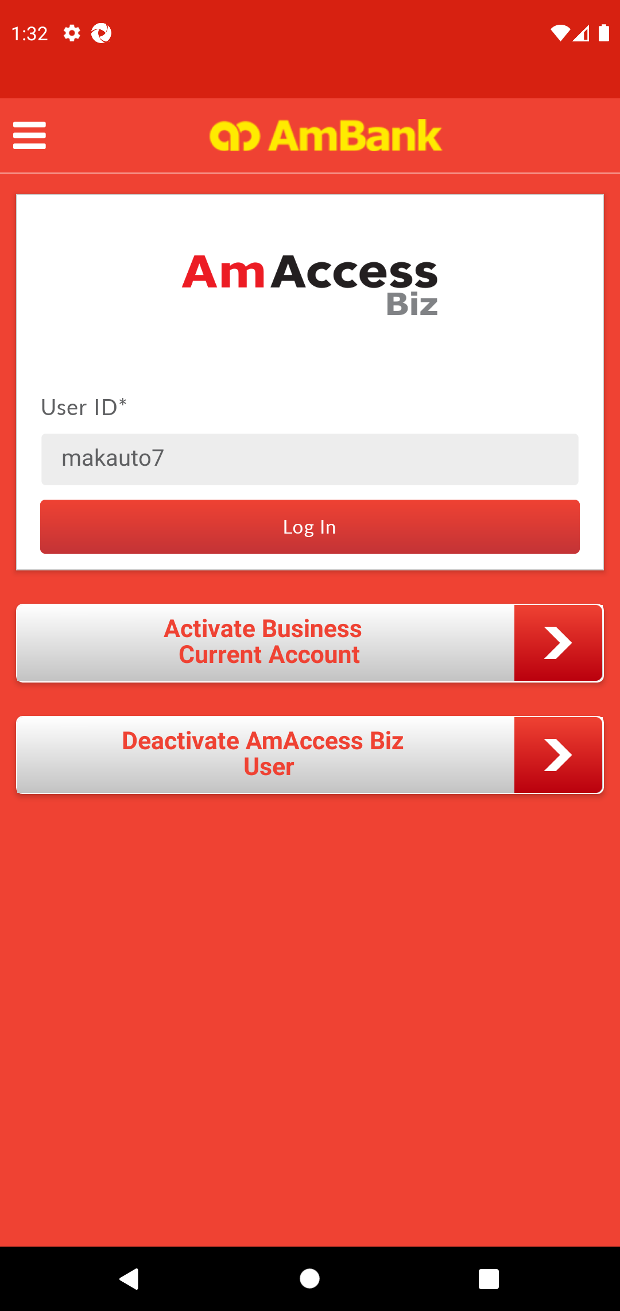  
  
**Test Step 3(PASS) :** [CFO] Click [Yes]  
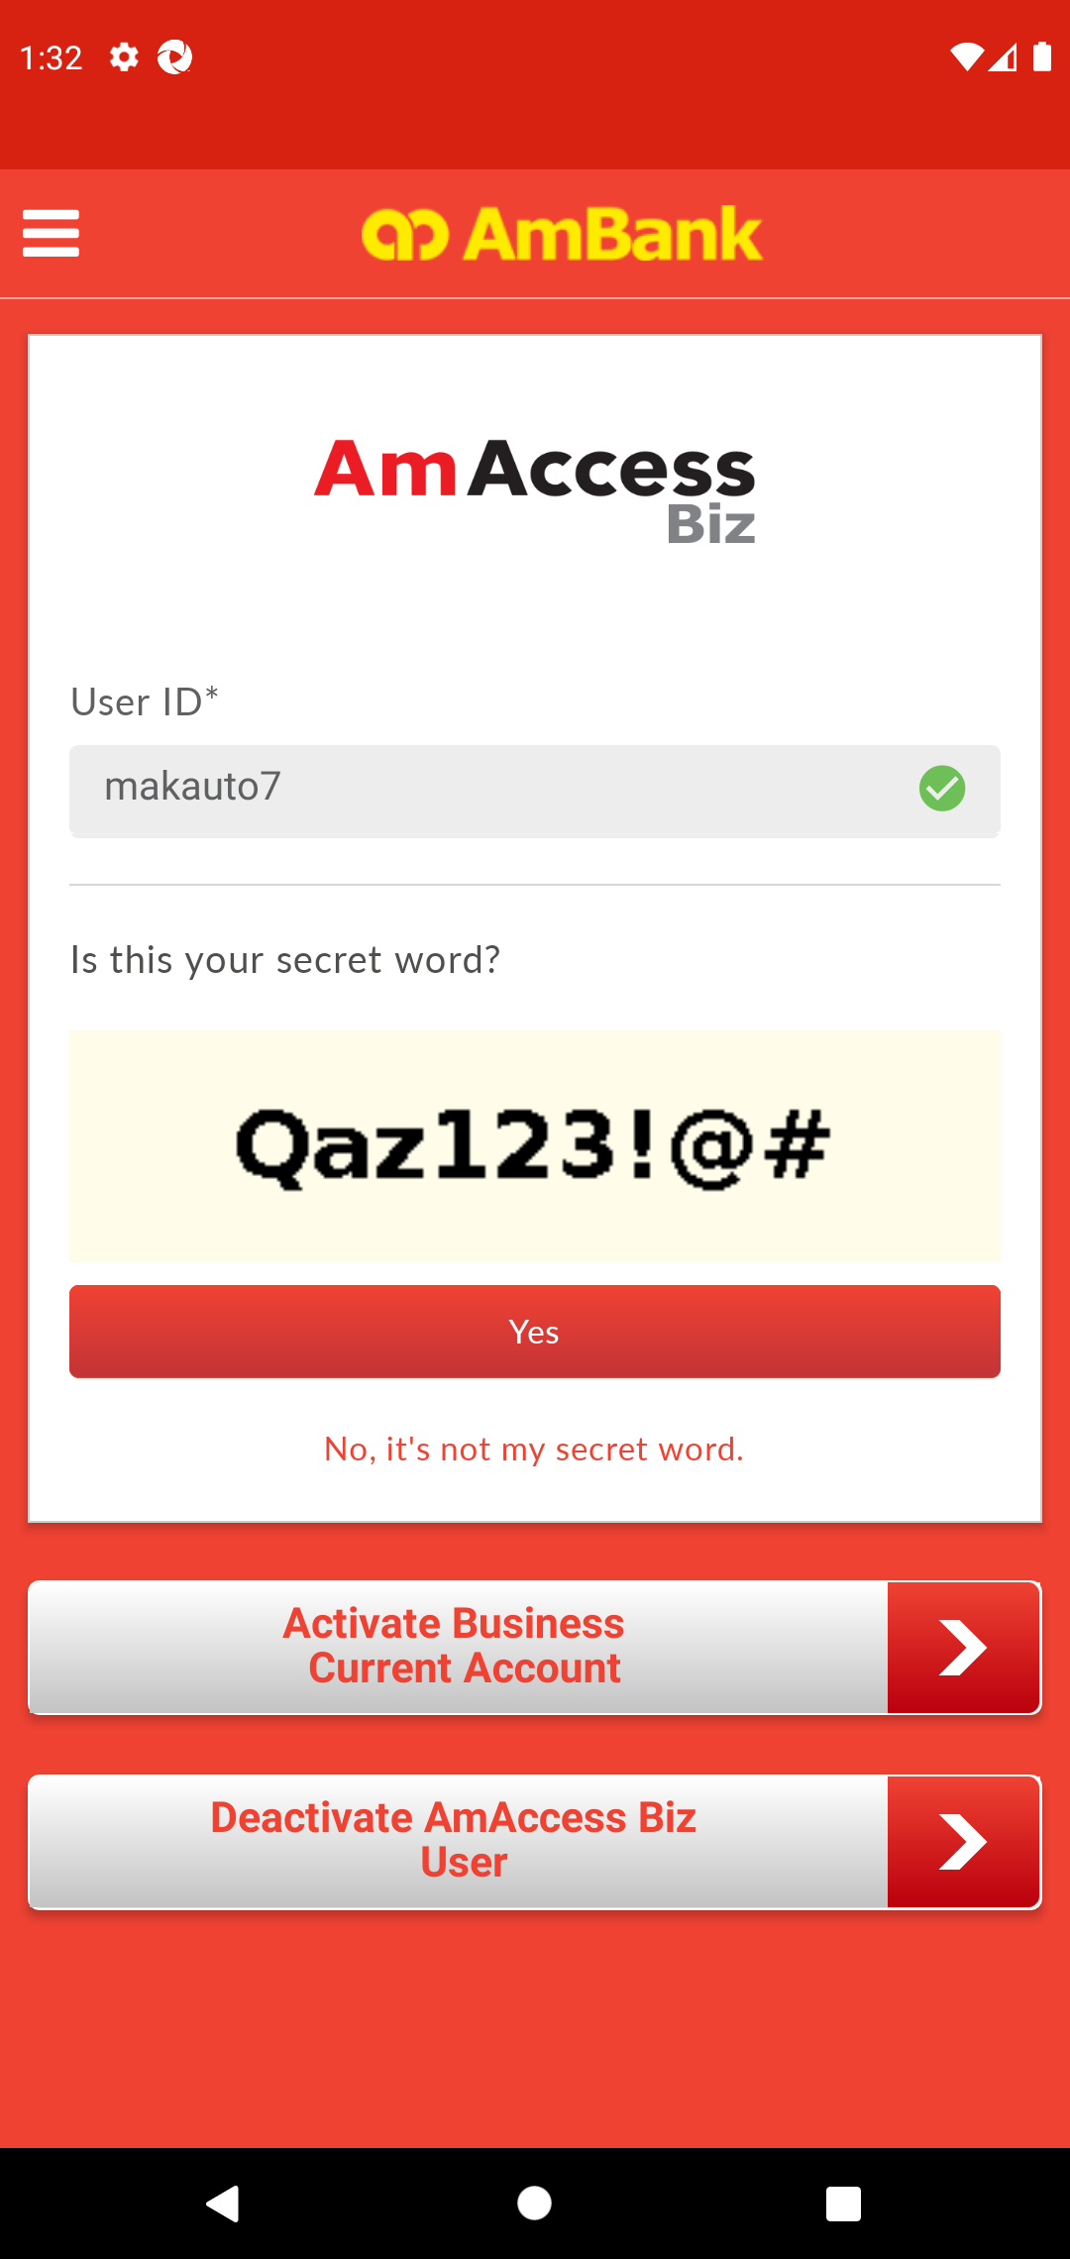  
  
**Test Step 4(PASS) :** [CFO] Input [Password]  
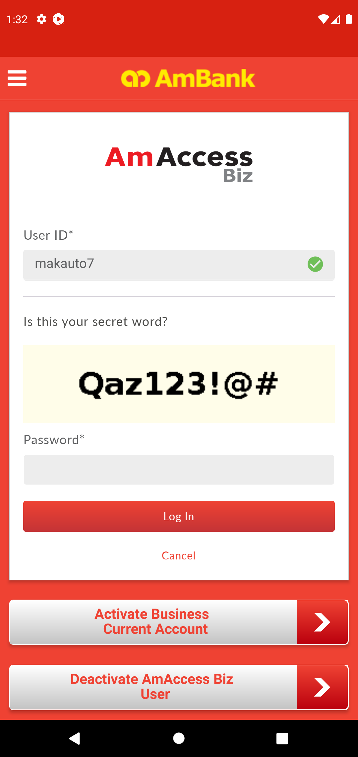  
  
**Test Step 5(PASS) :** [CFO] Click [Log In]  
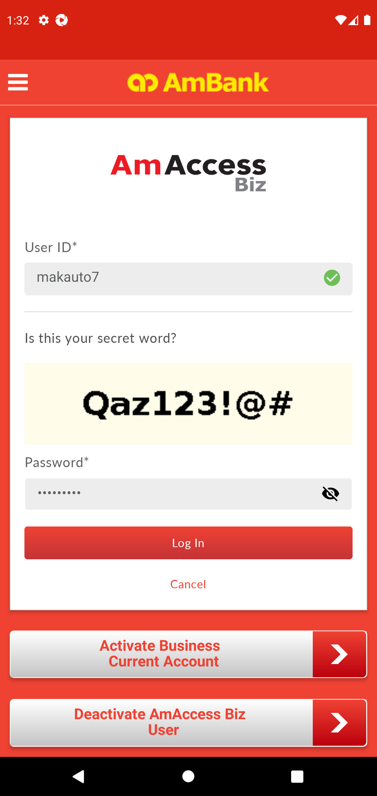  
  
**Test Step 6(PASS) :** [Local Transfer] Click [Perform Transaction]  
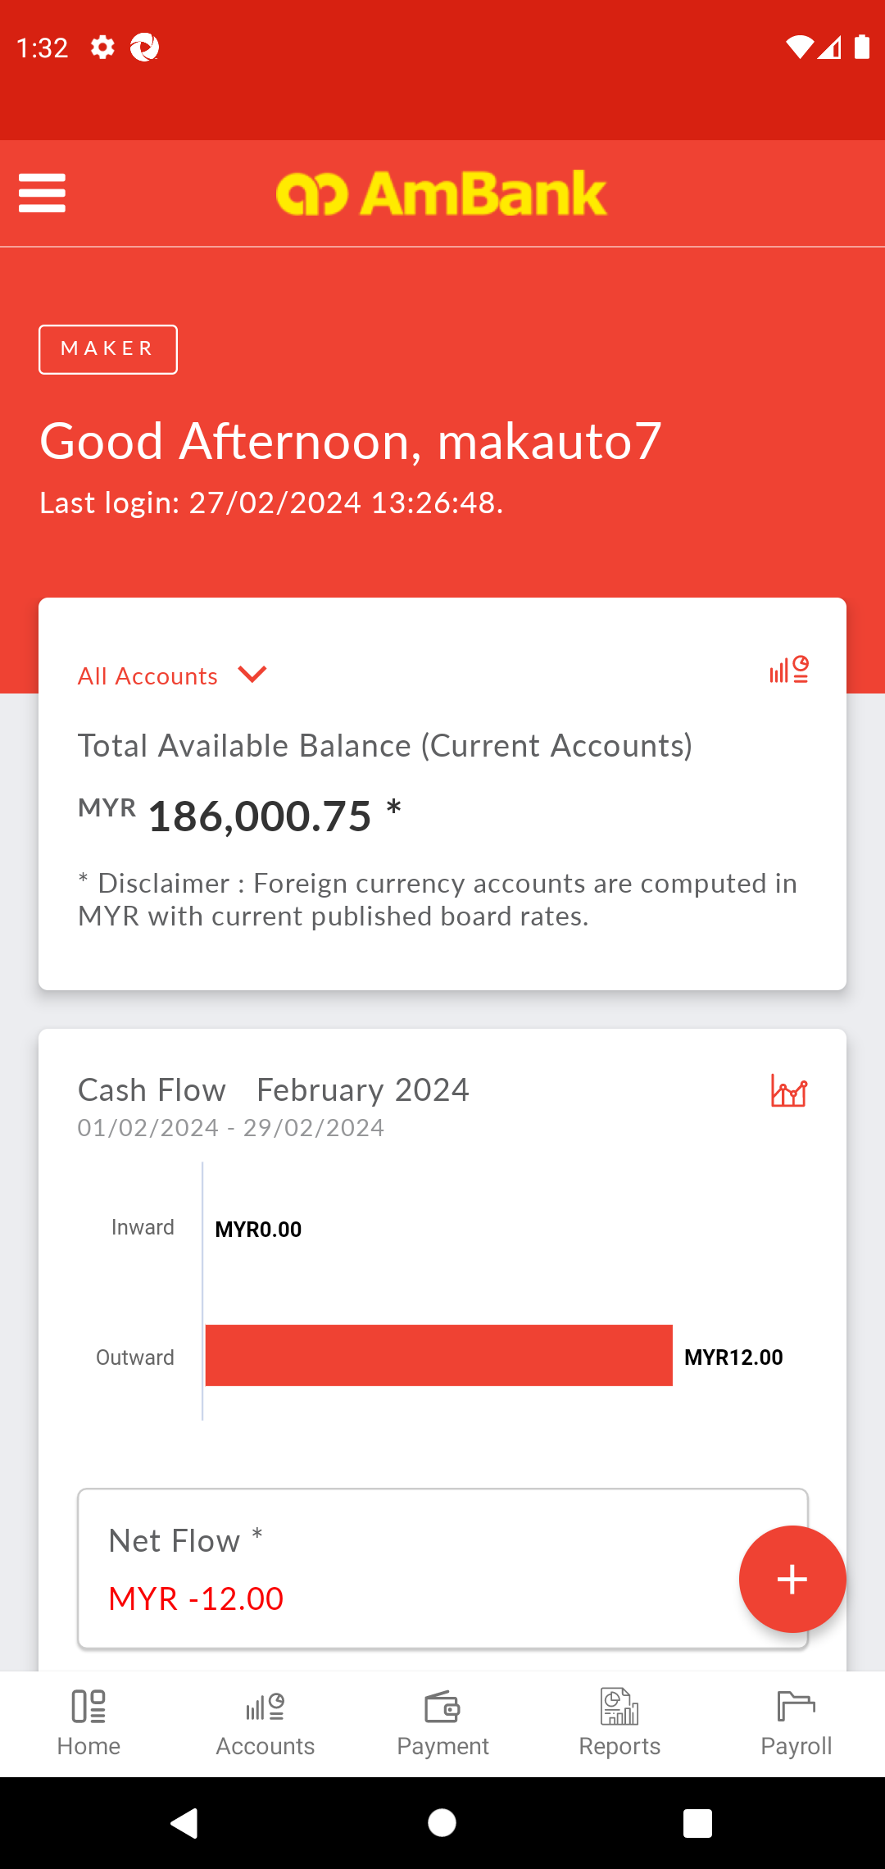  
  
**Test Step 7(PASS) :** [Local Transfer] Click [Transaction]  
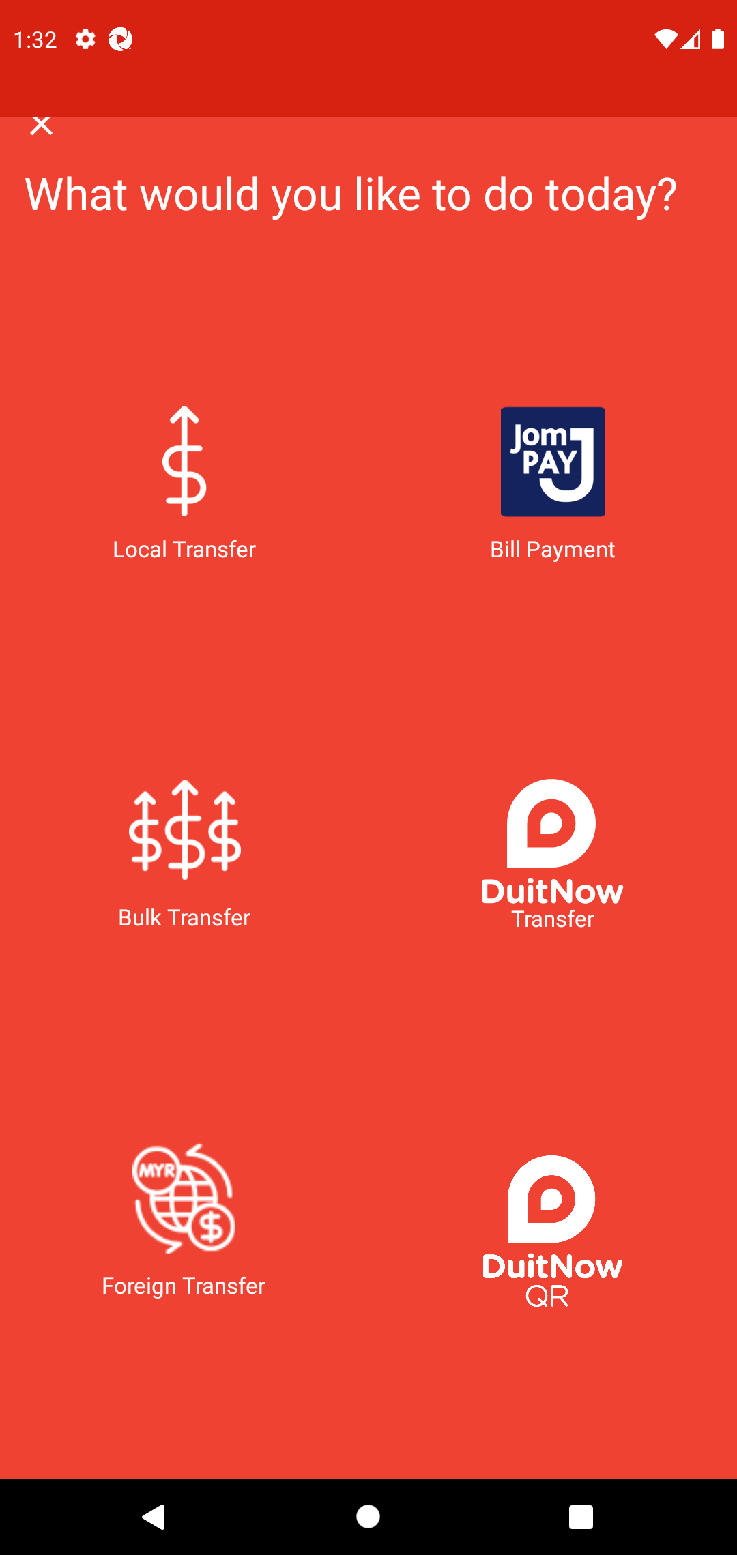  
  
**Test Step 8(PASS) :** [Local Transfer] Click [Recipient Bank]  
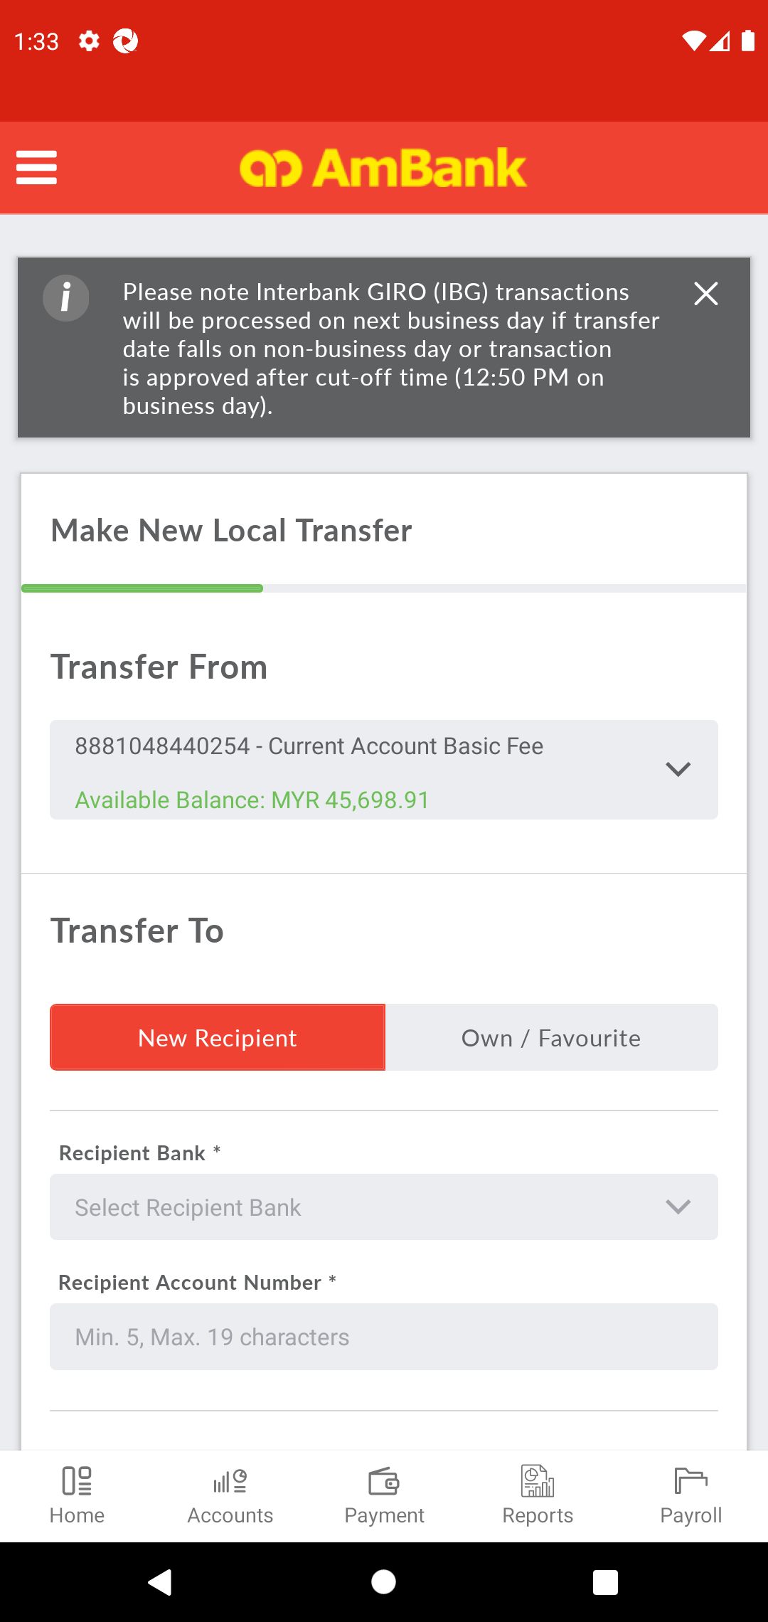  
  
**Test Step 9(PASS) :** [Local Transfer] Find [Recipient Bank]  
  
  
**Test Step 10(PASS) :** [Local Transfer] Select [Recipient Bank]  
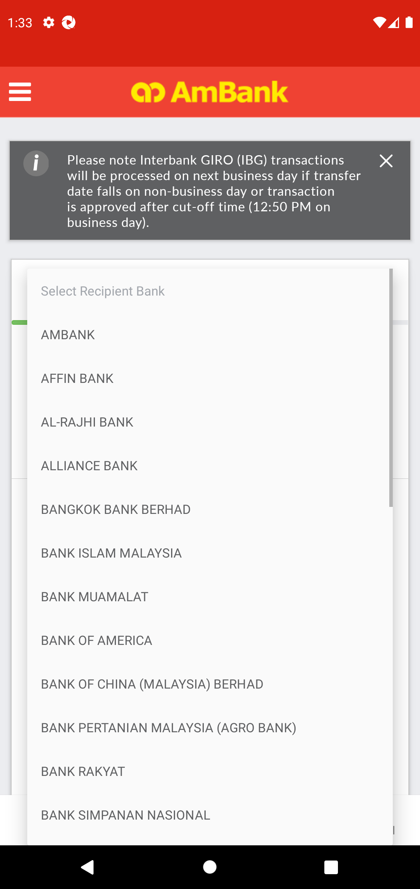  
  
**Test Step 11(PASS) :** Swipe Up to Transfer Details  
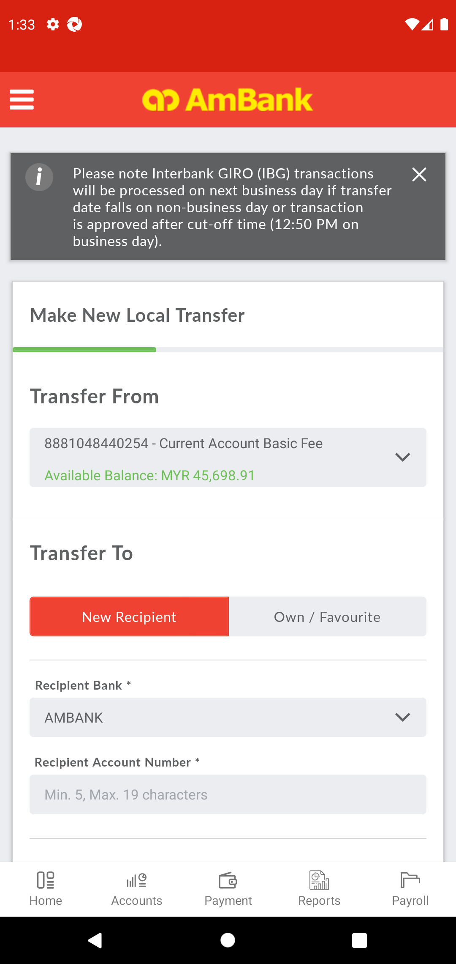  
  
**Test Step 12(PASS) :** [Local Transfer] Set [Recipient Account Number]  
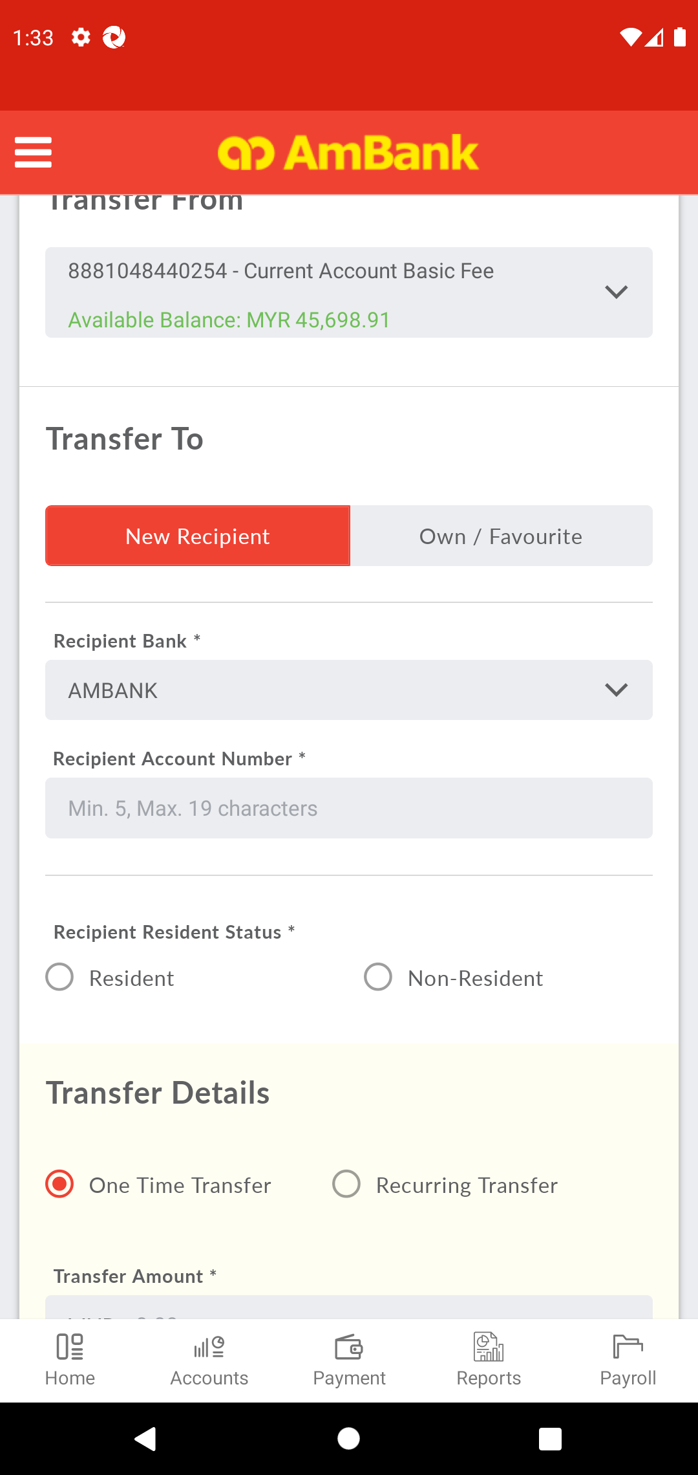  
  
**Test Step 13(PASS) :** [Local Transfer] Click [Resident Status]  
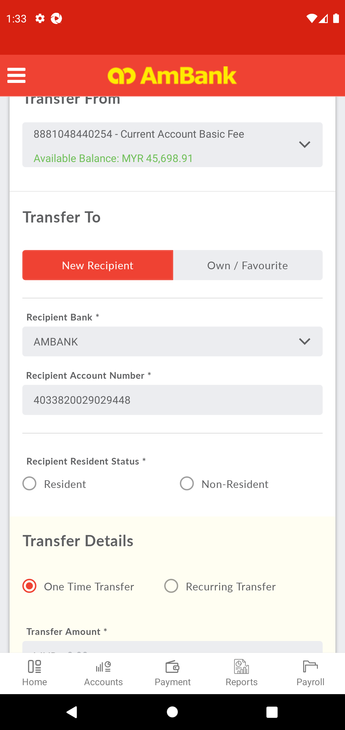  
  
**Test Step 14(PASS) :** Swipe Up to Transfer Type *  
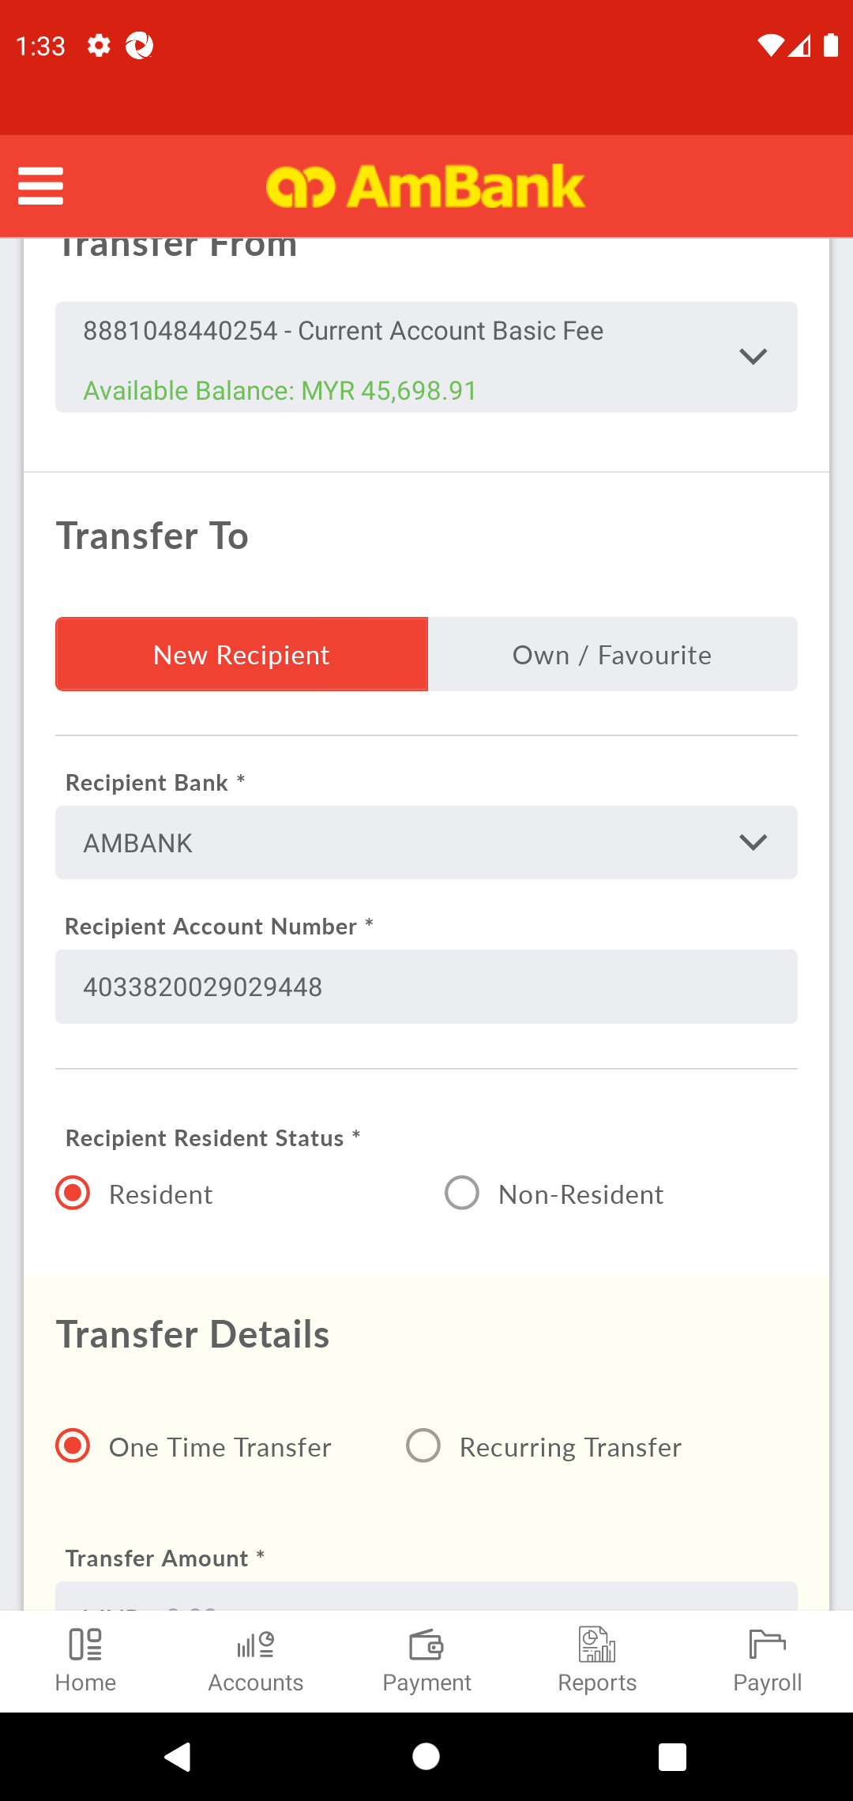  
  
**Test Step 15(PASS) :** [Local Transfer] Click [Amount Field]  
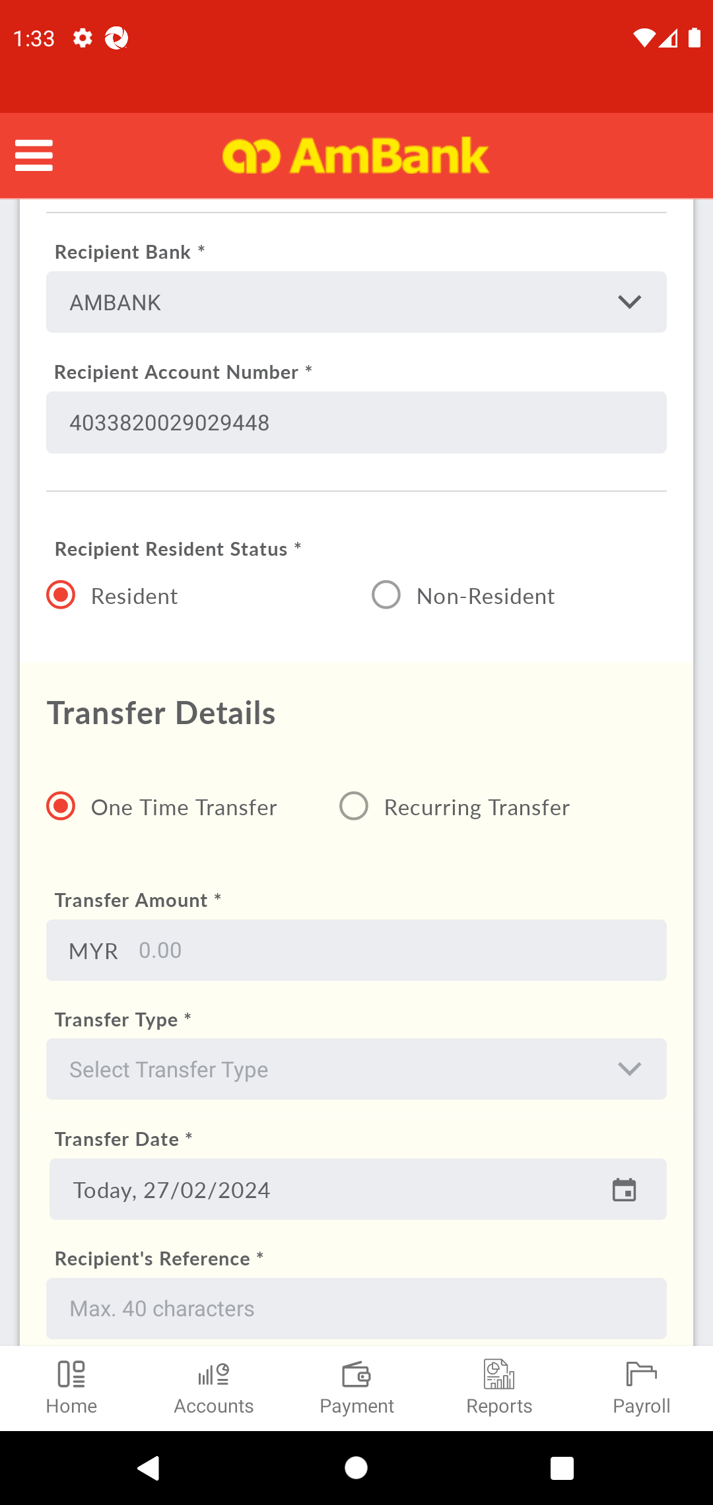  
  
**Test Step 16(PASS) :** [Local Transfer] Set [Amount]  
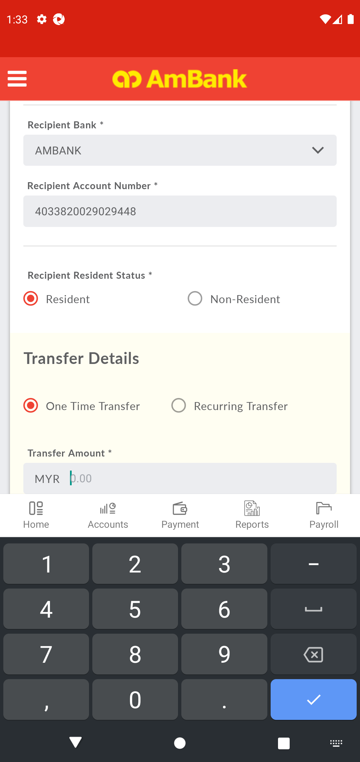  
  
**Test Step 17(PASS) :** [Local Transfer] Click [Back]  
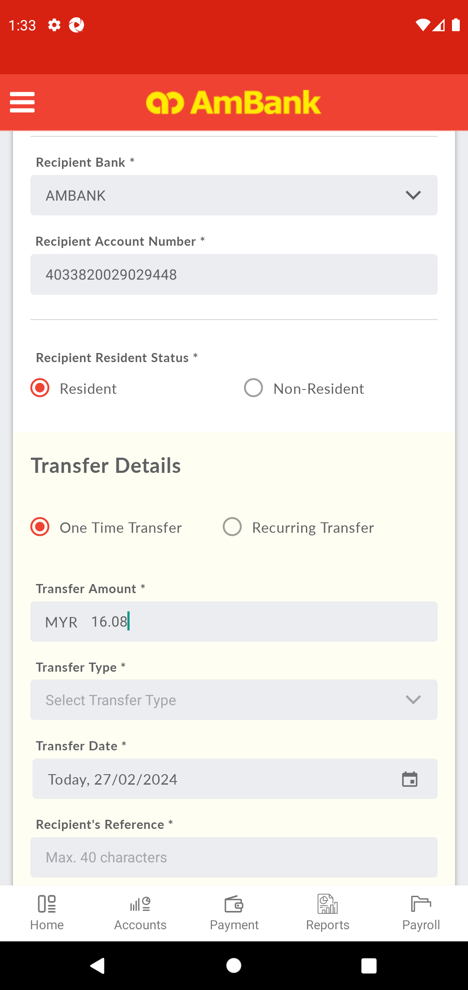  
  
**Test Step 18(PASS) :** Swipe Up to Recipient Reference *  
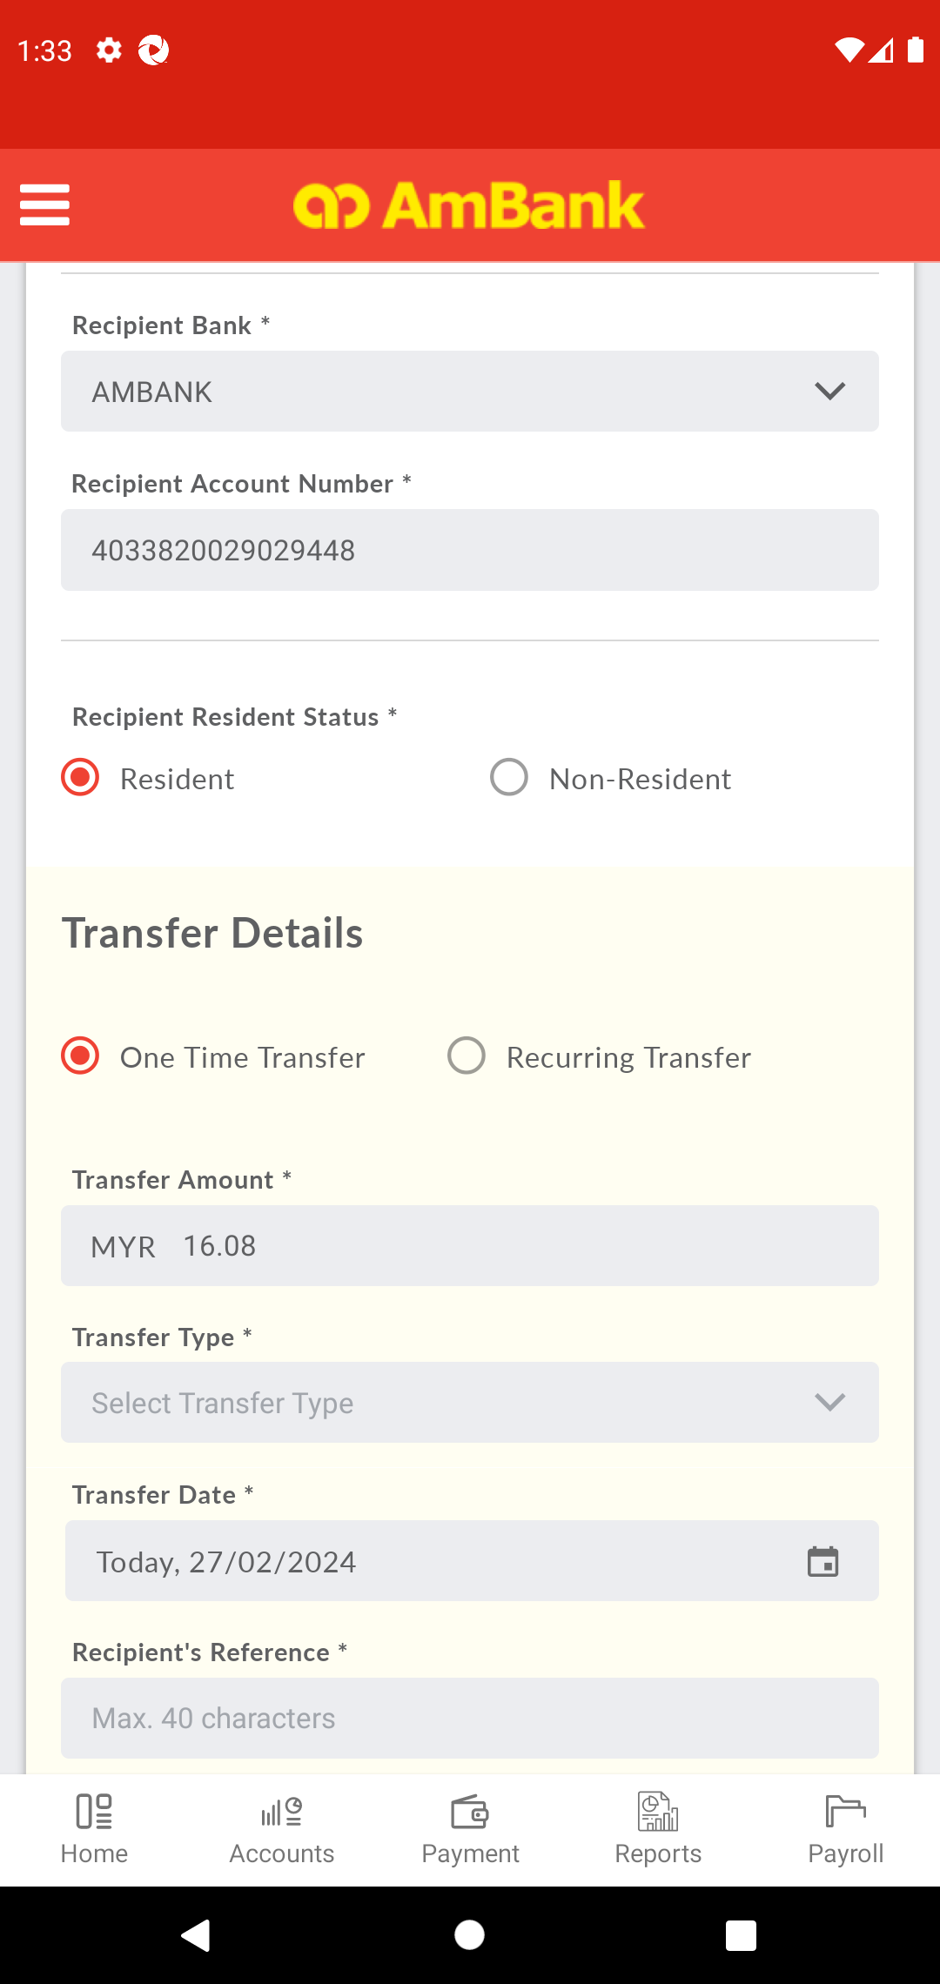  
  
**Test Step 19(PASS) :** [Local Transfer] Click [Transfer Type]  
  
  
**Test Step 20(PASS) :** [Local Transfer] Find [Transfer Type]  
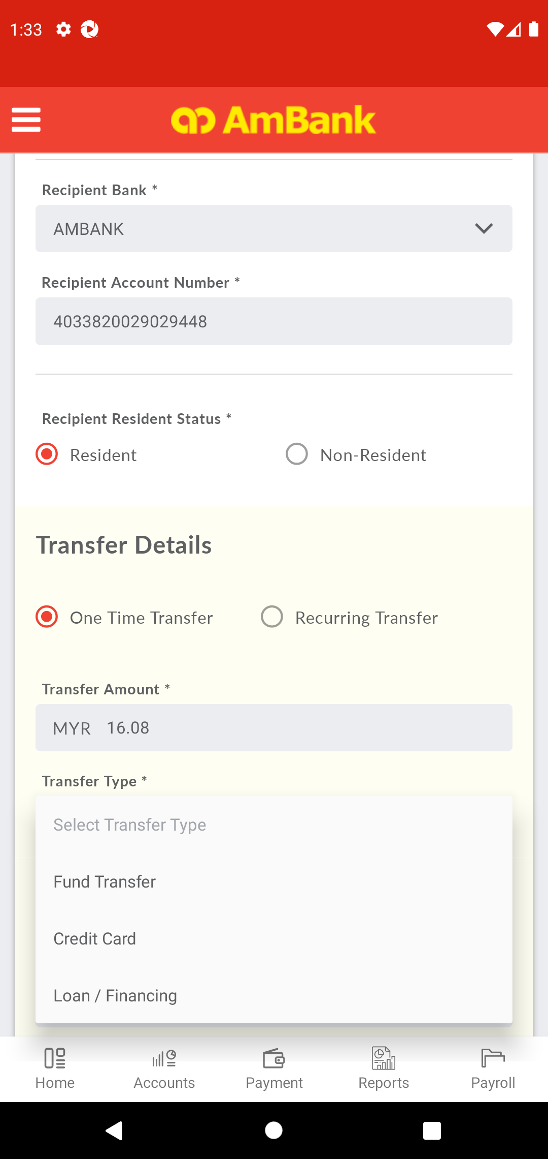  
  
**Test Step 21(PASS) :** [Local Transfer] Select [Transfer Type]  
  
  
**Test Step 22(PASS) :** Swipe Up To Transfer Date  
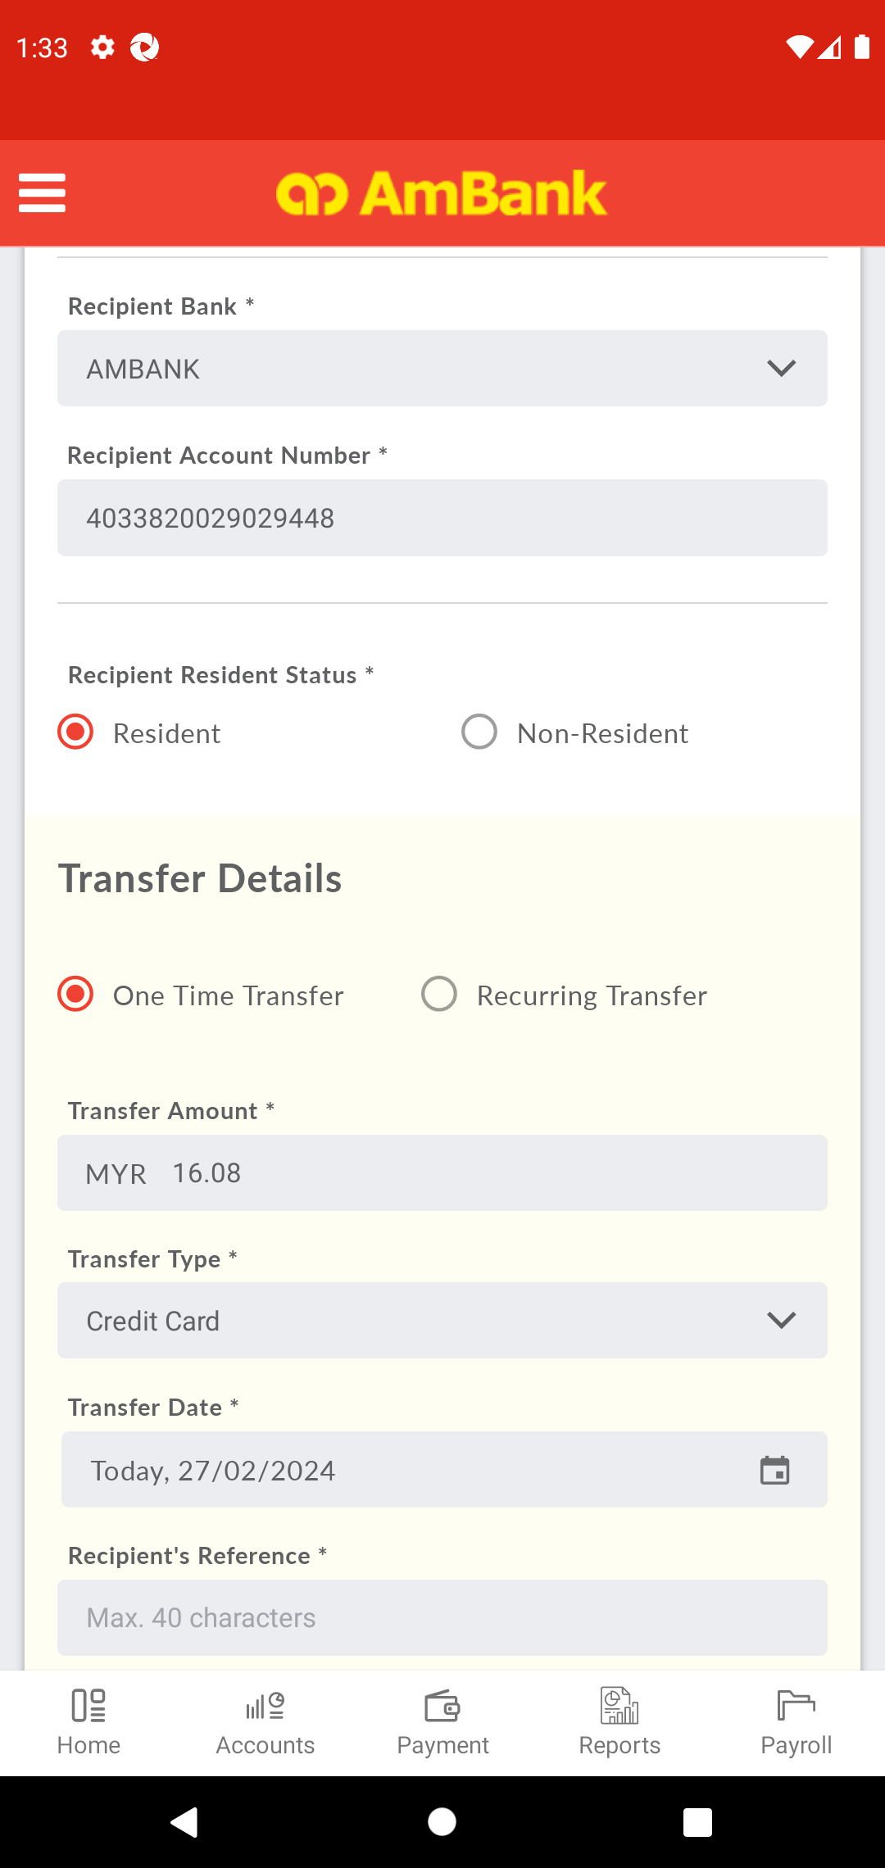  
  
**Test Step 23(PASS) :** [Local Transfer] Click [Date]  
  
  
**Test Step 24(PASS) :** [Local Transfer] Select [Date]  
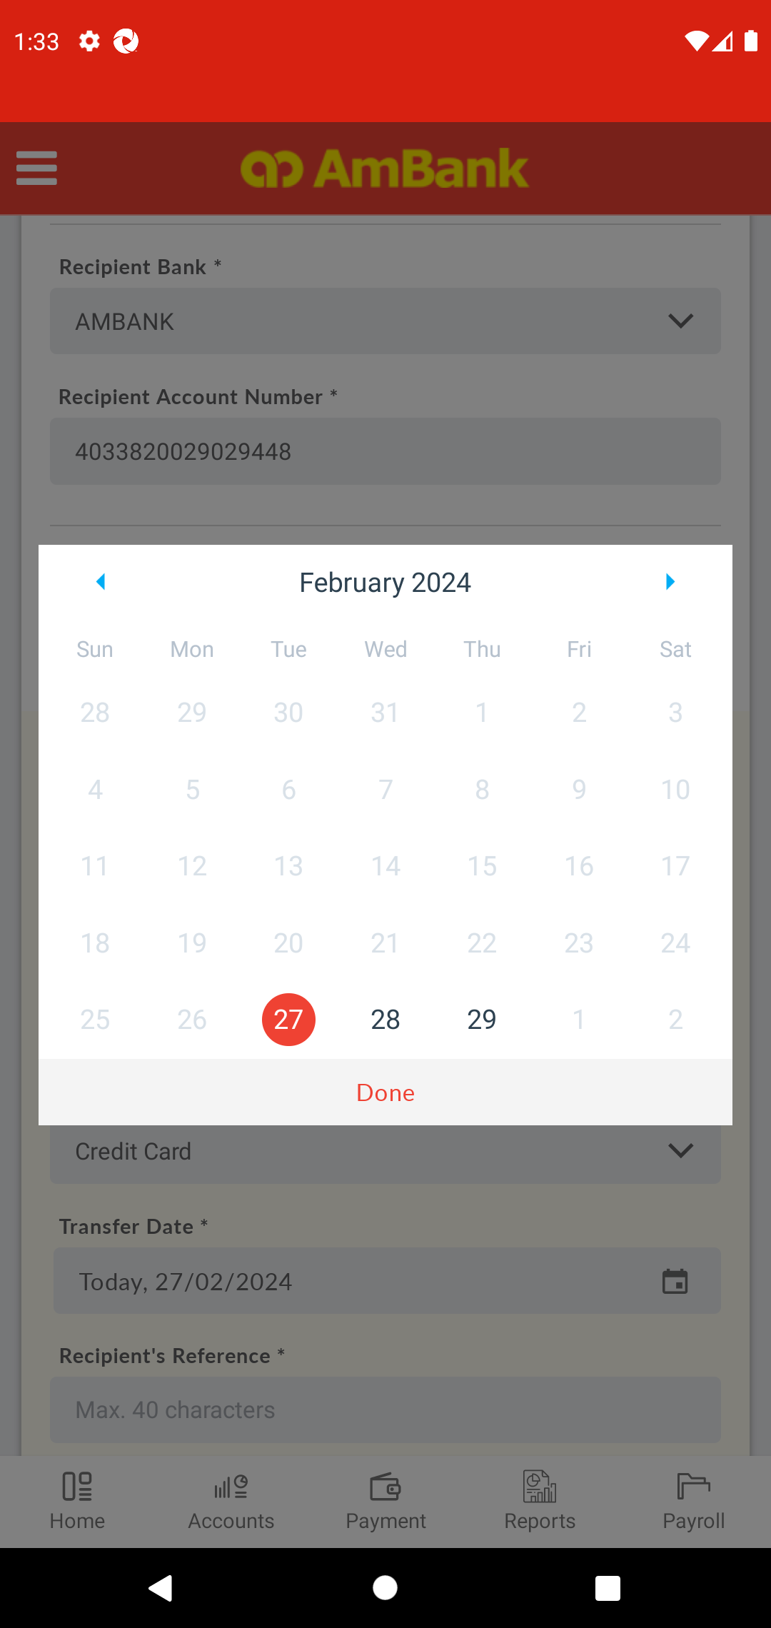  
  
**Test Step 25(PASS) :** [Local Transfer] Click [Done]  
  
  
**Test Step 26(PASS) :** Swipe Up to Other Transfer Details  
  
  
**Test Step 27(PASS) :** [Local Transfer] Set [Recipient's Reference]  
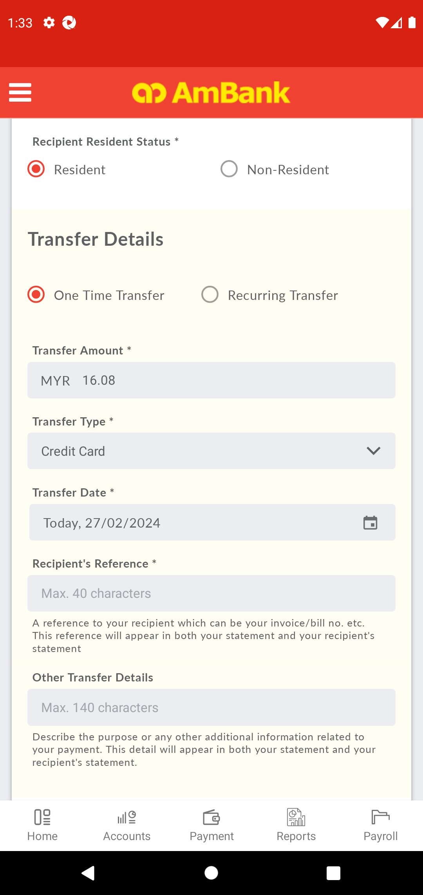  
  
**Test Step 28(PASS) :** [Local Transfer] Set [Other Details]  
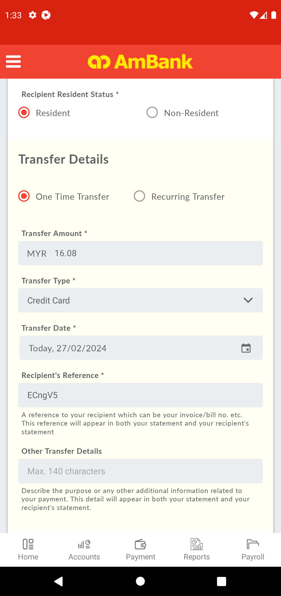  
  
**Test Step 29(PASS) :** Swipe Up to Next Button  
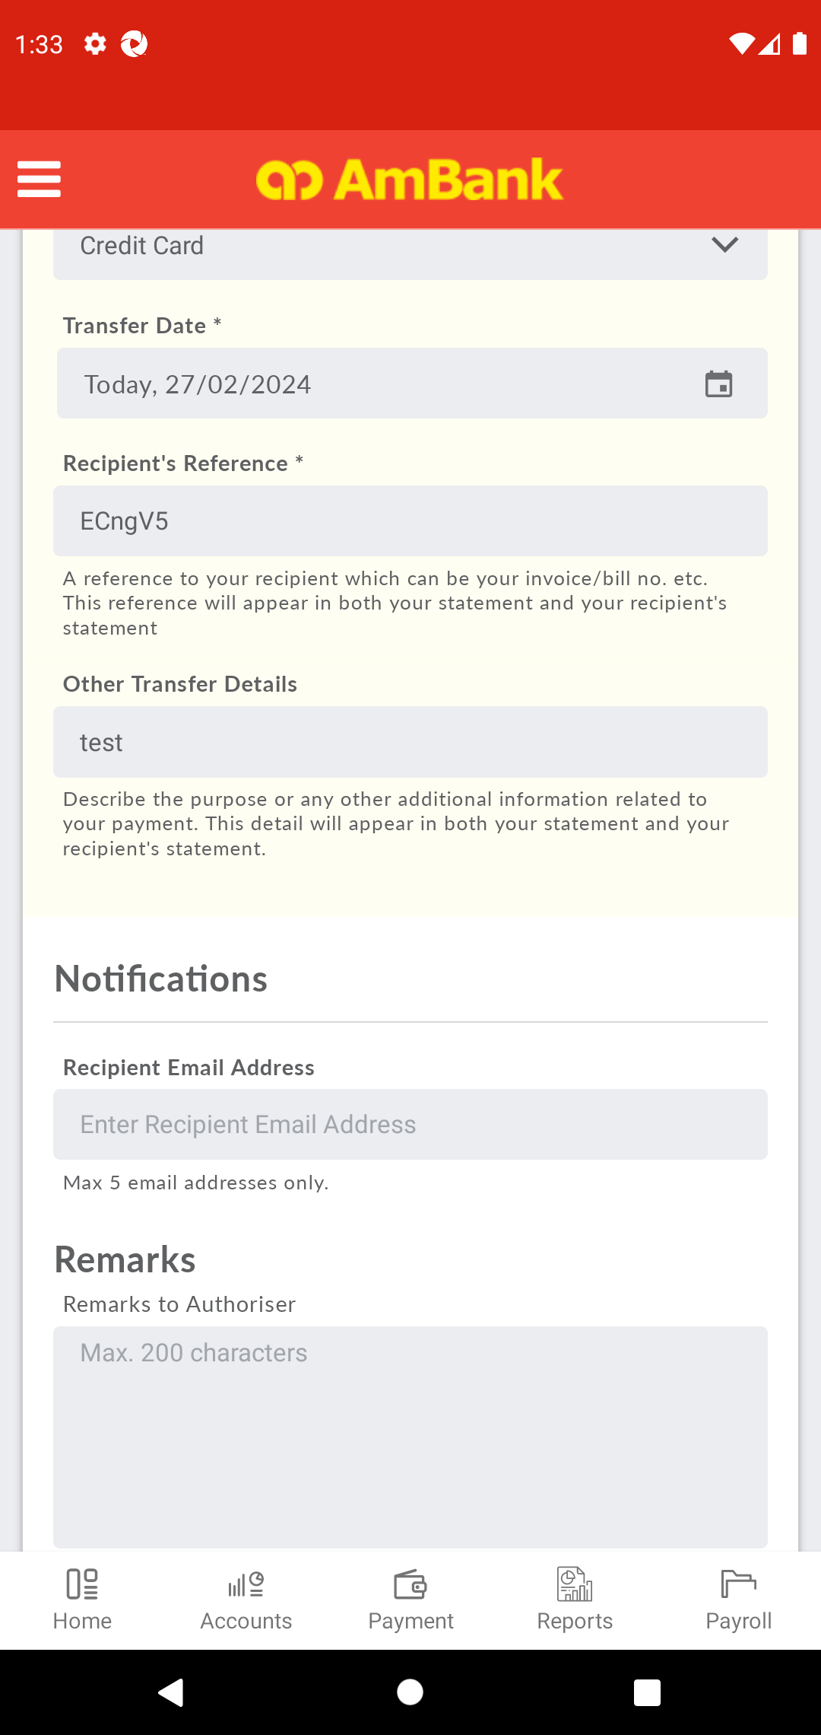  
  
**Test Step 30(PASS) :** [Local Transfer] Click [Recipient's Email Address]  
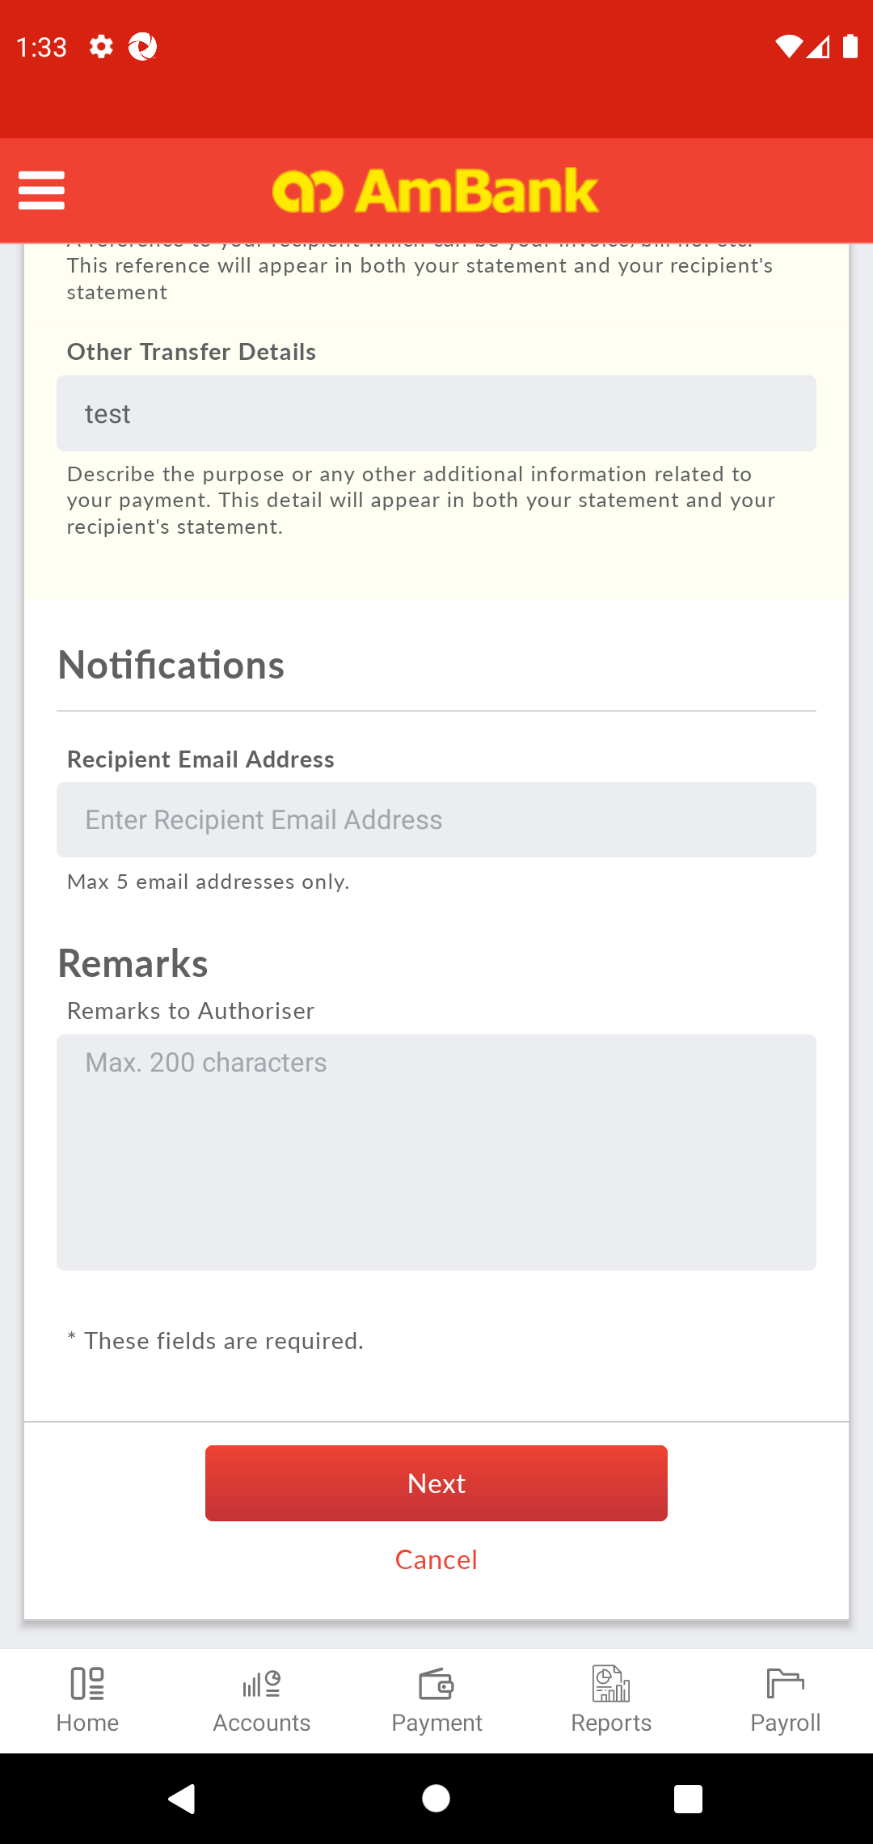  
  
**Test Step 31(PASS) :** [Local Transfer] Set [Recipient's Email Address]  
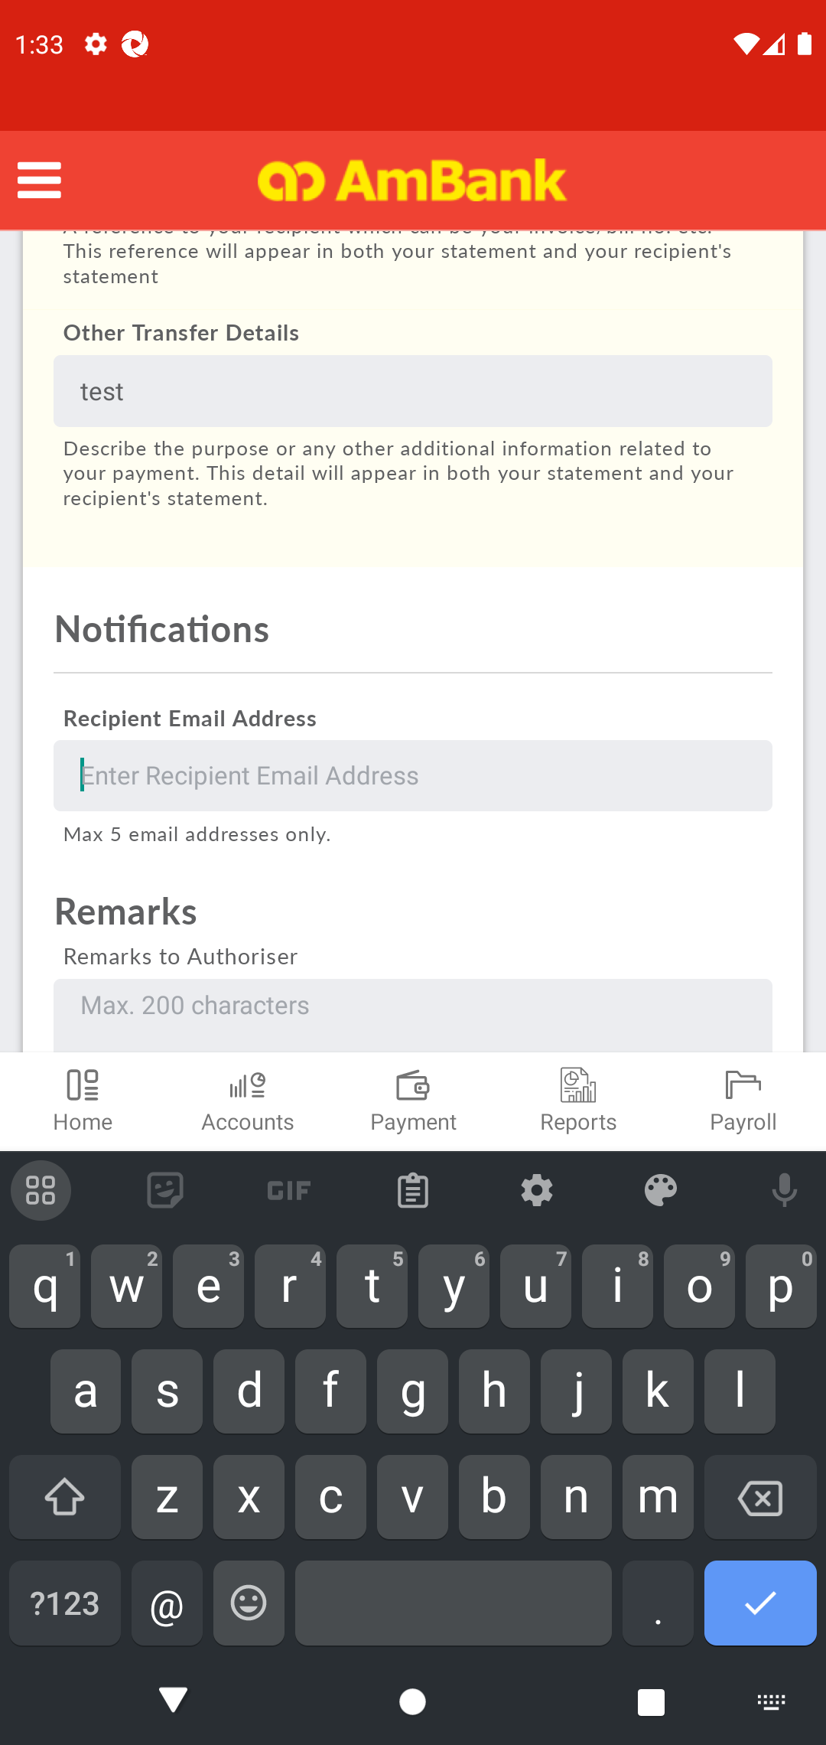  
  
**Test Step 32(PASS) :** [Local Transfer] Click [Back]  
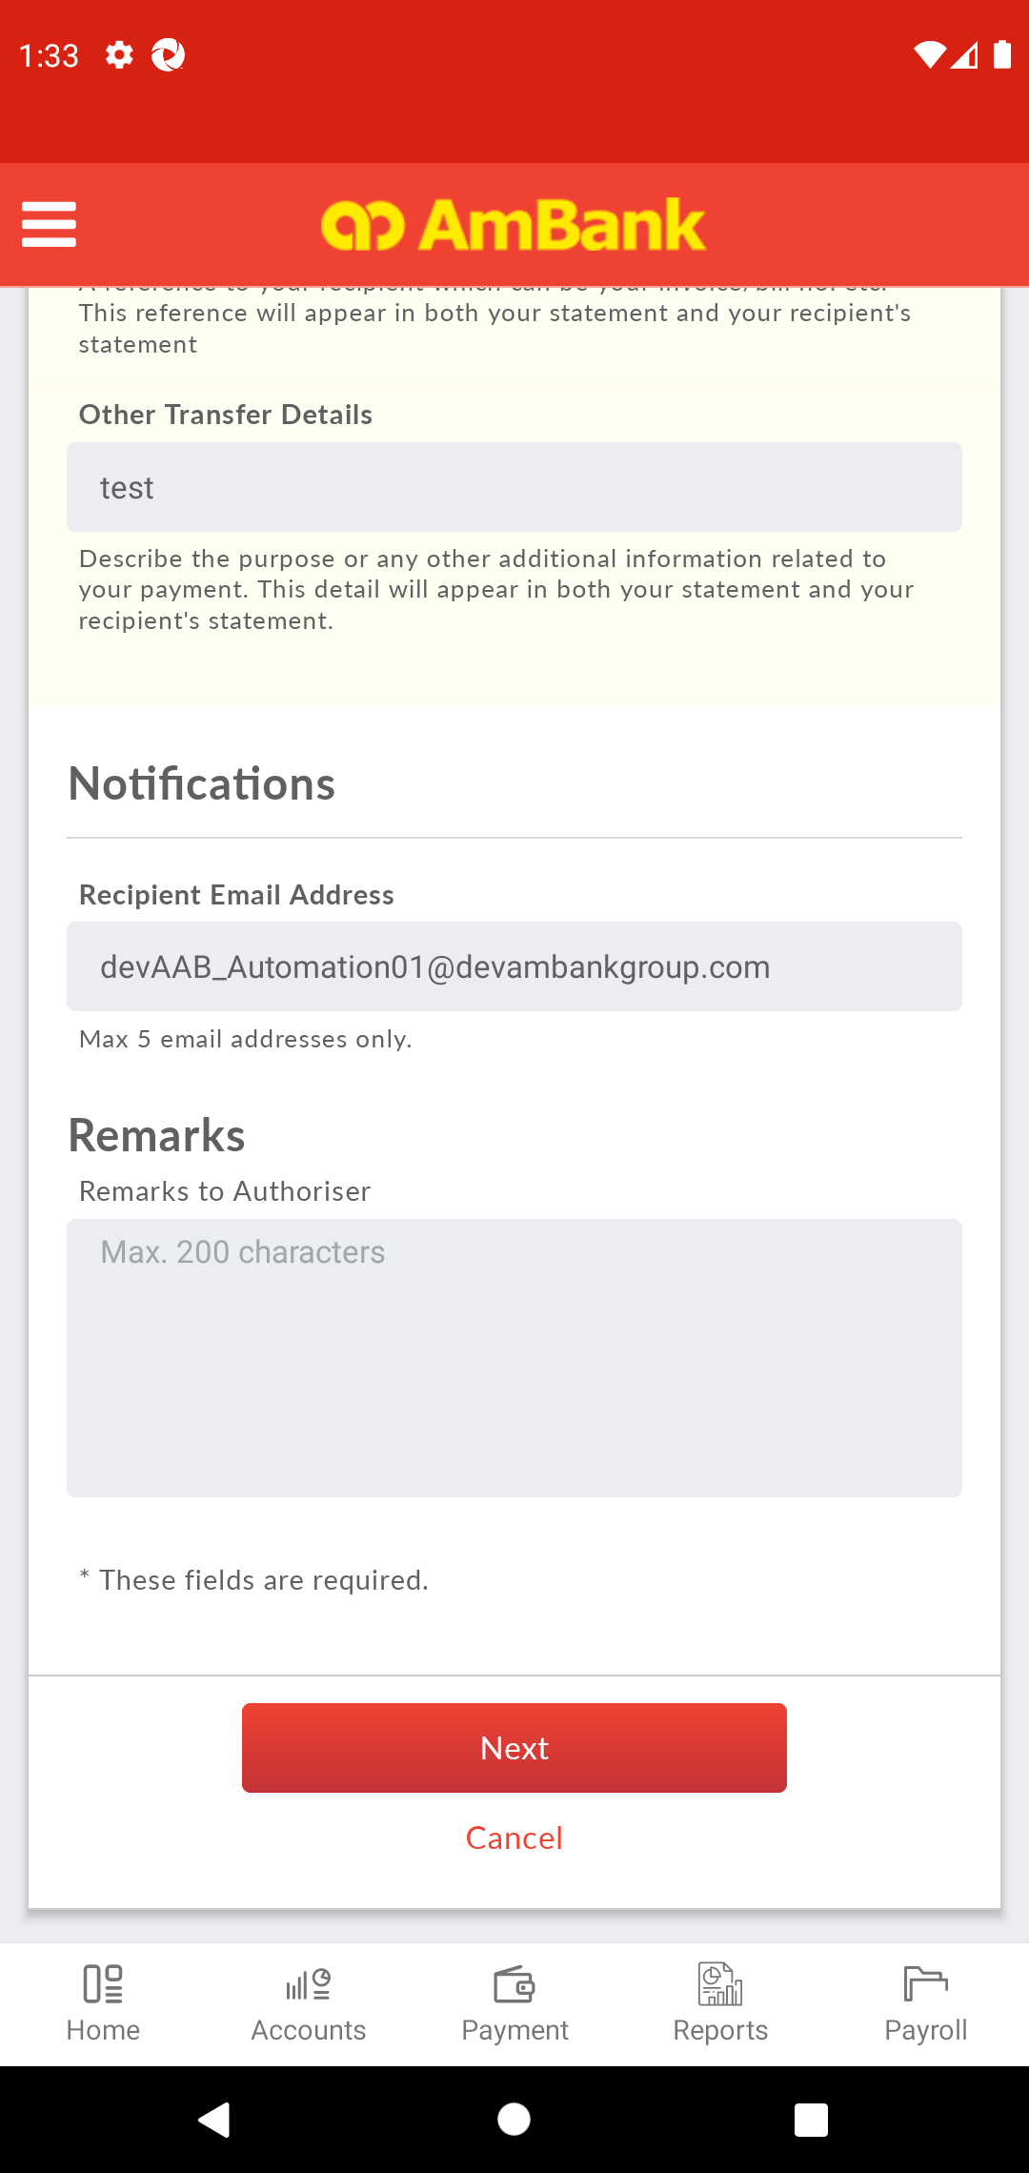  
  
**Test Step 33(PASS) :** [Local Transfer] Click [Remarks]  
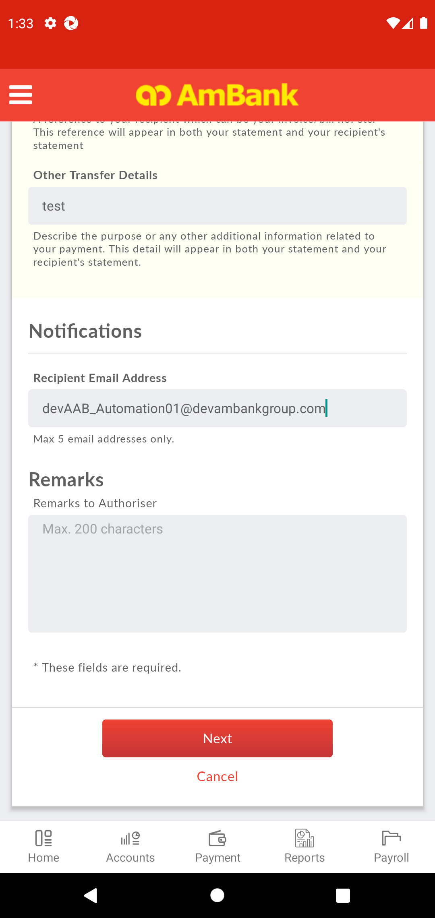  
  
**Test Step 34(PASS) :** [Local Transfer] Set [Remarks]  
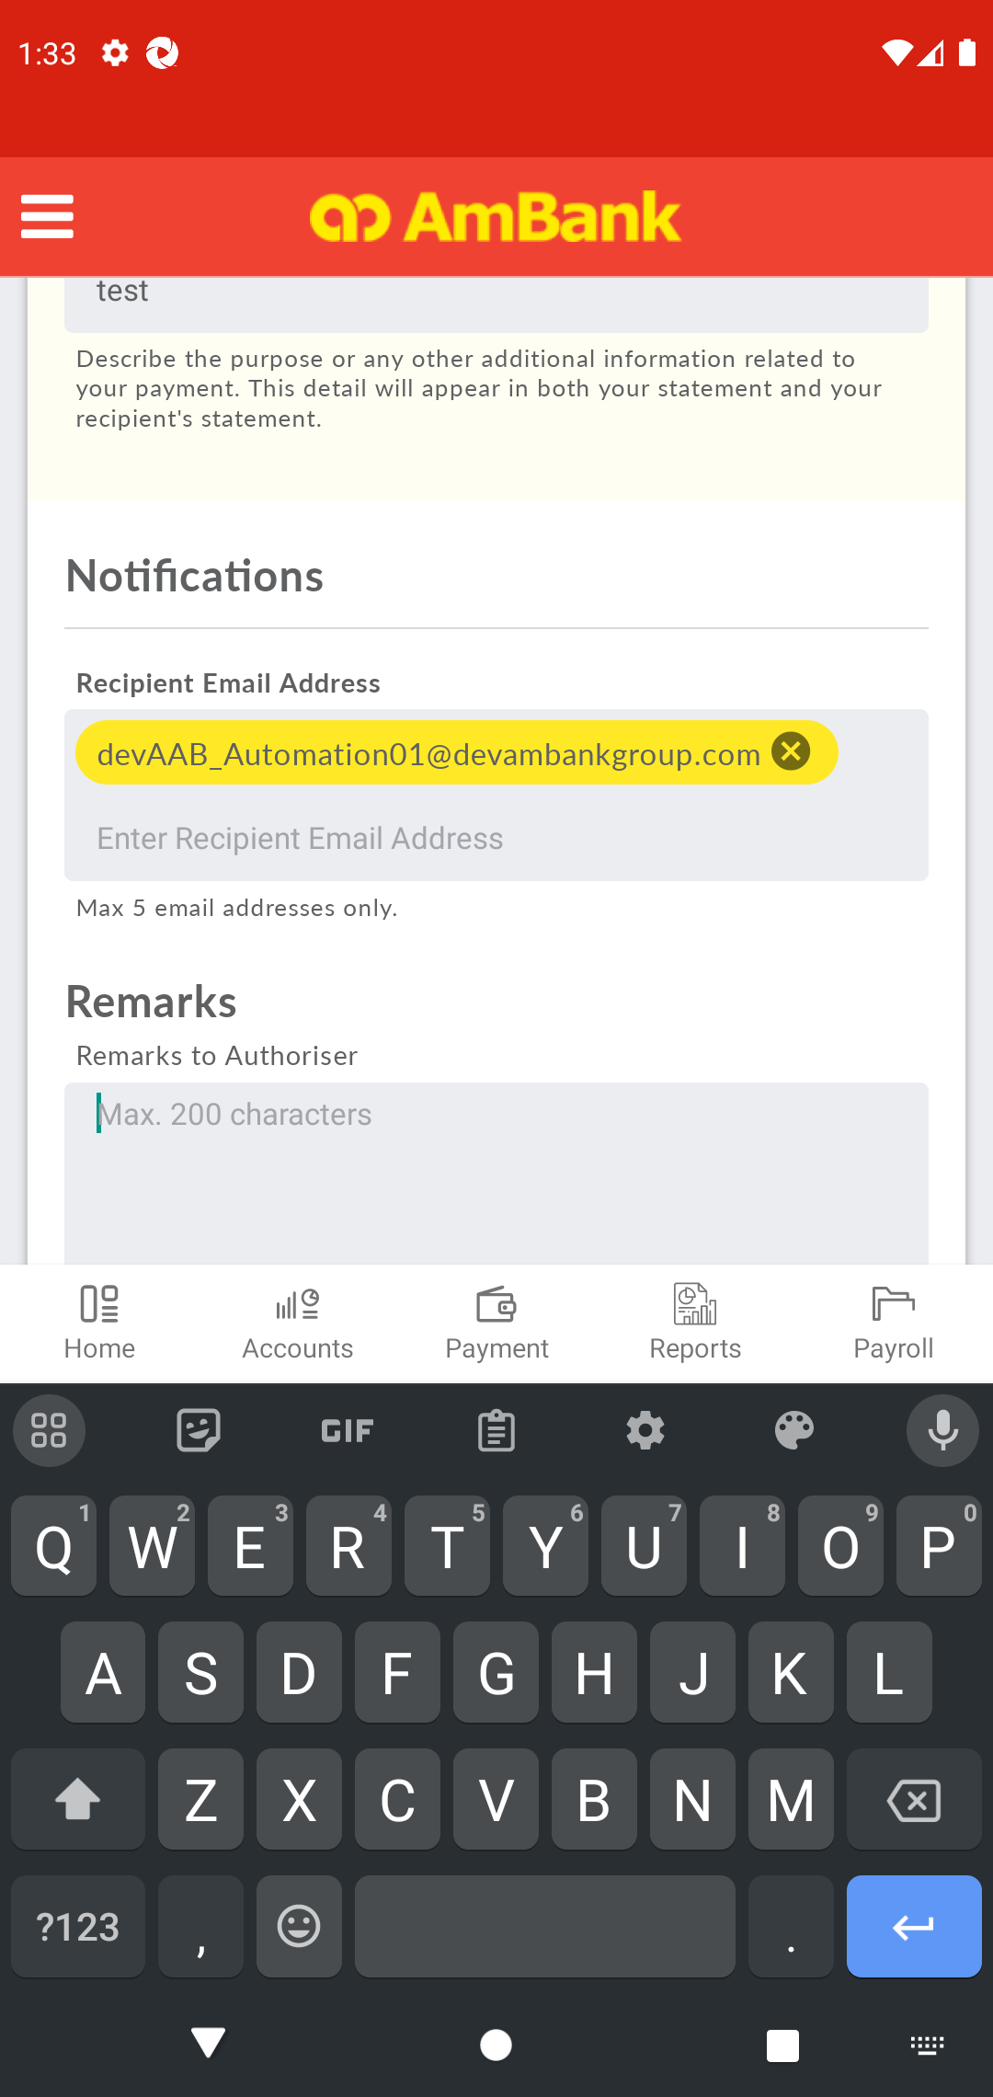  
  
**Test Step 35(PASS) :** Swipe Up to Next Button  
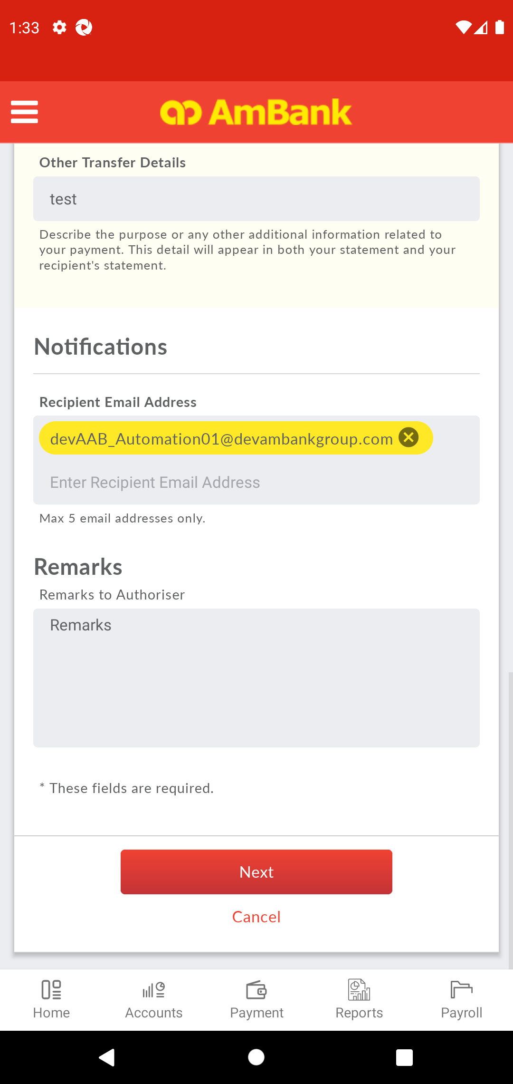  
  
**Test Step 36(PASS) :** [Local Transfer] Click [Next]  
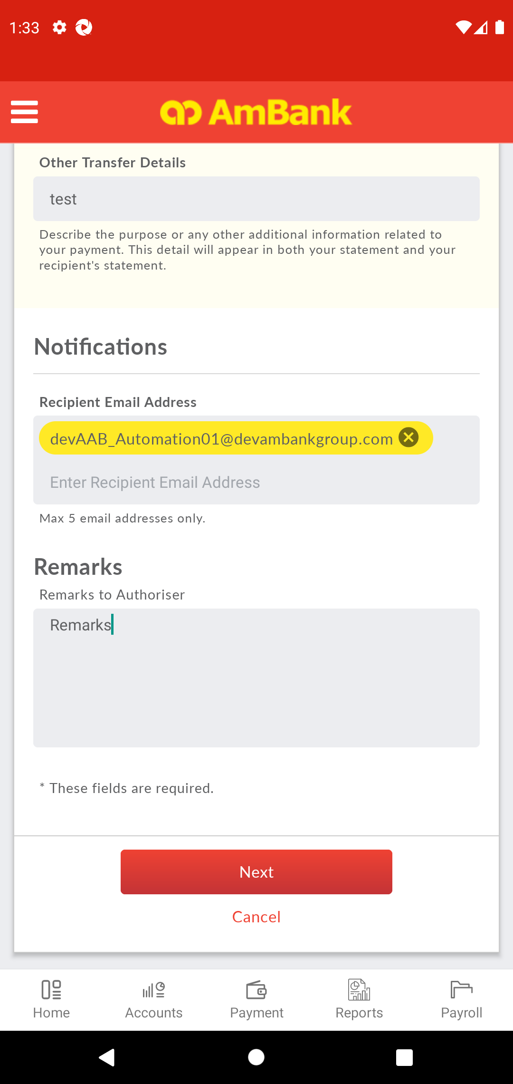  
  
**Test Step 37(PASS) :** Swipe Up To Recipient Account Number  
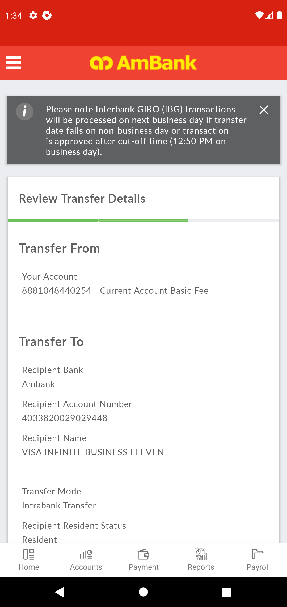  
  
**Test Step 38(PASS) :** [Local Transfer] Verify [Recipient Bank]  
  
  
**Test Step 39(PASS) :** [Local Transfer] Verify [Recipient Account Number]  
  
  
**Test Step 40(PASS) :** Swipe Up To Transfer Mode  
  
  
**Test Step 41(PASS) :** [Local Transfer] Verify [Transfer Mode]  
  
  
**Test Step 42(PASS) :** Swipe Up To Transfer Type  
  
  
**Test Step 43(PASS) :** [Local Transfer] Verify [Transfer Type]  
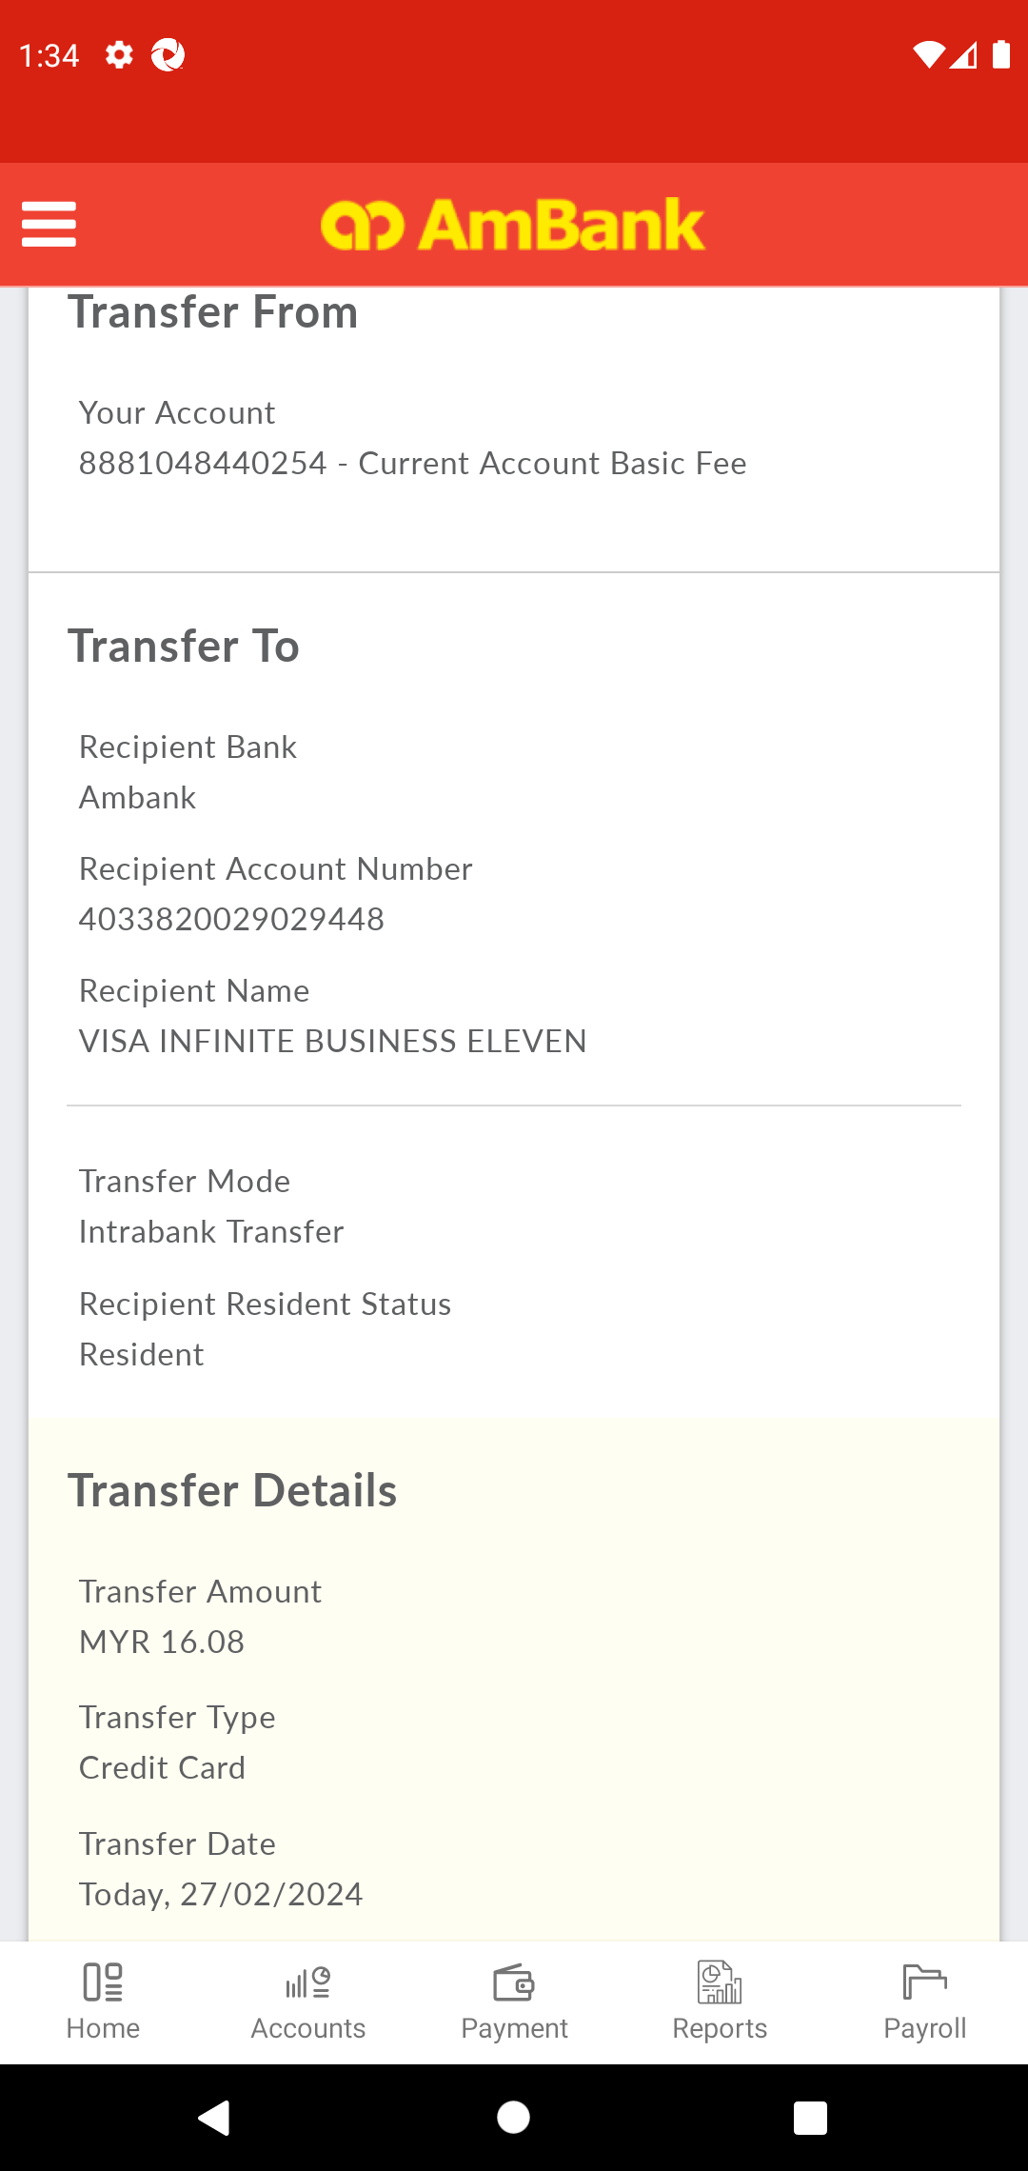  
  
**Test Step 44(PASS) :** Swipe Up To Recipient Reference  
  
  
**Test Step 45(PASS) :** [Local Transfer] Verify [Recipient's Reference]  
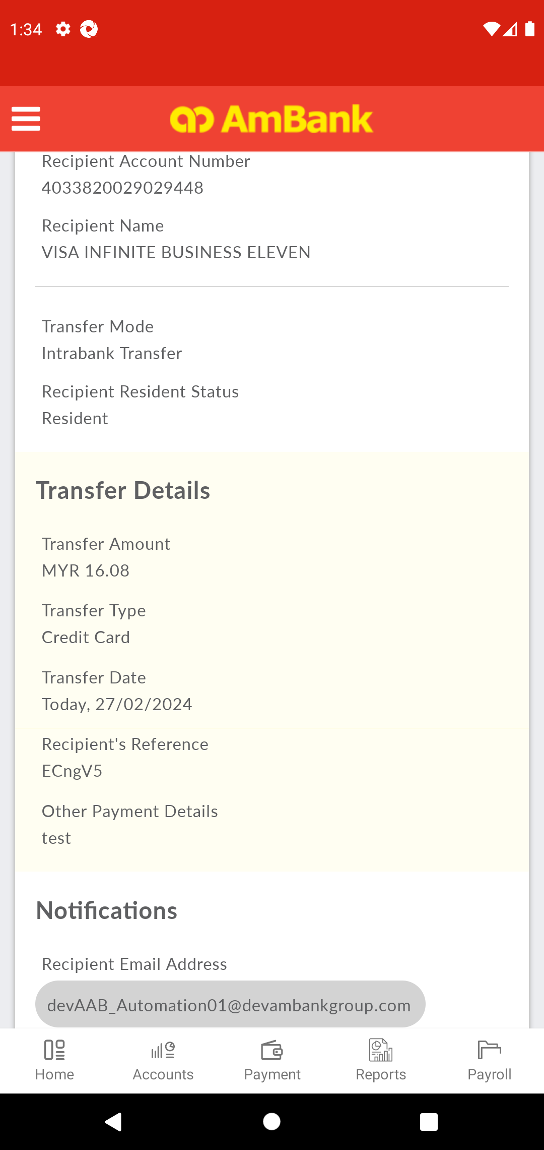  
  
**Test Step 46(PASS) :** Swipe Up To Other Details  
  
  
**Test Step 47(PASS) :** [Local Transfer] Verify [Other Details]  
  
  
**Test Step 48(PASS) :** Swipe Up To Confirm  
  
  
**Test Step 49(PASS) :** [Local Transfer] Click [Confirm]  
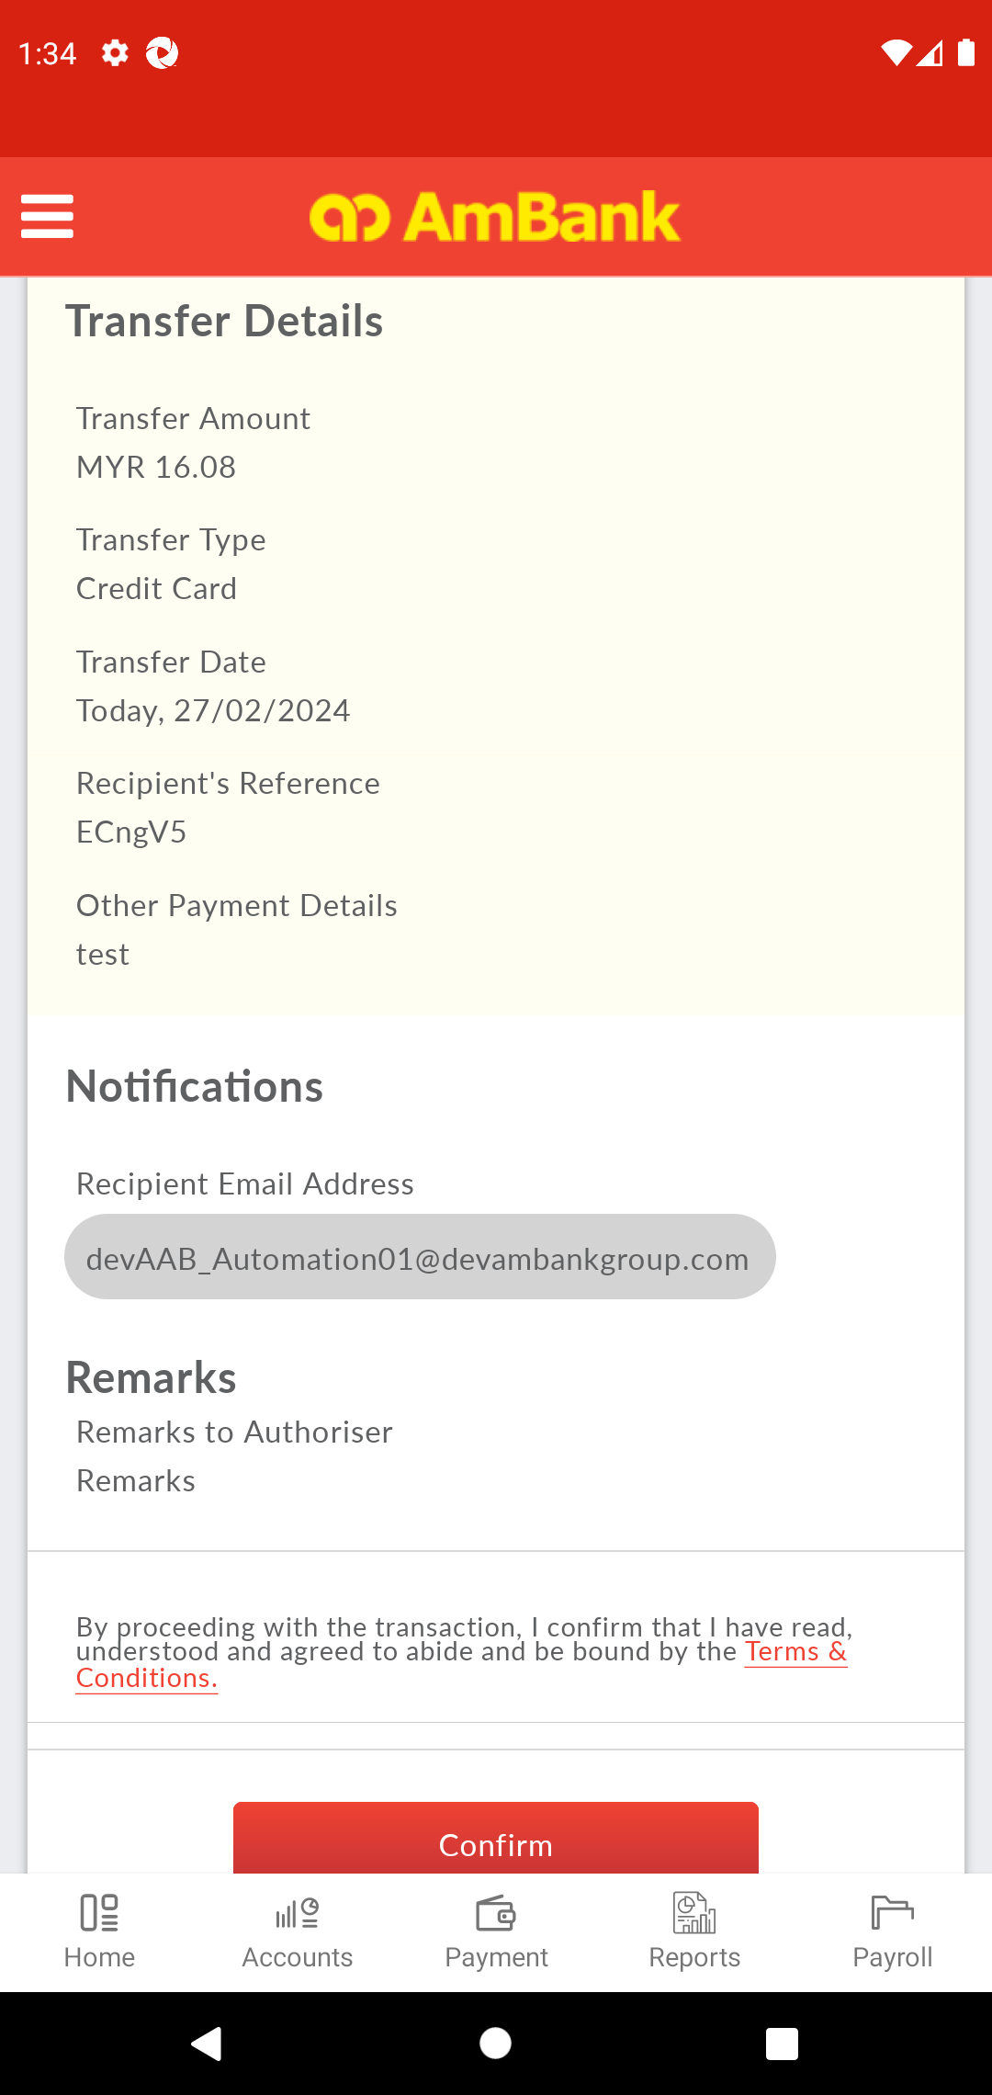  
  
**Test Step 50(PASS) :** [Local Transfer] Click [Confirm]  
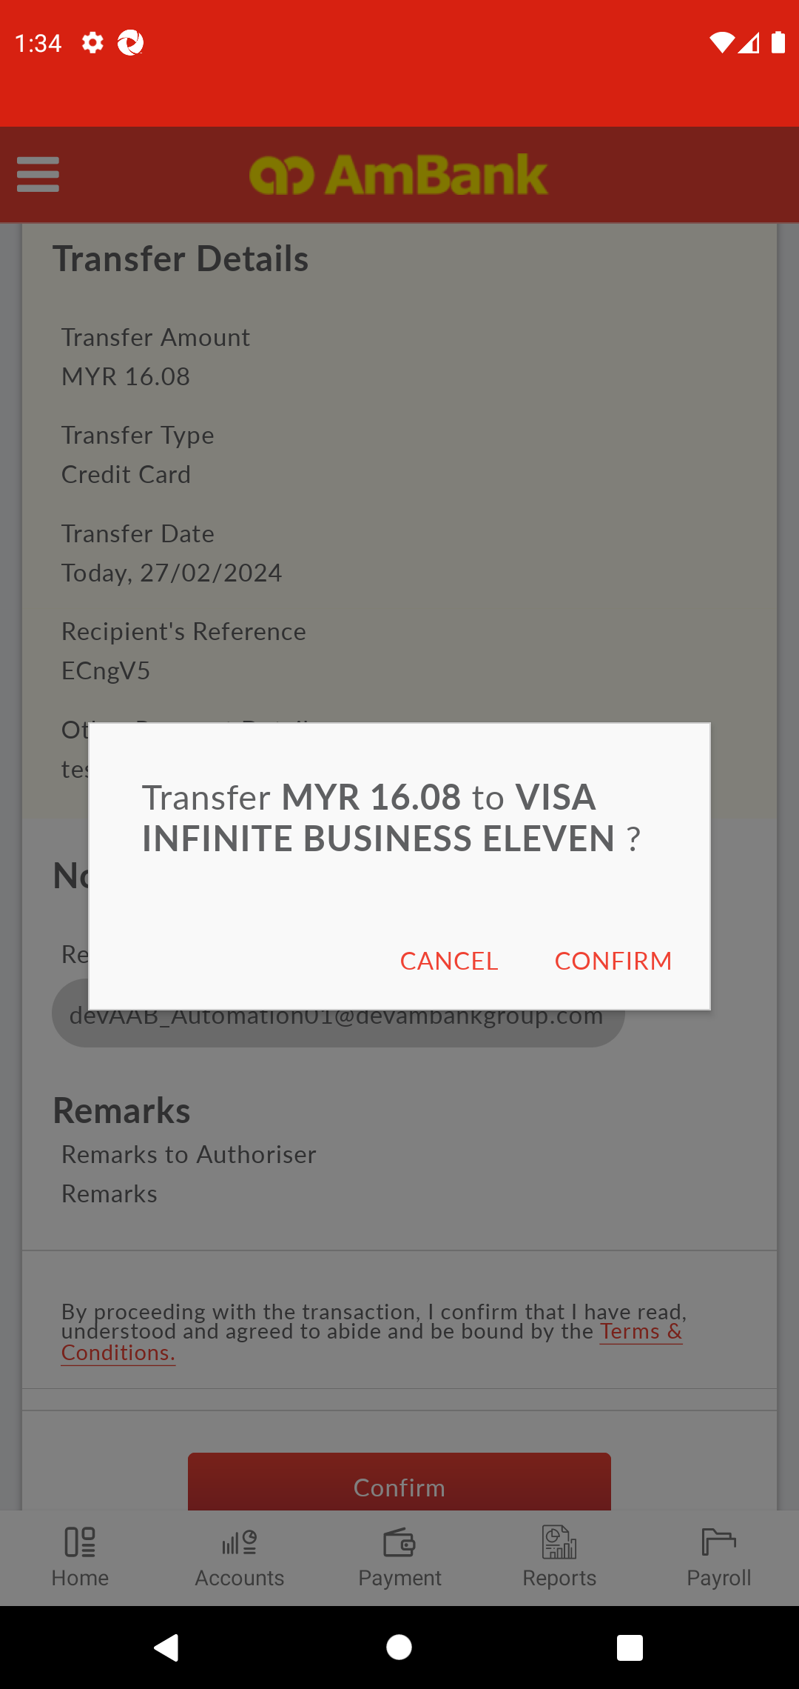  
  
**Test Step 51(PASS) :** [Local Transfer] Capture [Reference Number]  
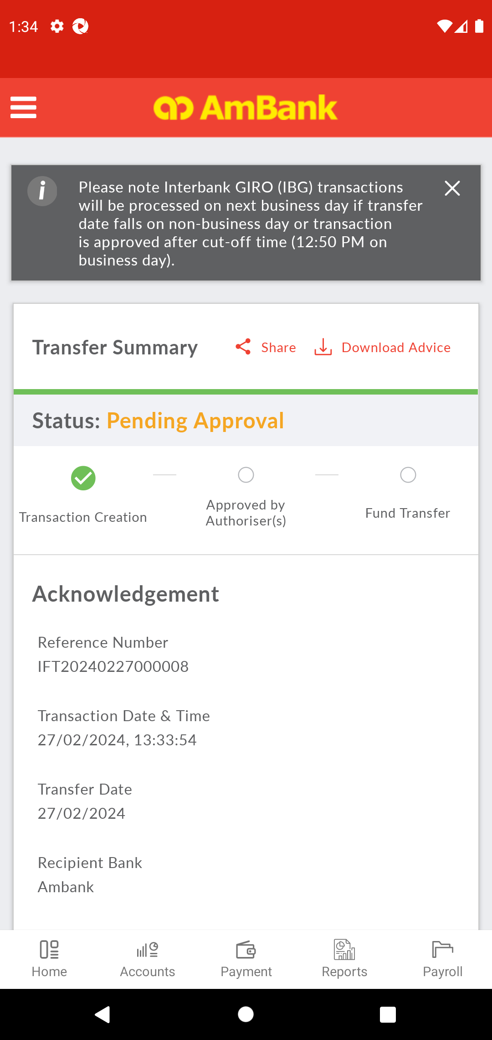  
  
**Test Step 52(PASS) :** [Local Transfer] Verify [Status]  
  
  
**Test Step 53(PASS) :** [Local Transfer] Click [Download Advice]  
  
  
**Test Step 54(PASS) :** SCREENSHOT  
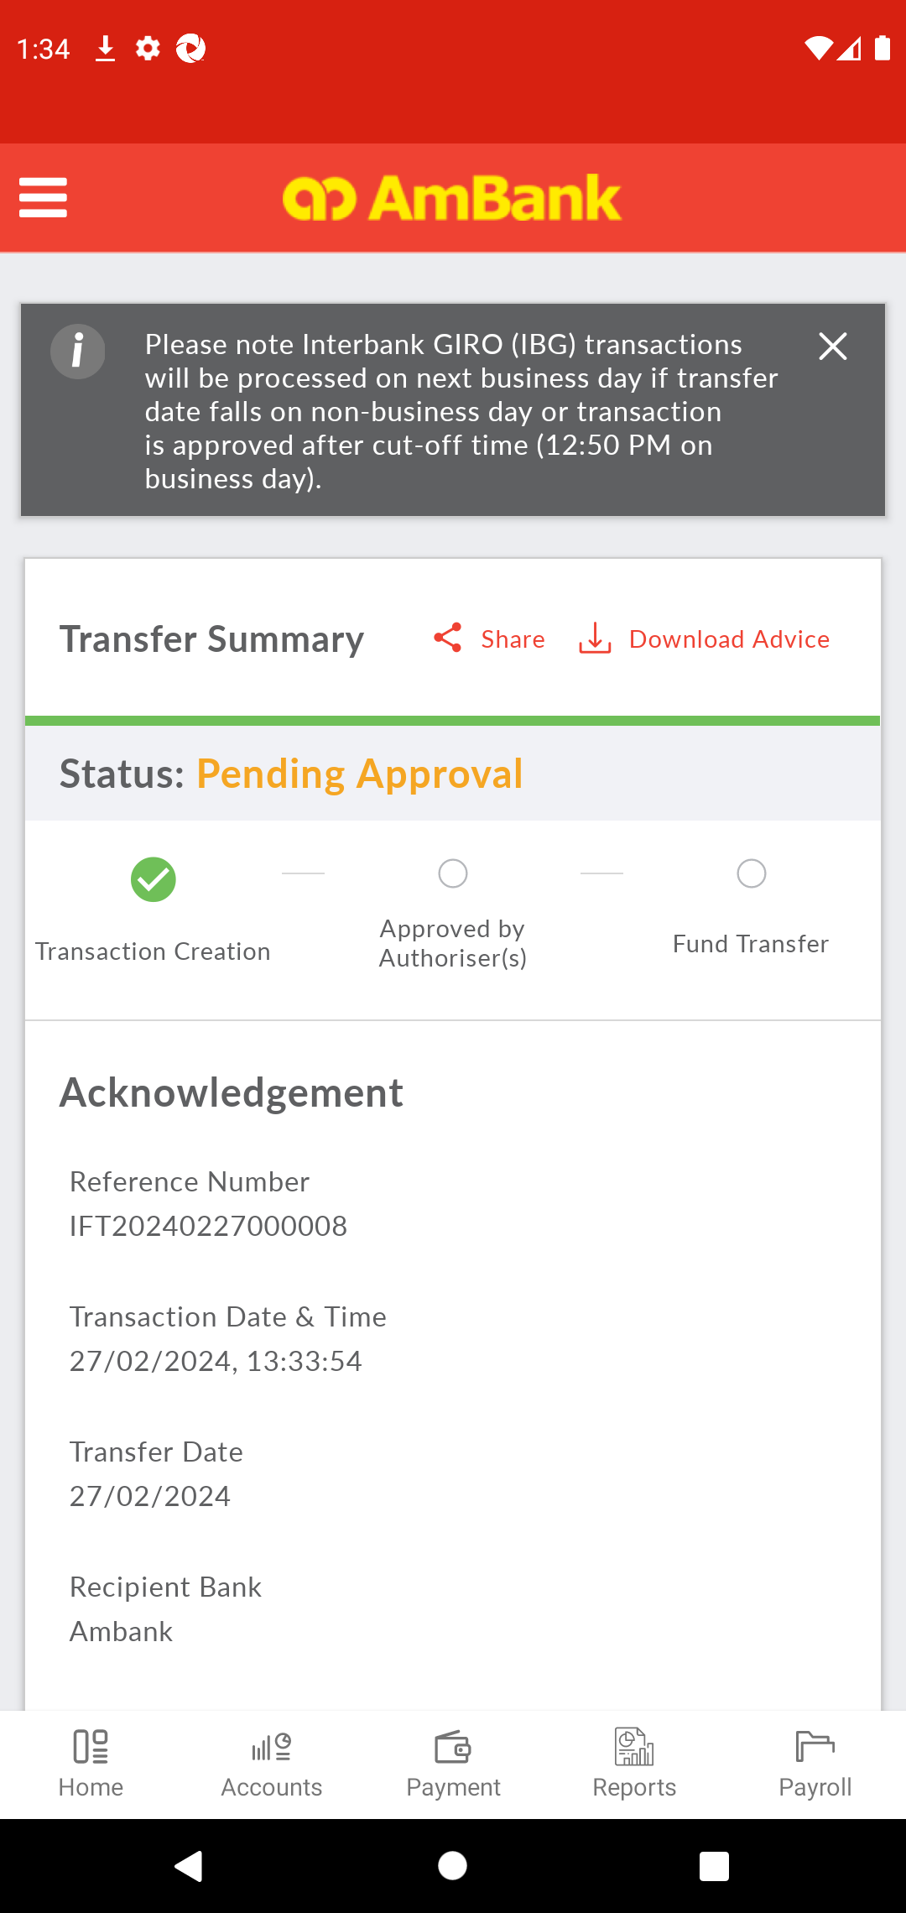  
  
**Test Step 55(PASS) :** [PDF] Back to CFO  
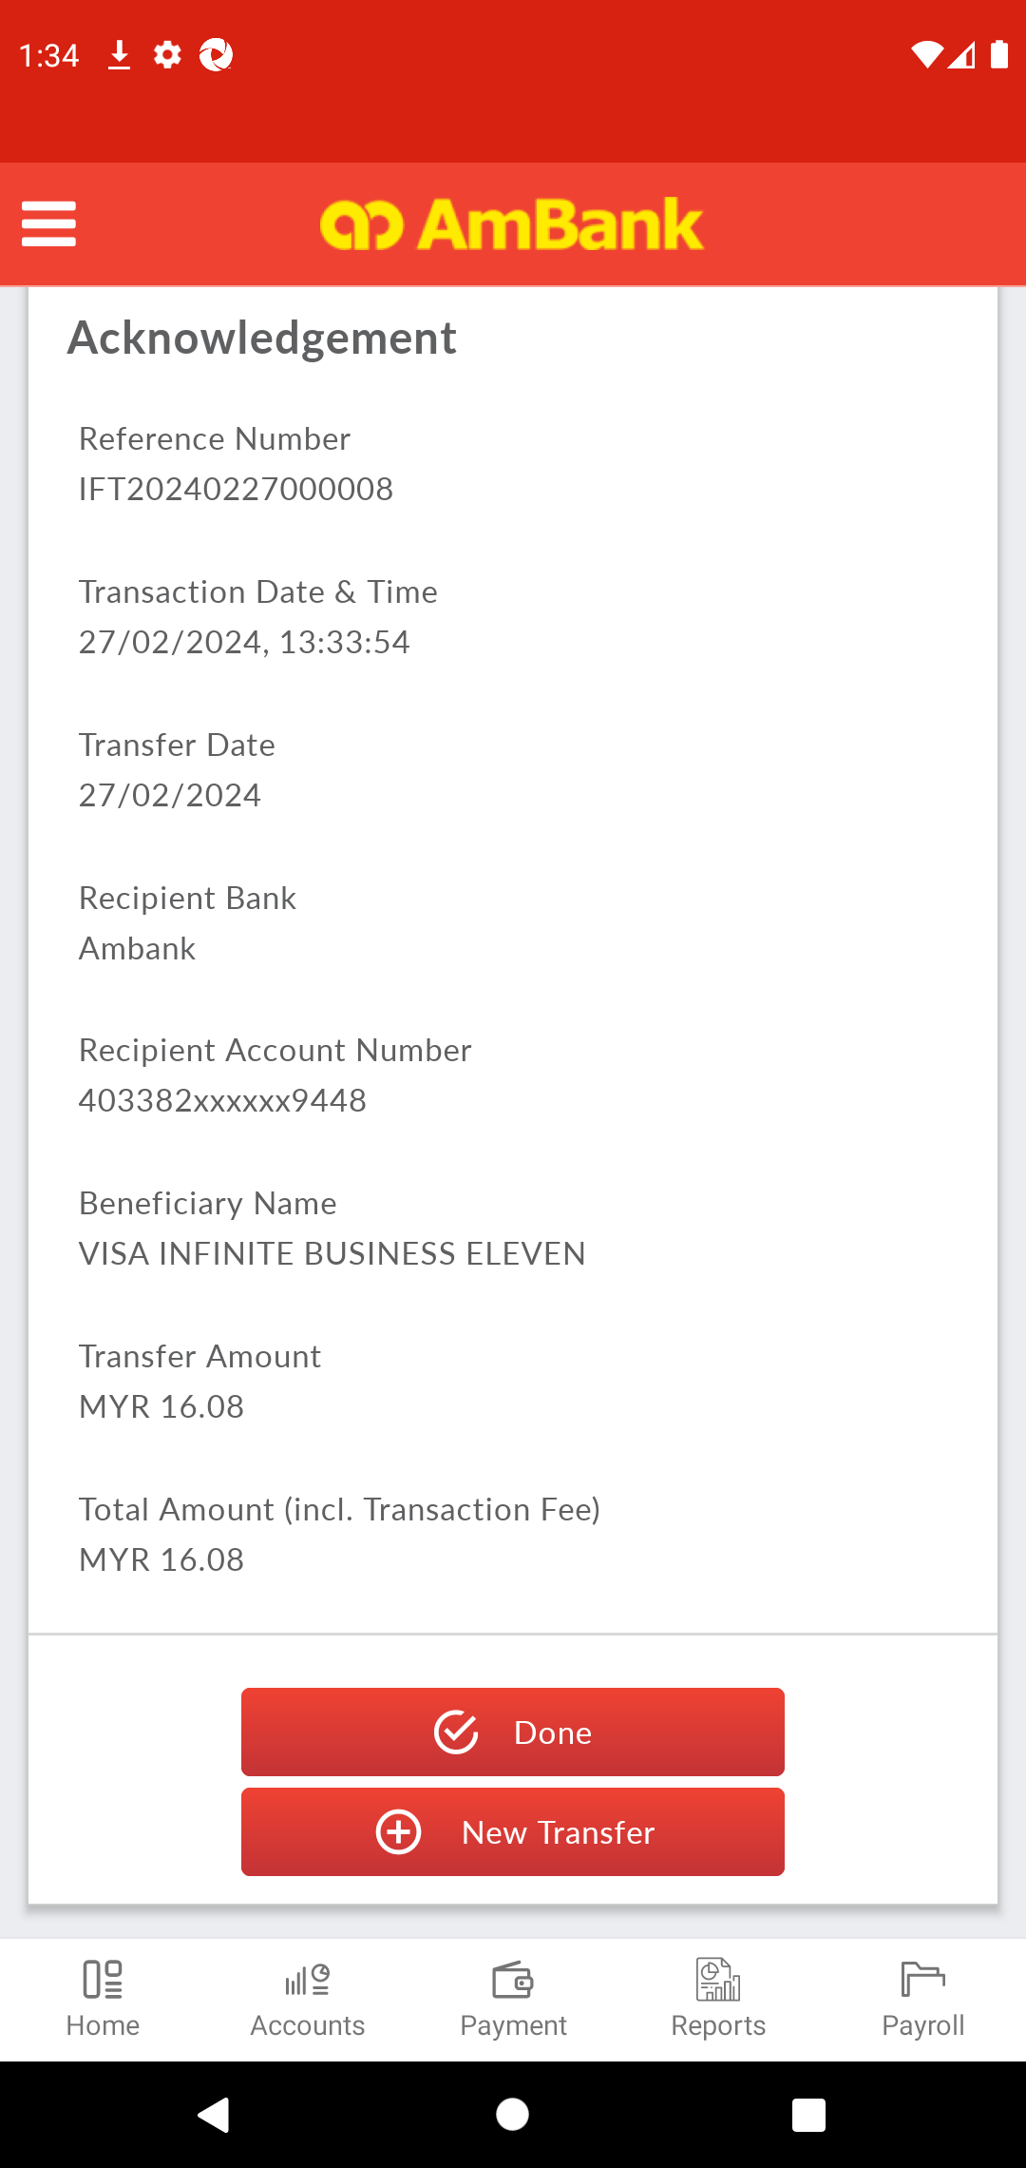  
  
**Test Step 56(PASS) :** Swipe Up To Done  
  
  
**Test Step 57(PASS) :** [Local Transfer] Click [Done]  
  
  
**Test Step 58(PASS) :** [CFO] Click [Menu]  
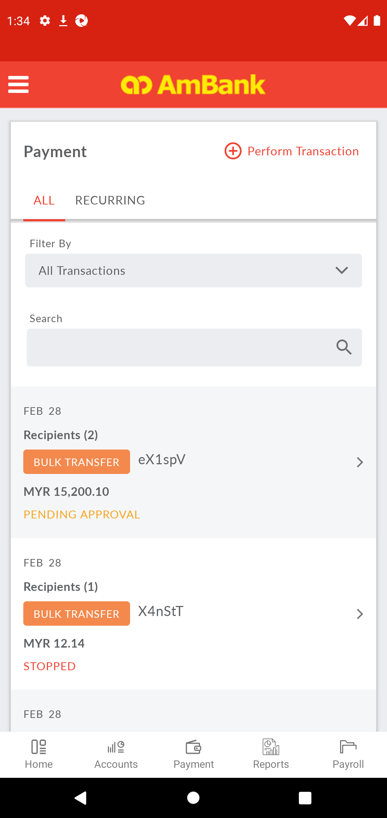  
  
**Test Step 59(PASS) :** [CFO] Click [Logout]  
  
  
**Test Step 60(PASS) :** [CFO] Click [Menu]  
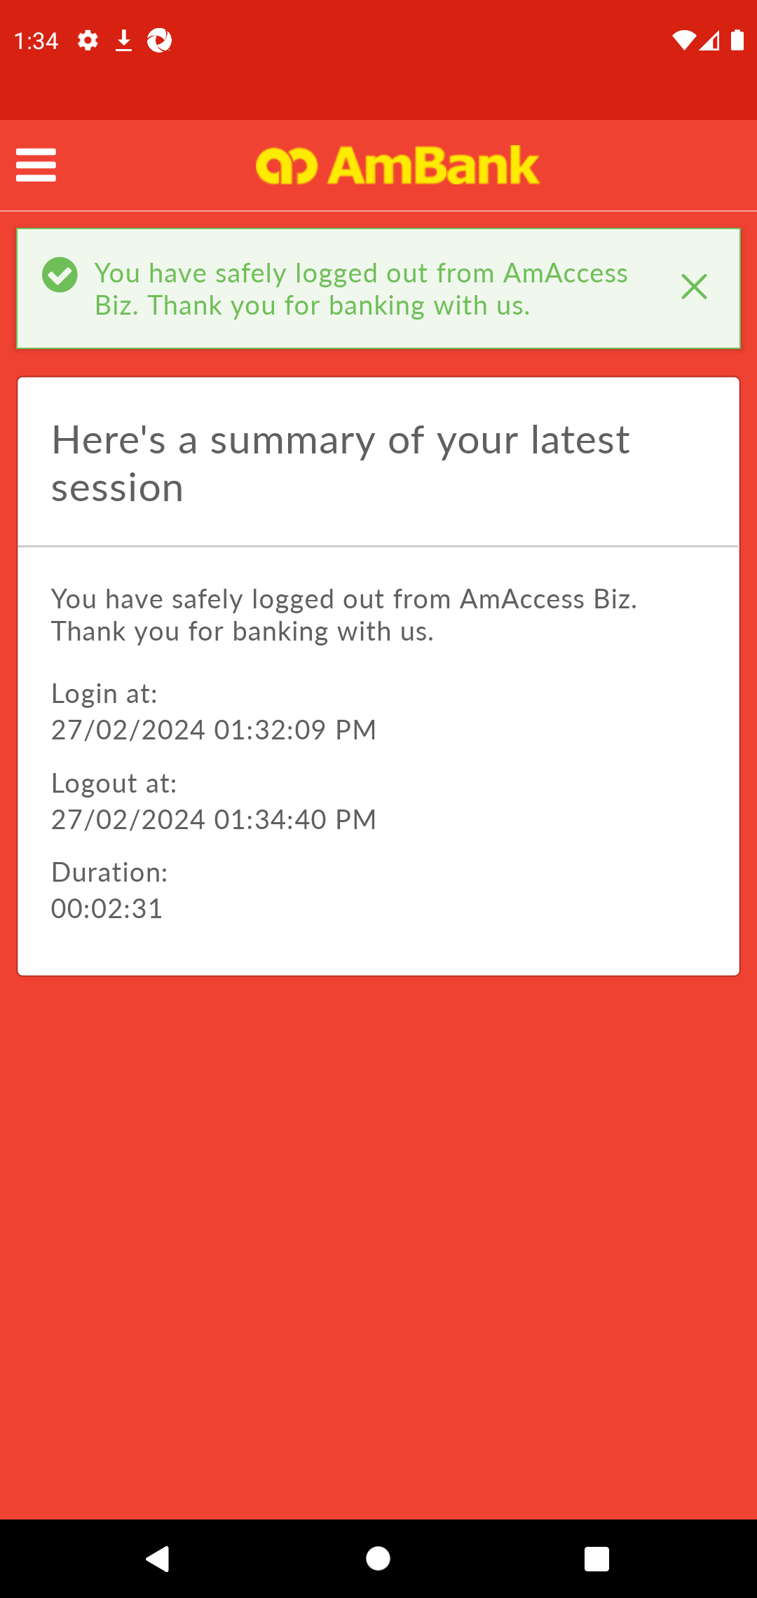  
  
**Test Step 61(PASS) :** [CFO] Click [Log In]  
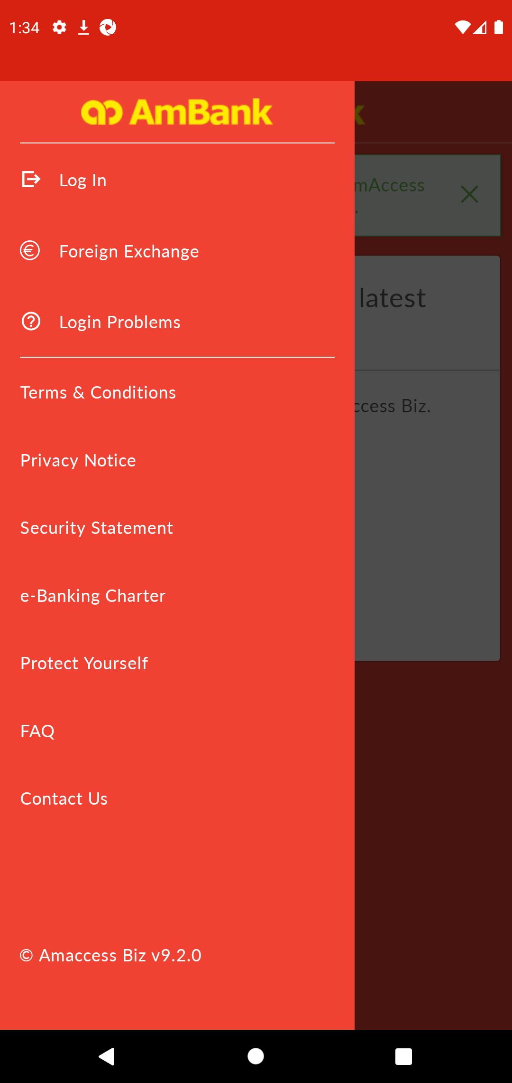  
  
**Test Step 62(PASS) :** [CFO] Input [User ID]  
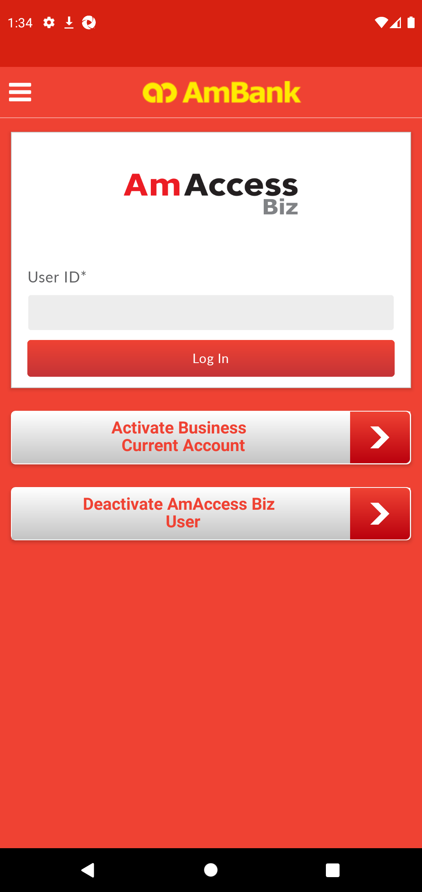  
  
**Test Step 63(PASS) :** [CFO] Click [Log In]  
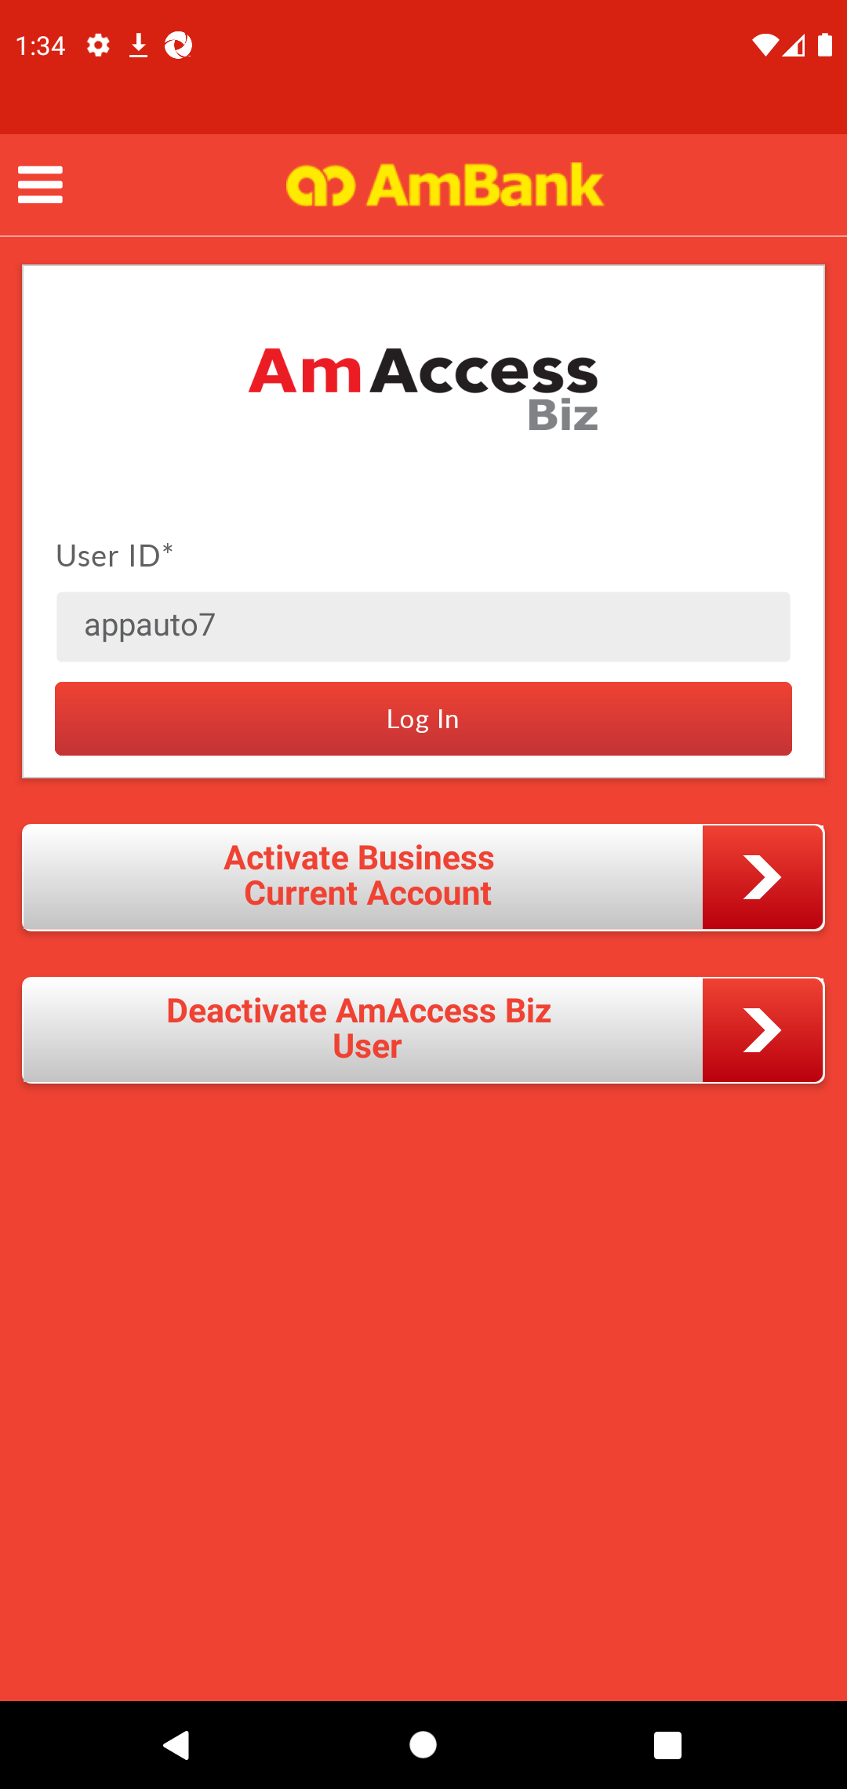  
  
**Test Step 64(PASS) :** [CFO] Click [Yes]  
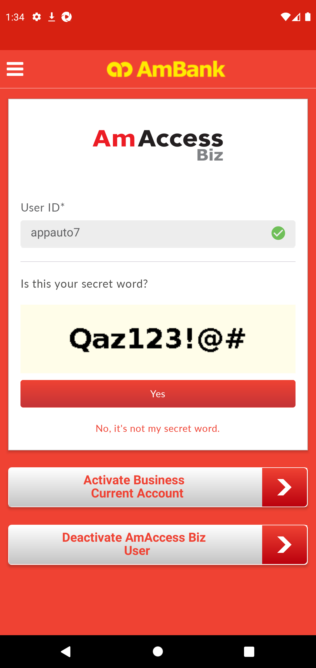  
  
**Test Step 65(PASS) :** [CFO] Input [Password]  
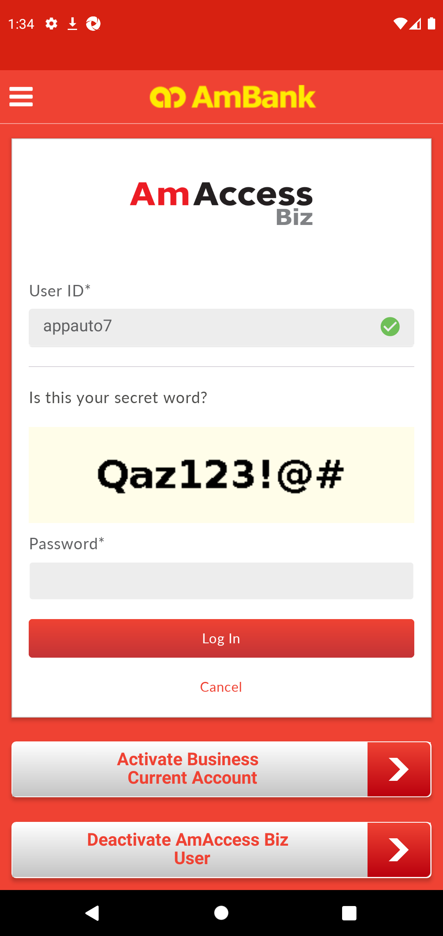  
  
**Test Step 66(PASS) :** [CFO] Click [Log In]  
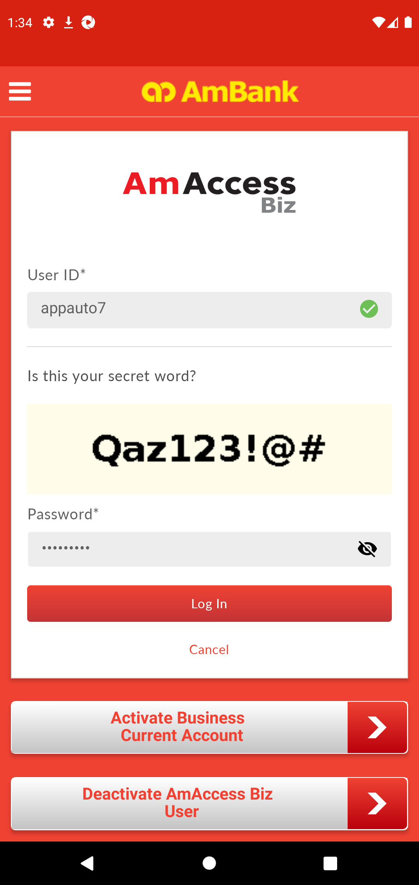  
  
**Test Step 67(PASS) :** [CFO] [Home] Click [Payment]  
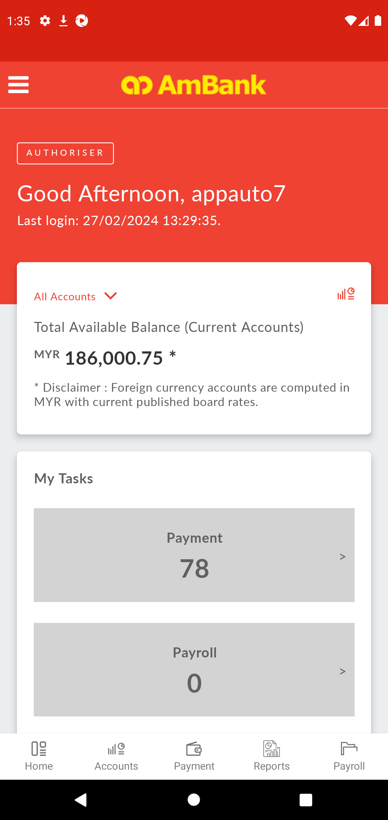  
  
**Test Step 68(PASS) :** [CFO] [Home] Click [All Transactions]  
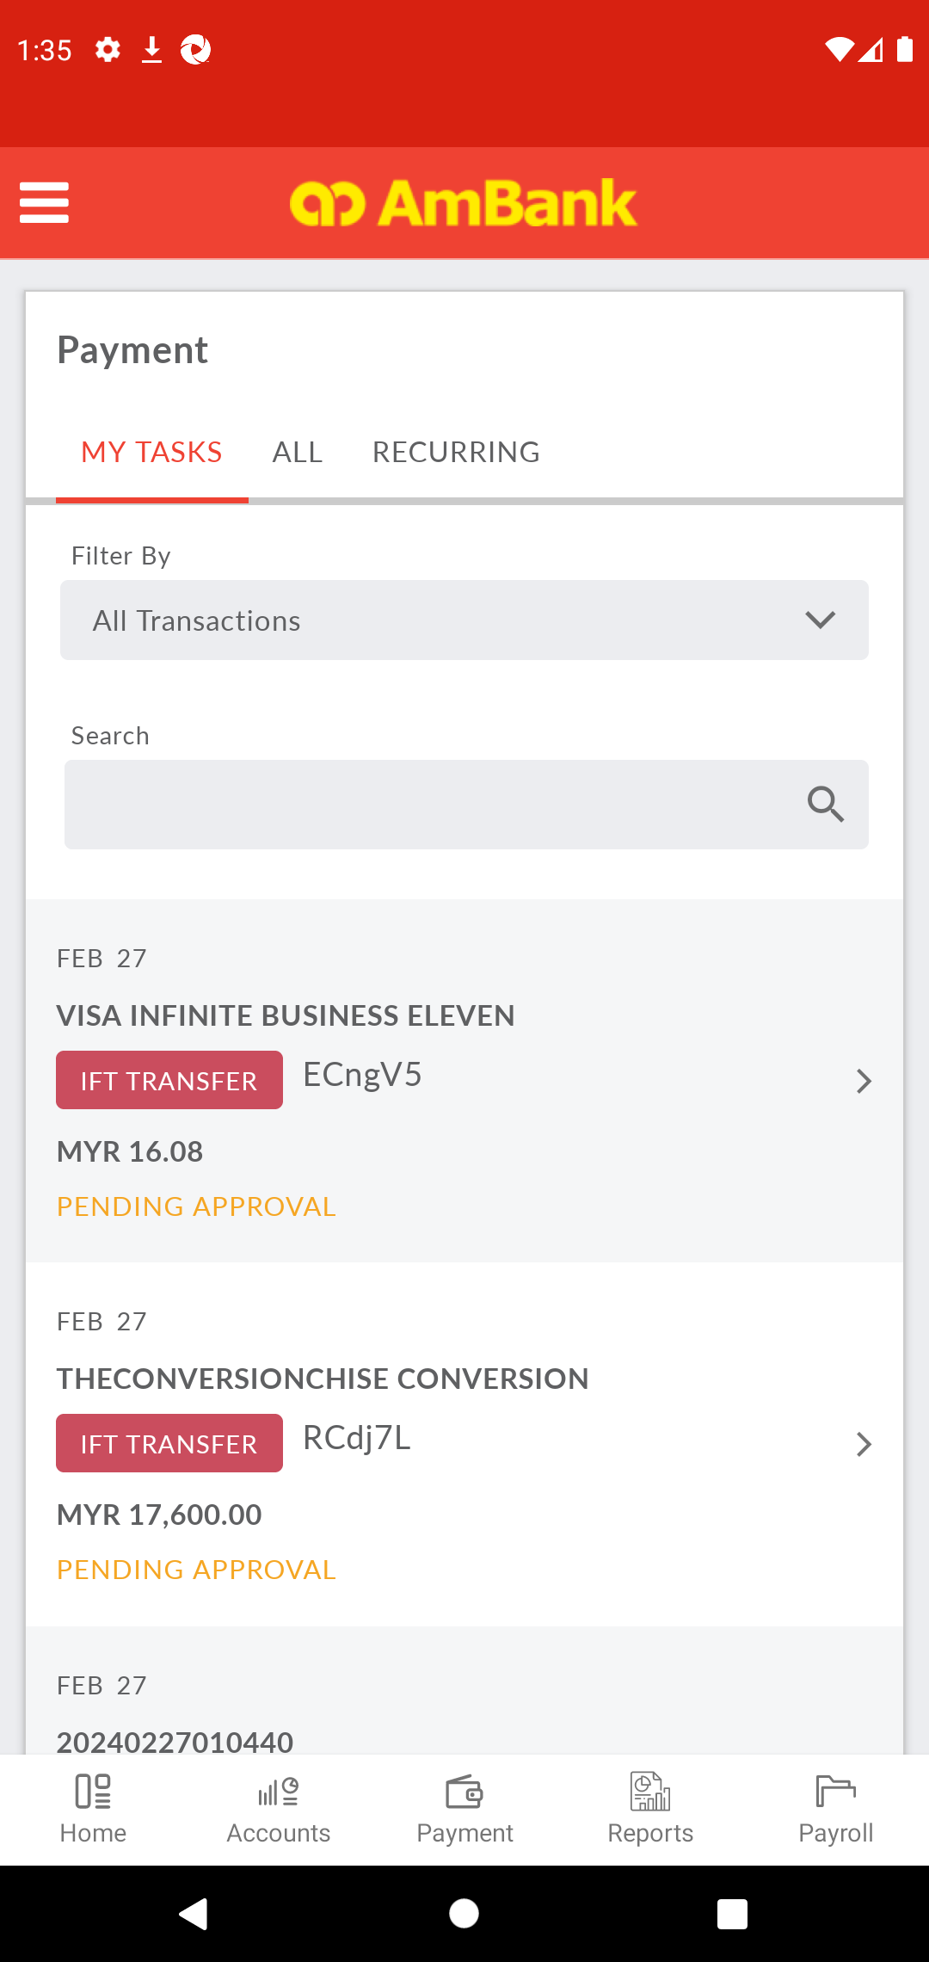  
  
**Test Step 69(PASS) :** [CFO] [Home] Click [Transaction Date]  
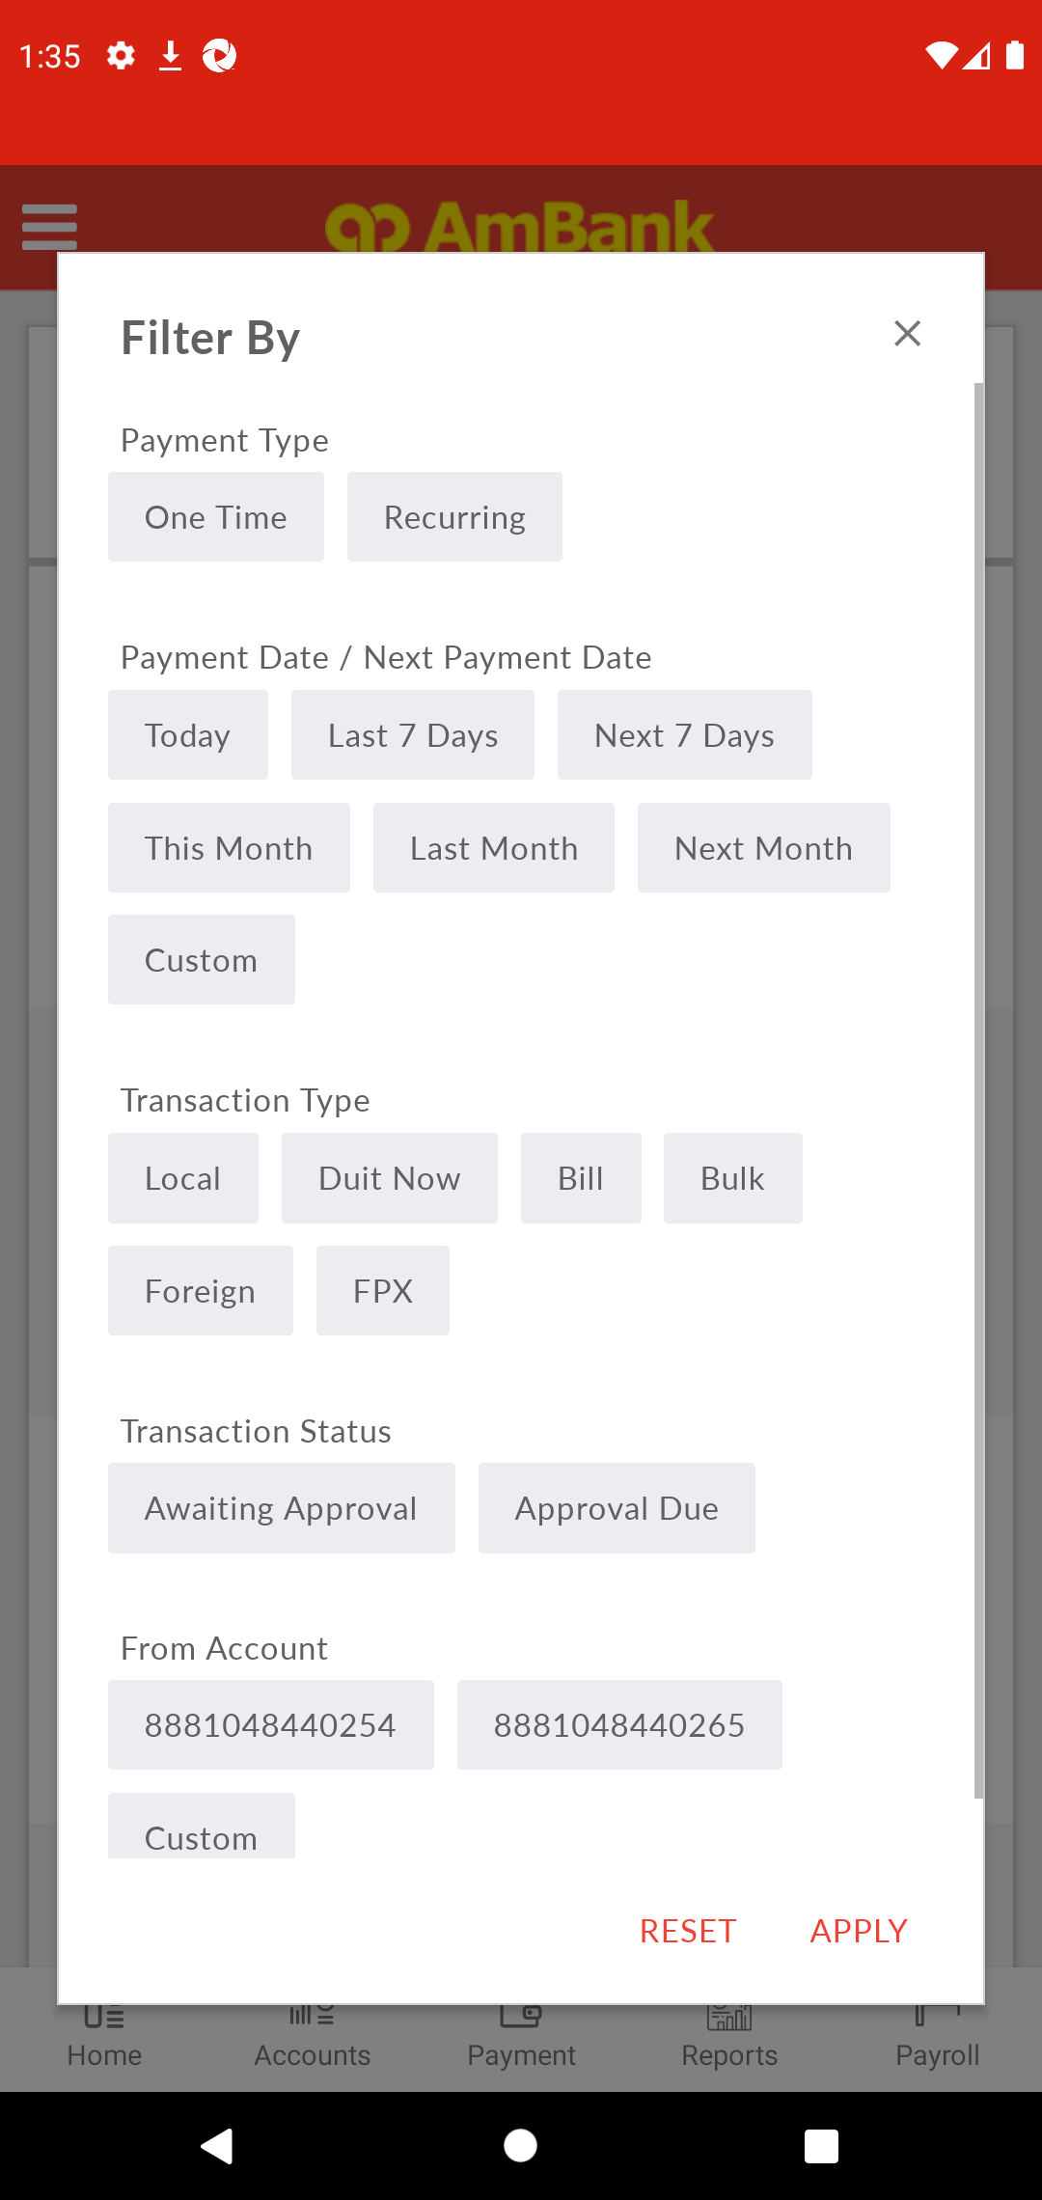  
  
**Test Step 70(PASS) :** [CFO] [Home] Click [Transaction Type]  
  
  
**Test Step 71(PASS) :** Swipe Up To Awaiting Approval  
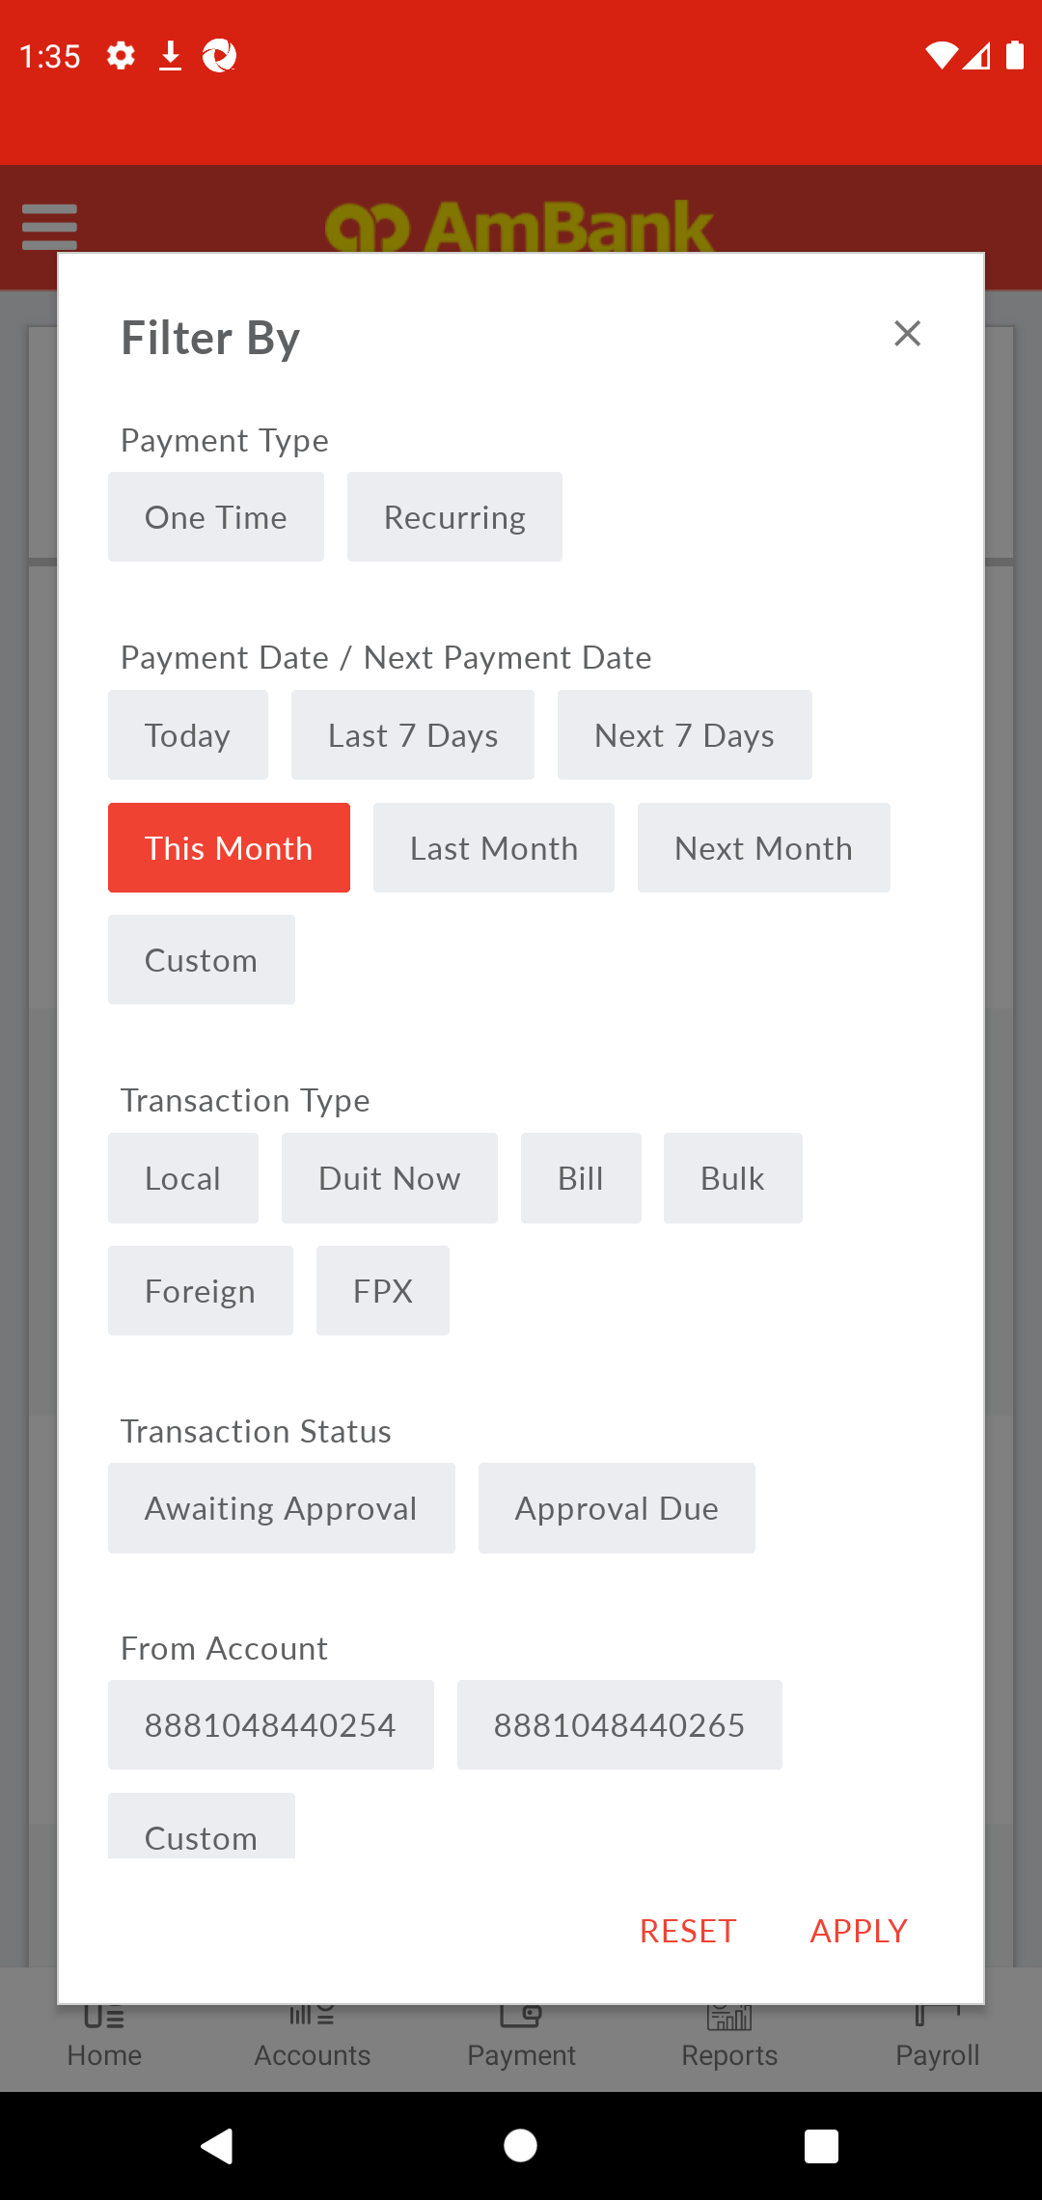  
  
**Test Step 72(PASS) :** [CFO] [Home] Click [Approval Due]  
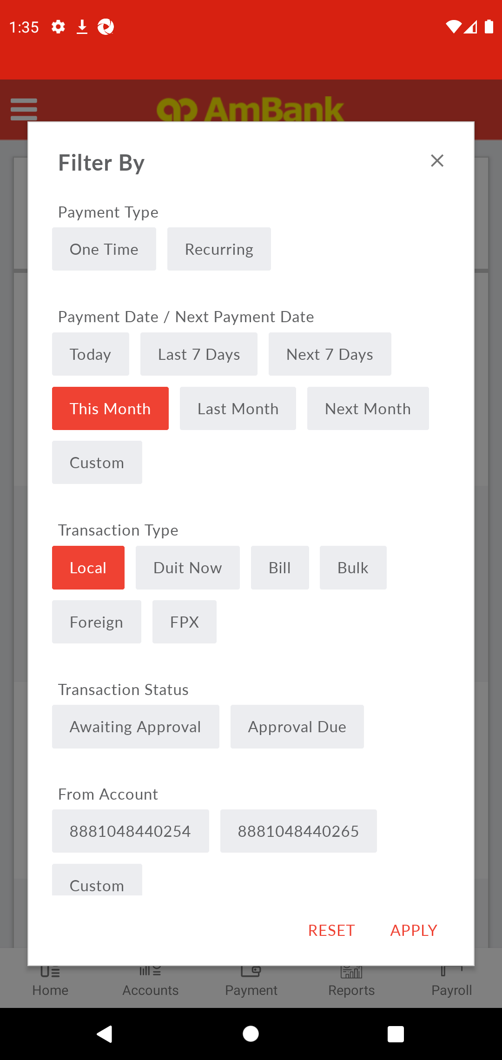  
  
**Test Step 73(PASS) :** [CFO] [Home] Click [Apply]  
  
  
**Test Step 74(PASS) :** Swipe Up To Transaction  
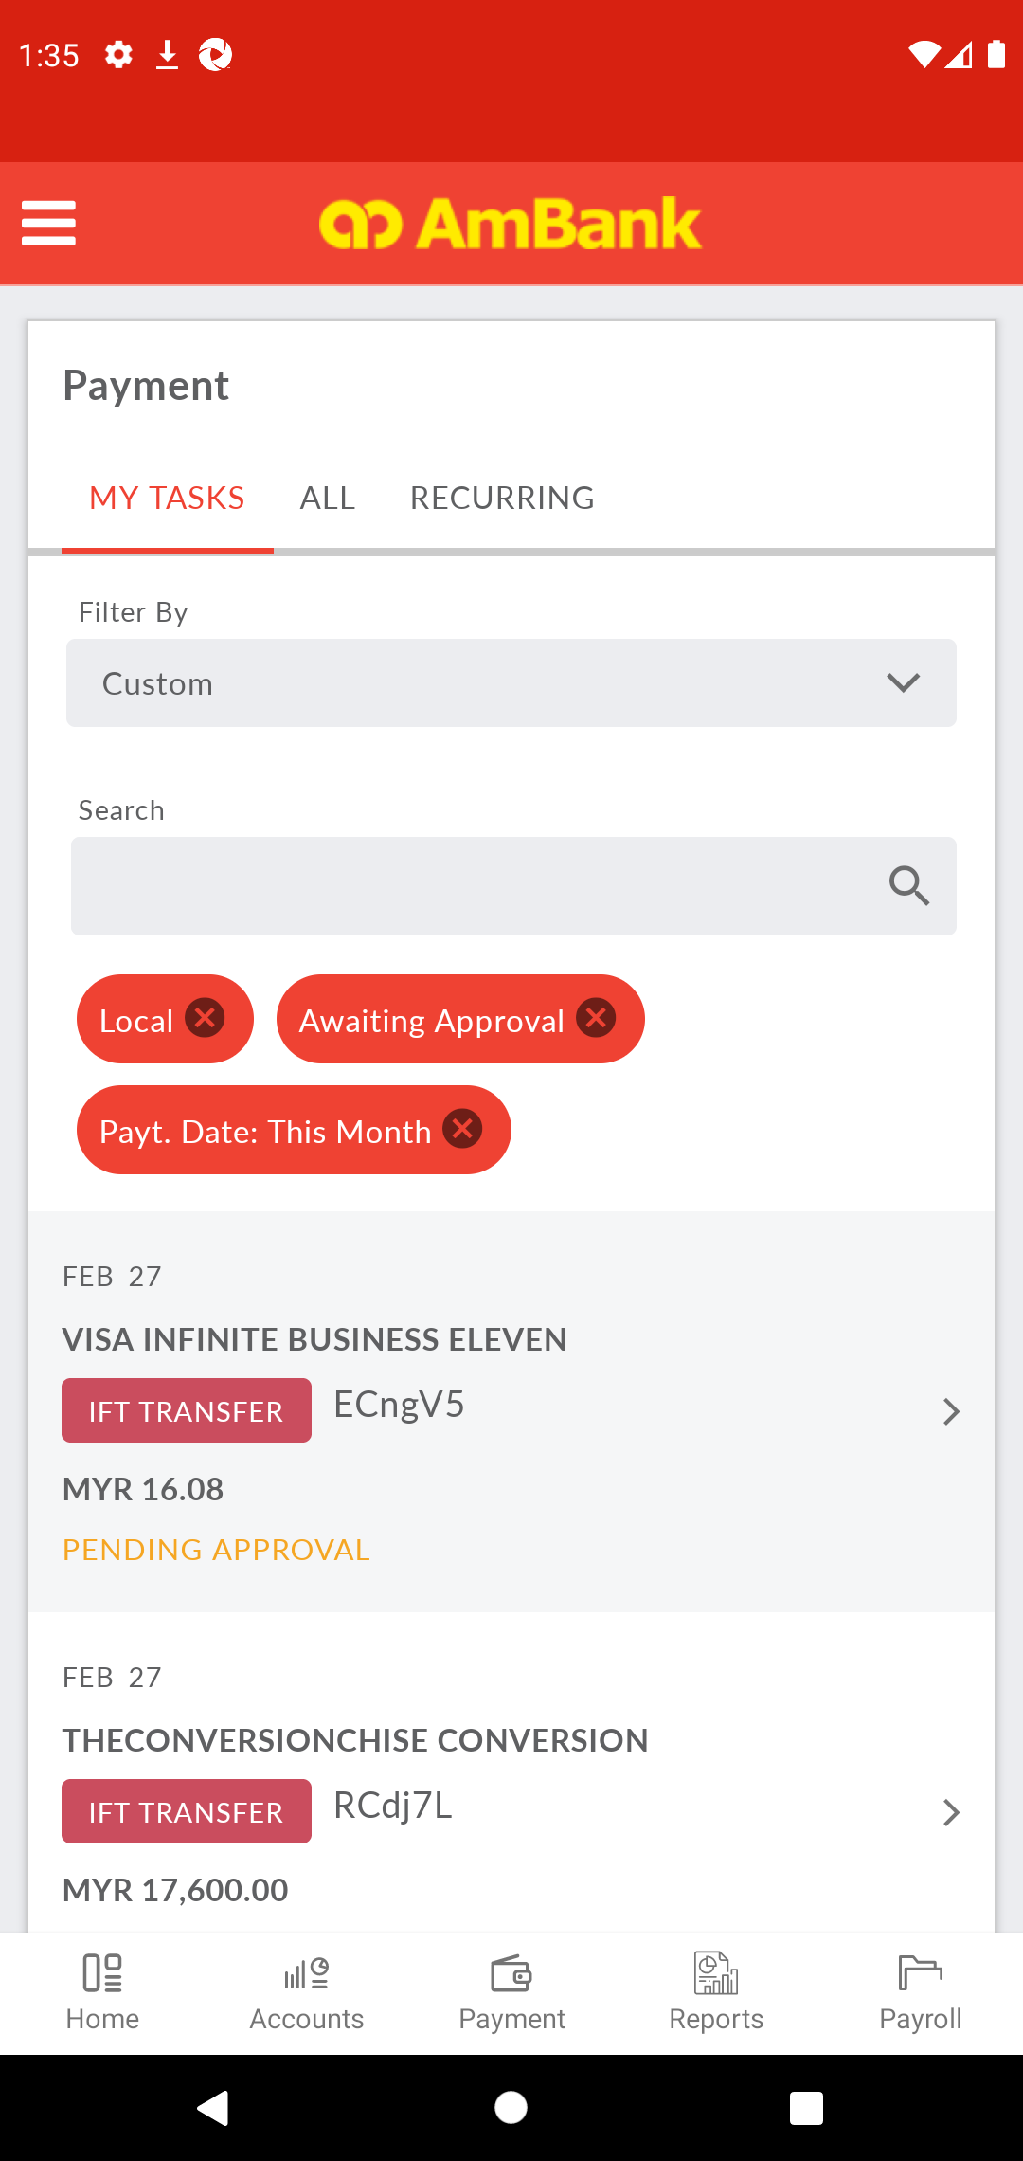  
  
**Test Step 75(PASS) :** [Local Transfer] Click [Transaction]  
  
  
**Test Step 76(PASS) :** [Local Transfer] Verify [Status]  
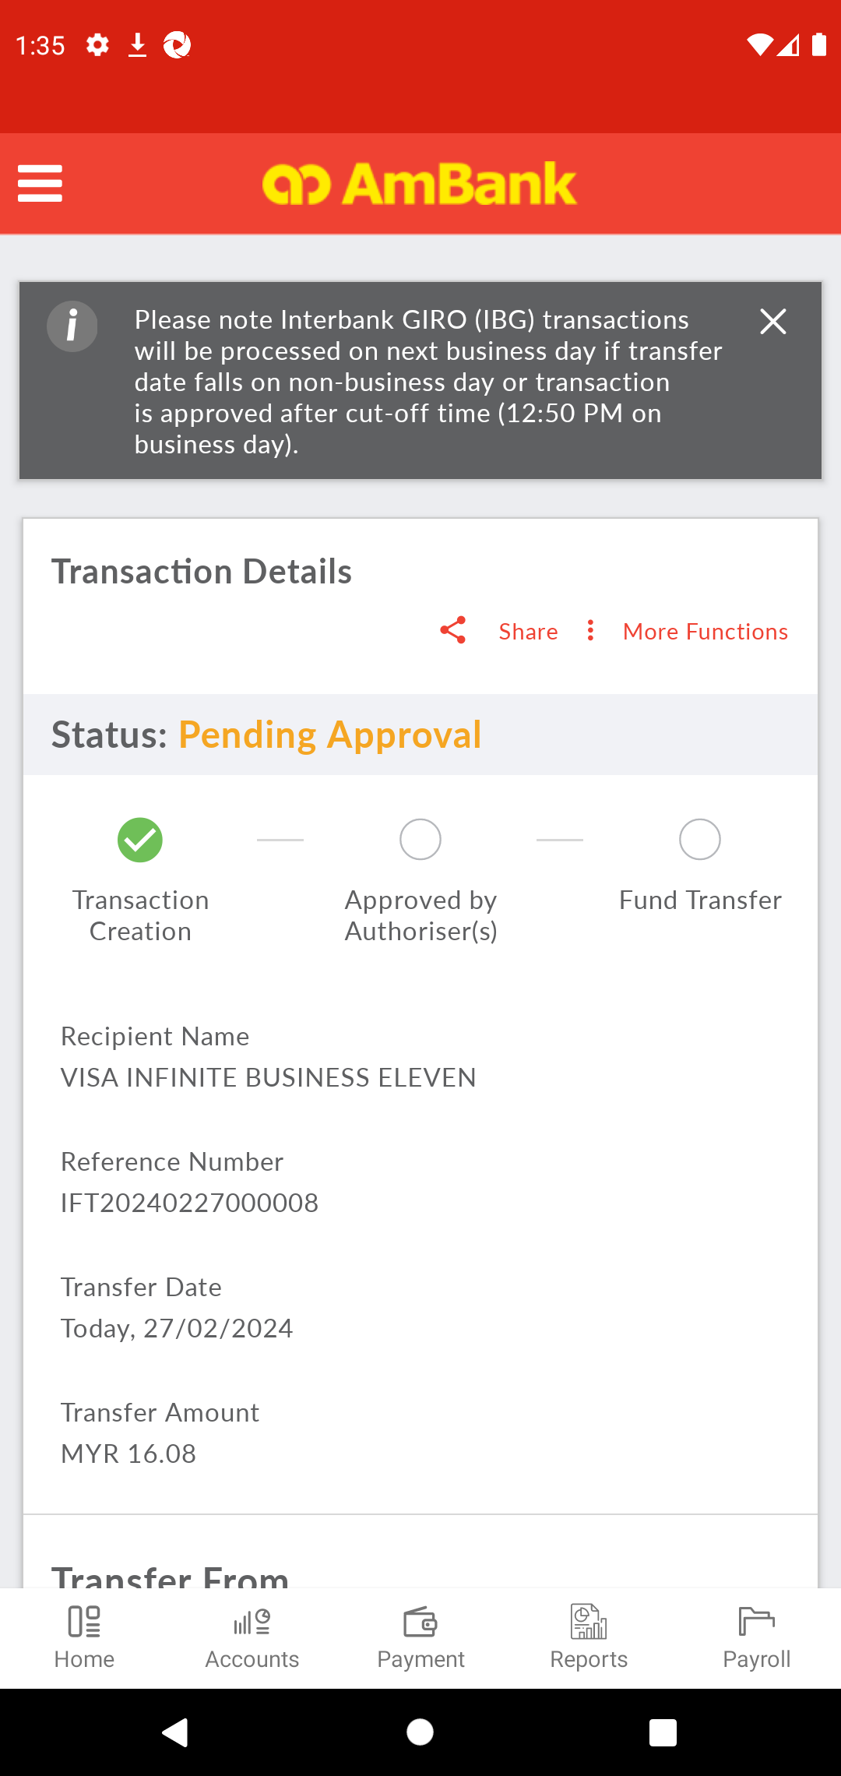  
  
**Test Step 77(PASS) :** Swipe Up To Masked Account Number Button  
  
  
**Test Step 78(PASS) :** [Local Transfer] Verify [Masked Account Number]  
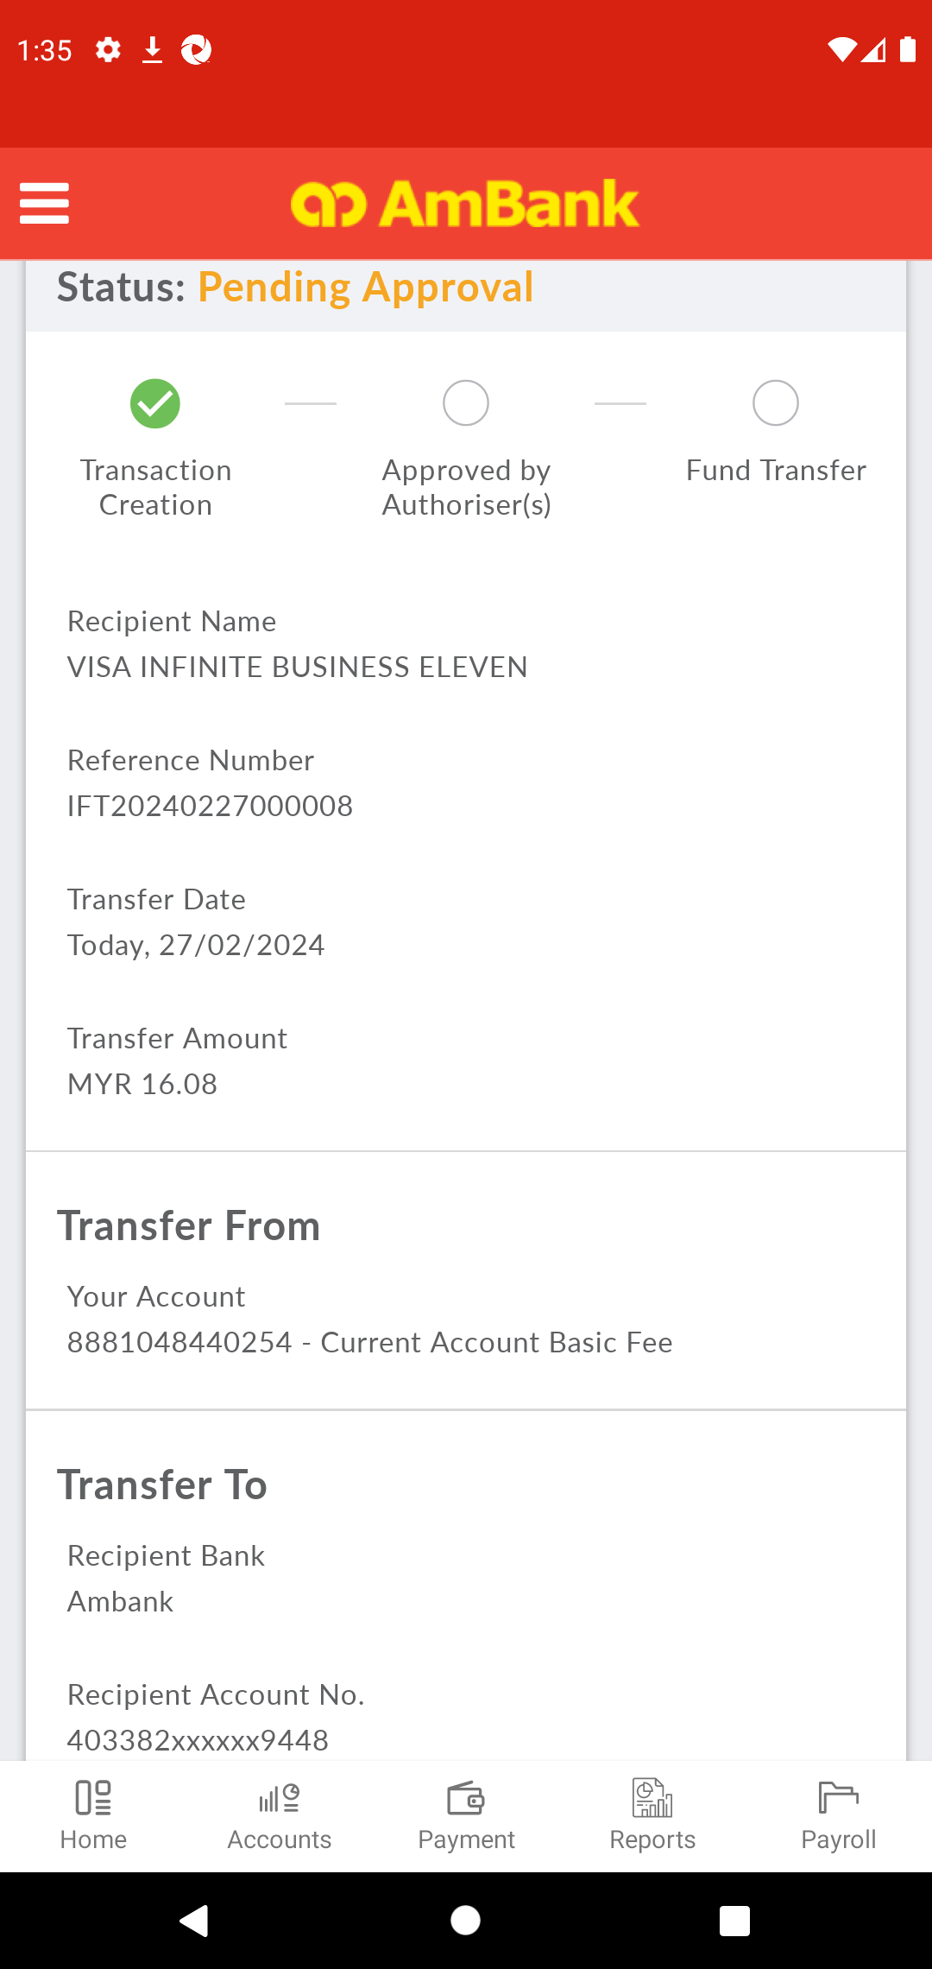  
  
**Test Step 79(PASS) :** Swipe Up To Approve Button  
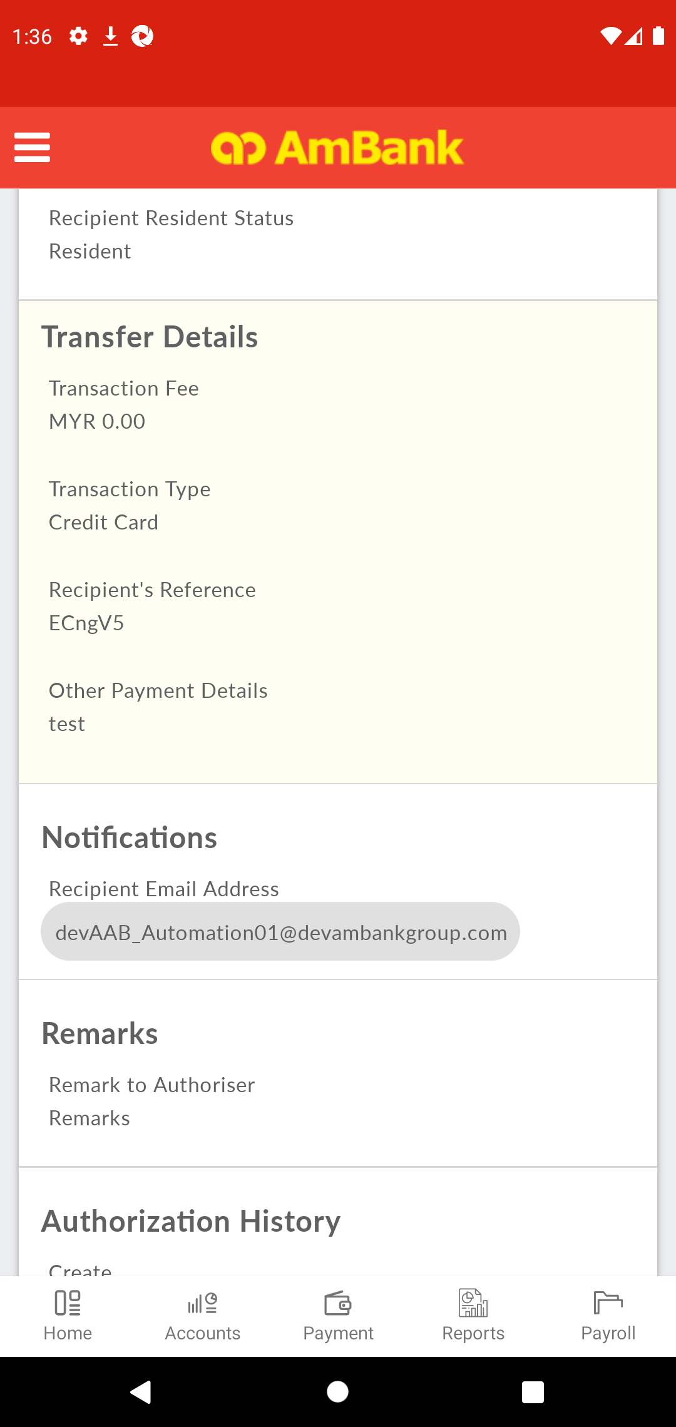  
  
**Test Step 80(PASS) :** [CFO] Click [Approve]  
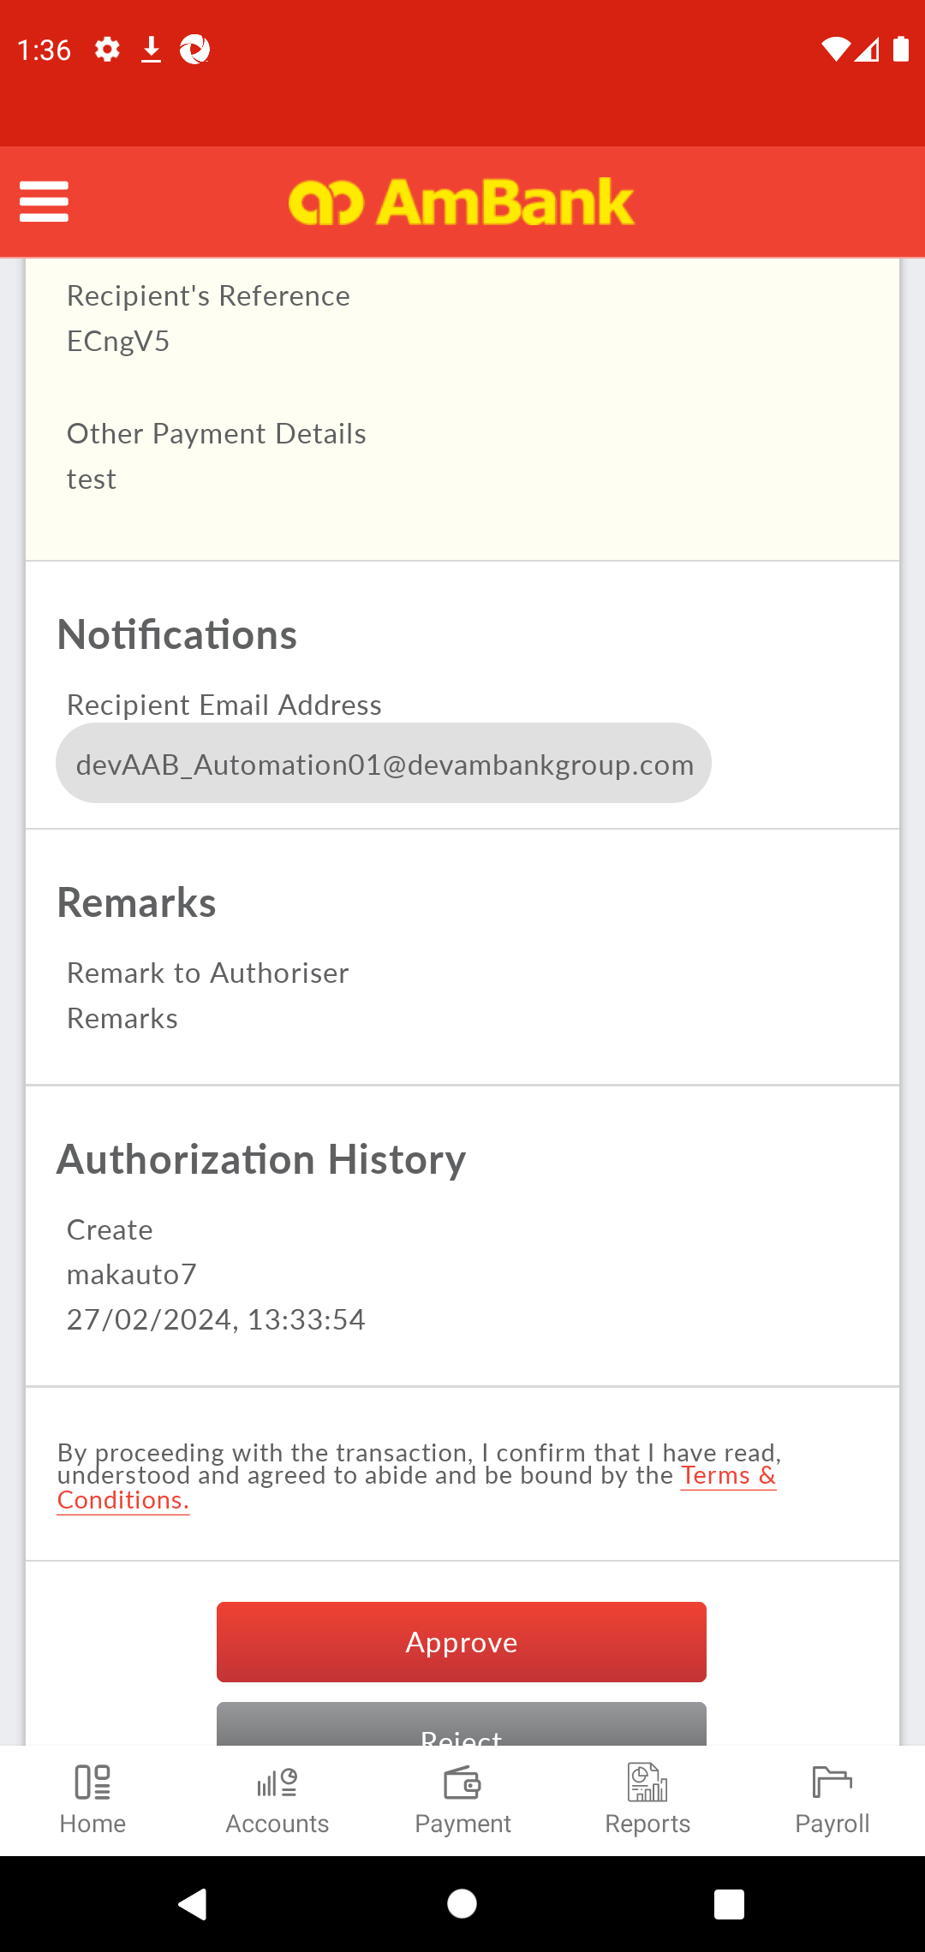  
  
**Test Step 81(PASS) :** Swipe Up To Approve Button  
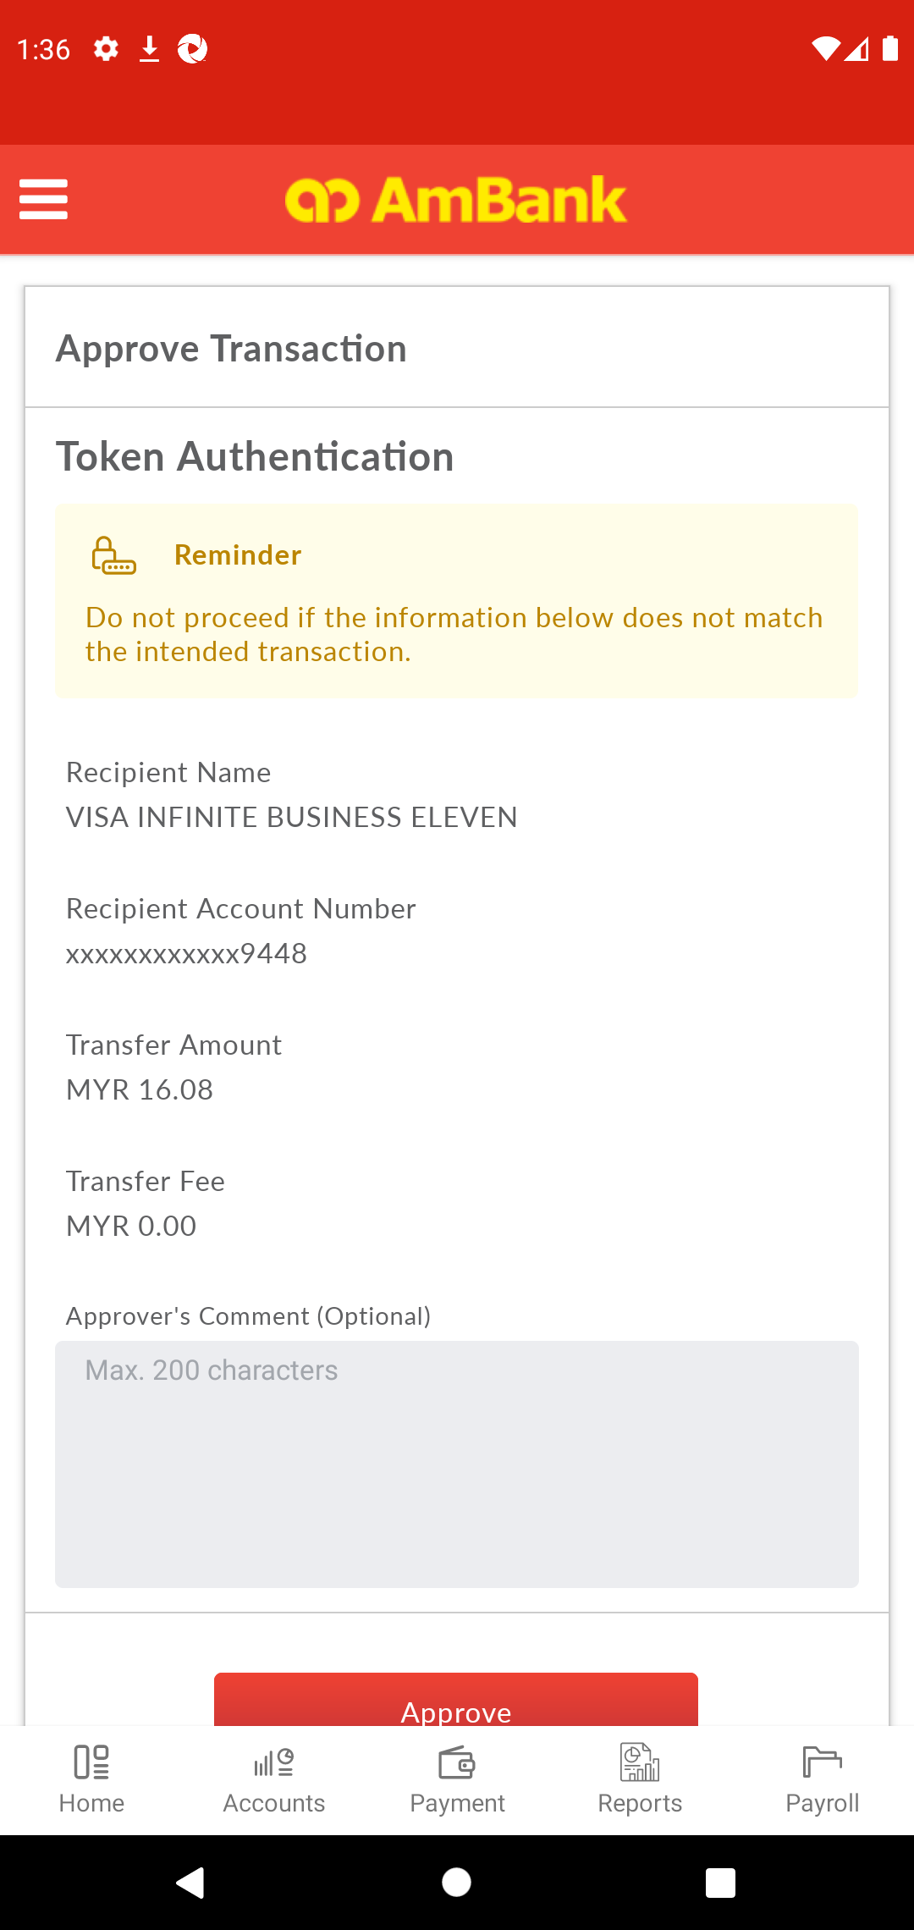  
  
**Test Step 82(PASS) :** [Digital Token] Insert [Comment]  
  
  
**Test Step 83(PASS) :** [Digital Token] Click [Approve]  
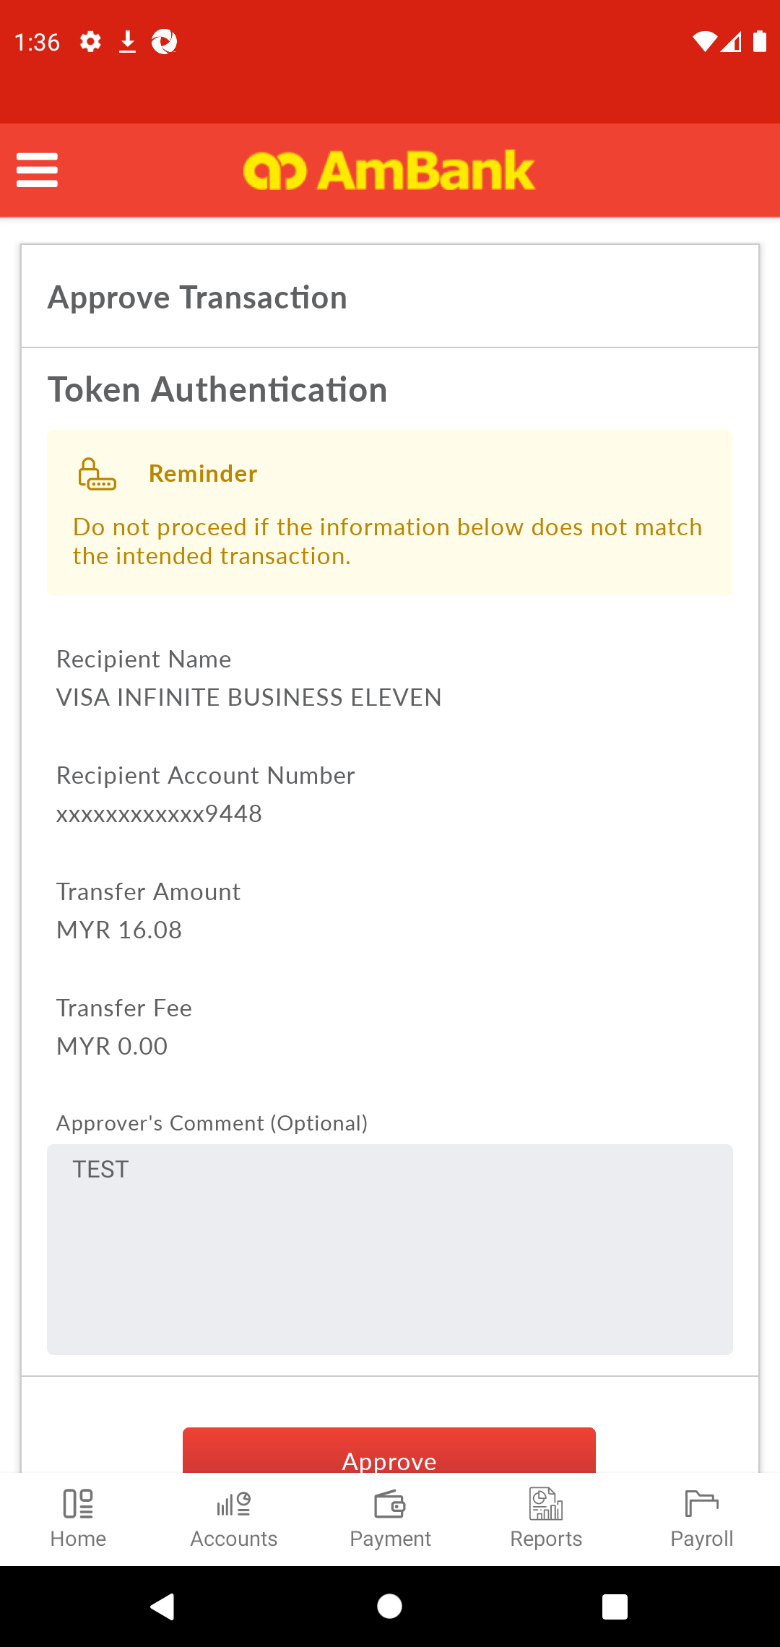  
  
**Test Step 84(PASS) :** [Digital Token] Click [PIN]  
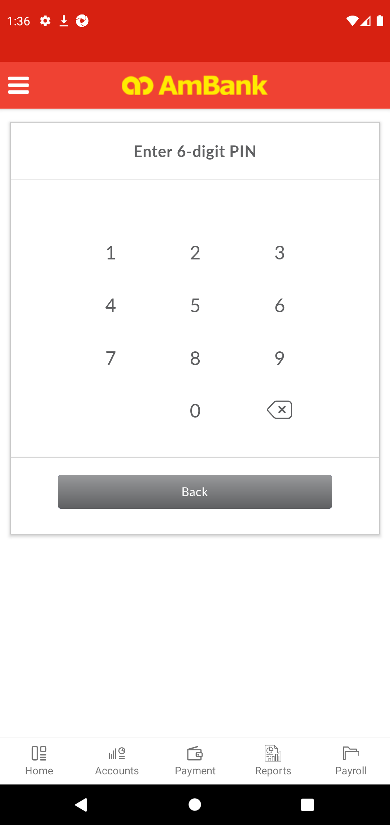  
  
**Test Step 85(PASS) :** [Digital Token] Click [PIN]  
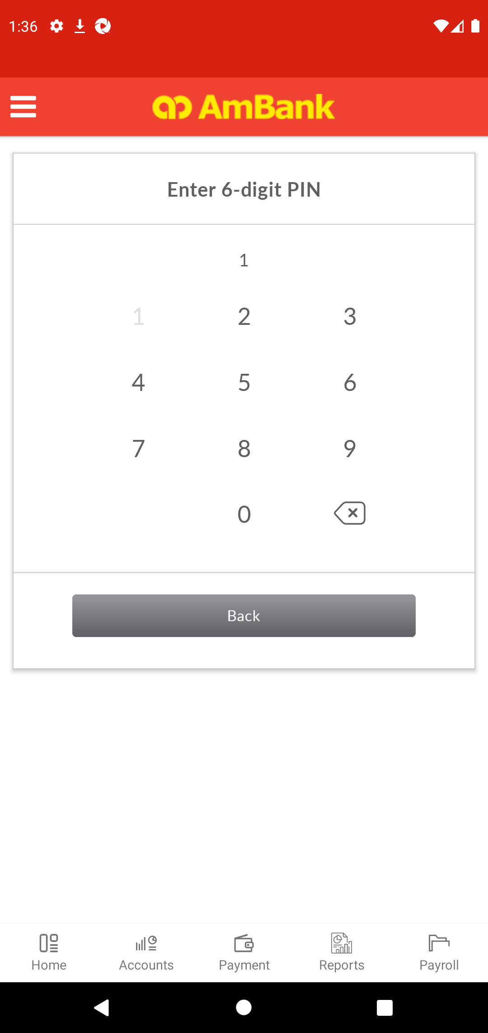  
  
**Test Step 86(PASS) :** [Digital Token] Click [PIN]  
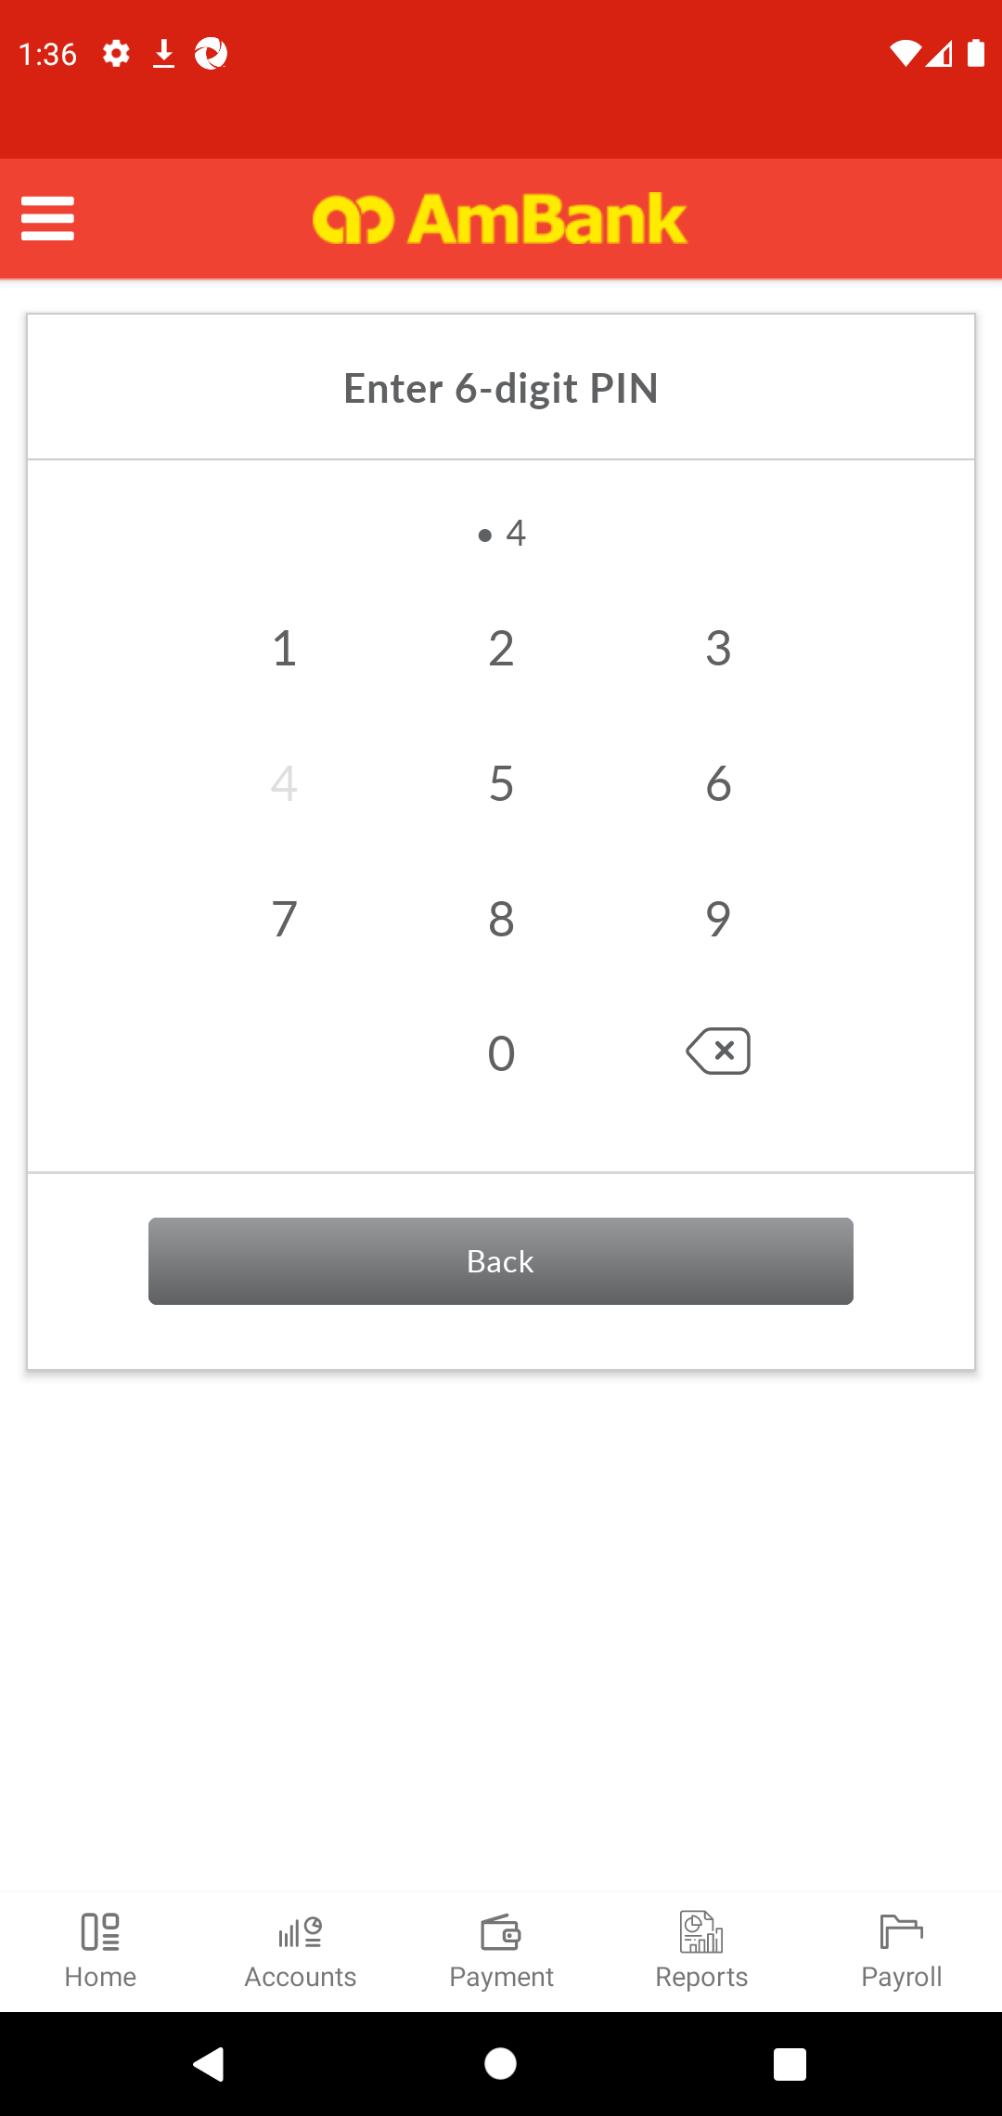  
  
**Test Step 87(PASS) :** [Digital Token] Click [PIN]  
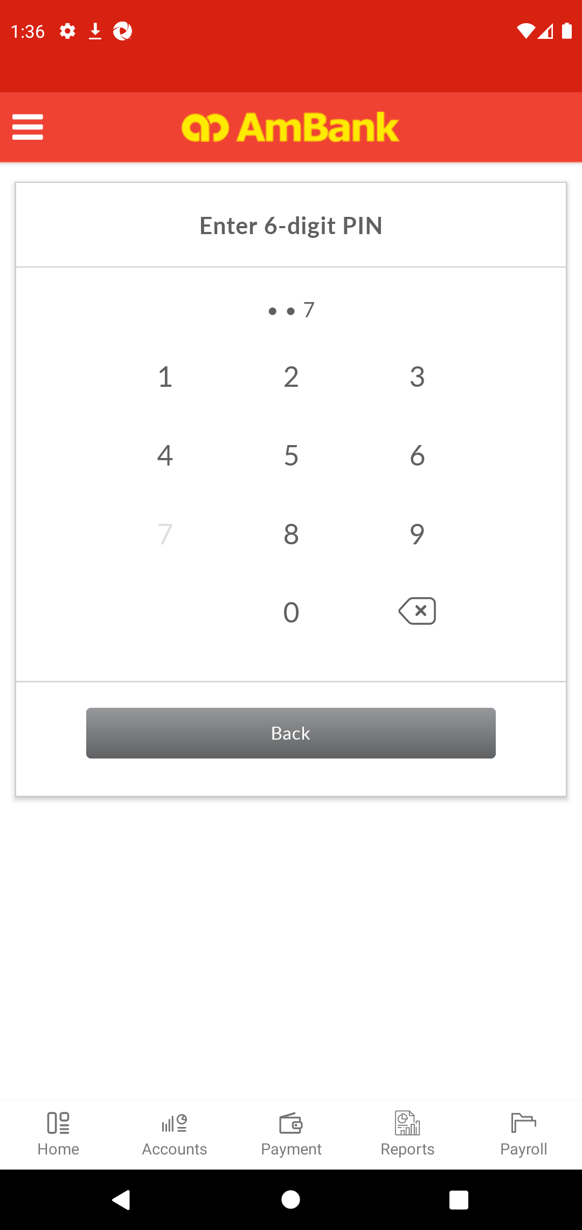  
  
**Test Step 88(PASS) :** [Digital Token] Click [PIN]  
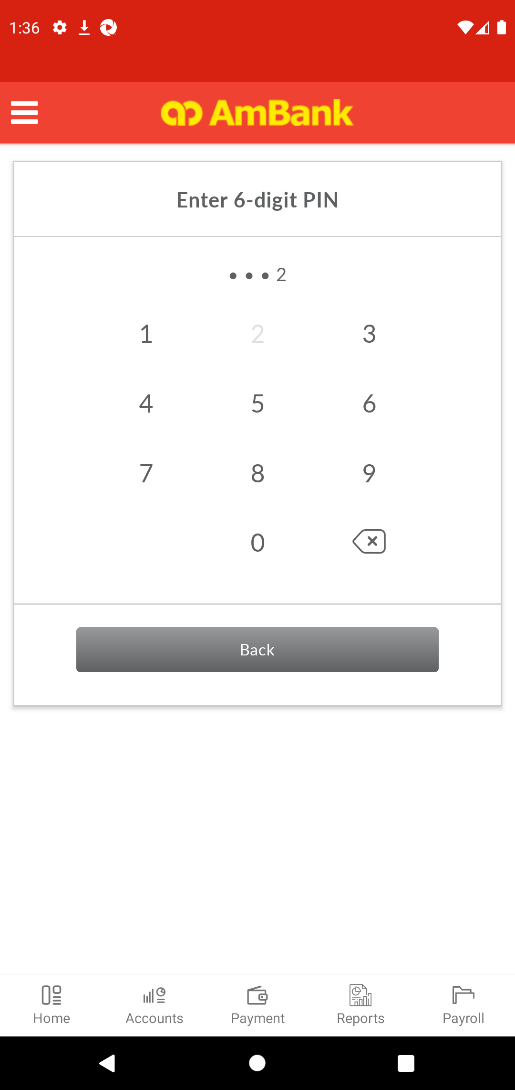  
  
**Test Step 89(PASS) :** [Digital Token] Click [PIN]  
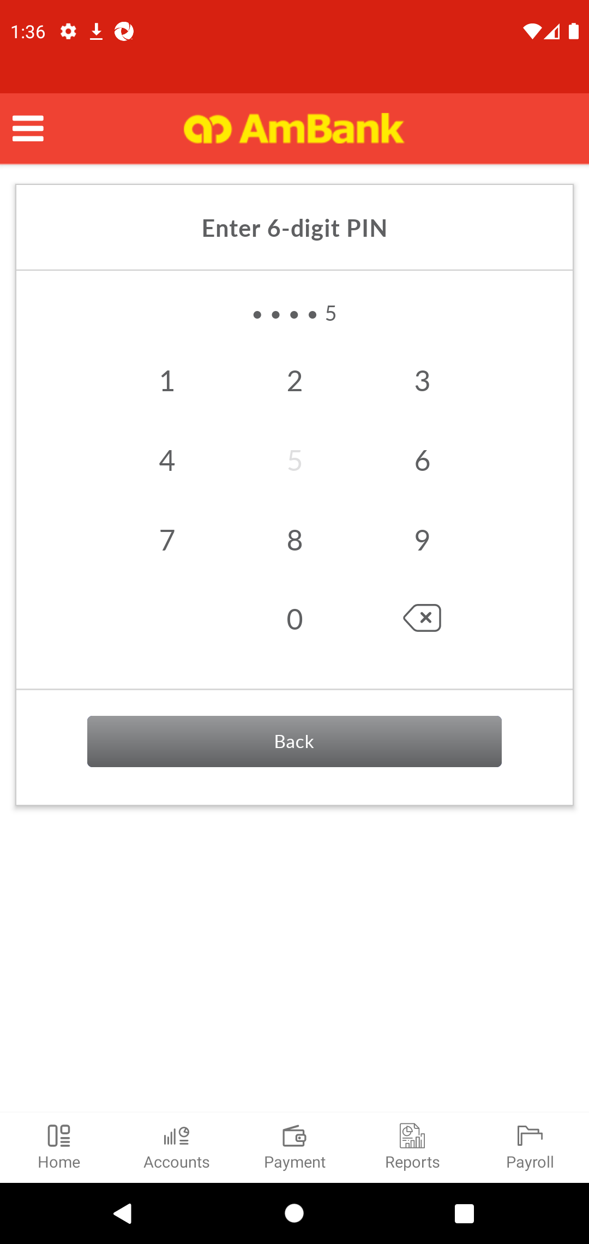  
  
**Test Step 90(PASS) :** [Local Transfer] Verify [Status]  
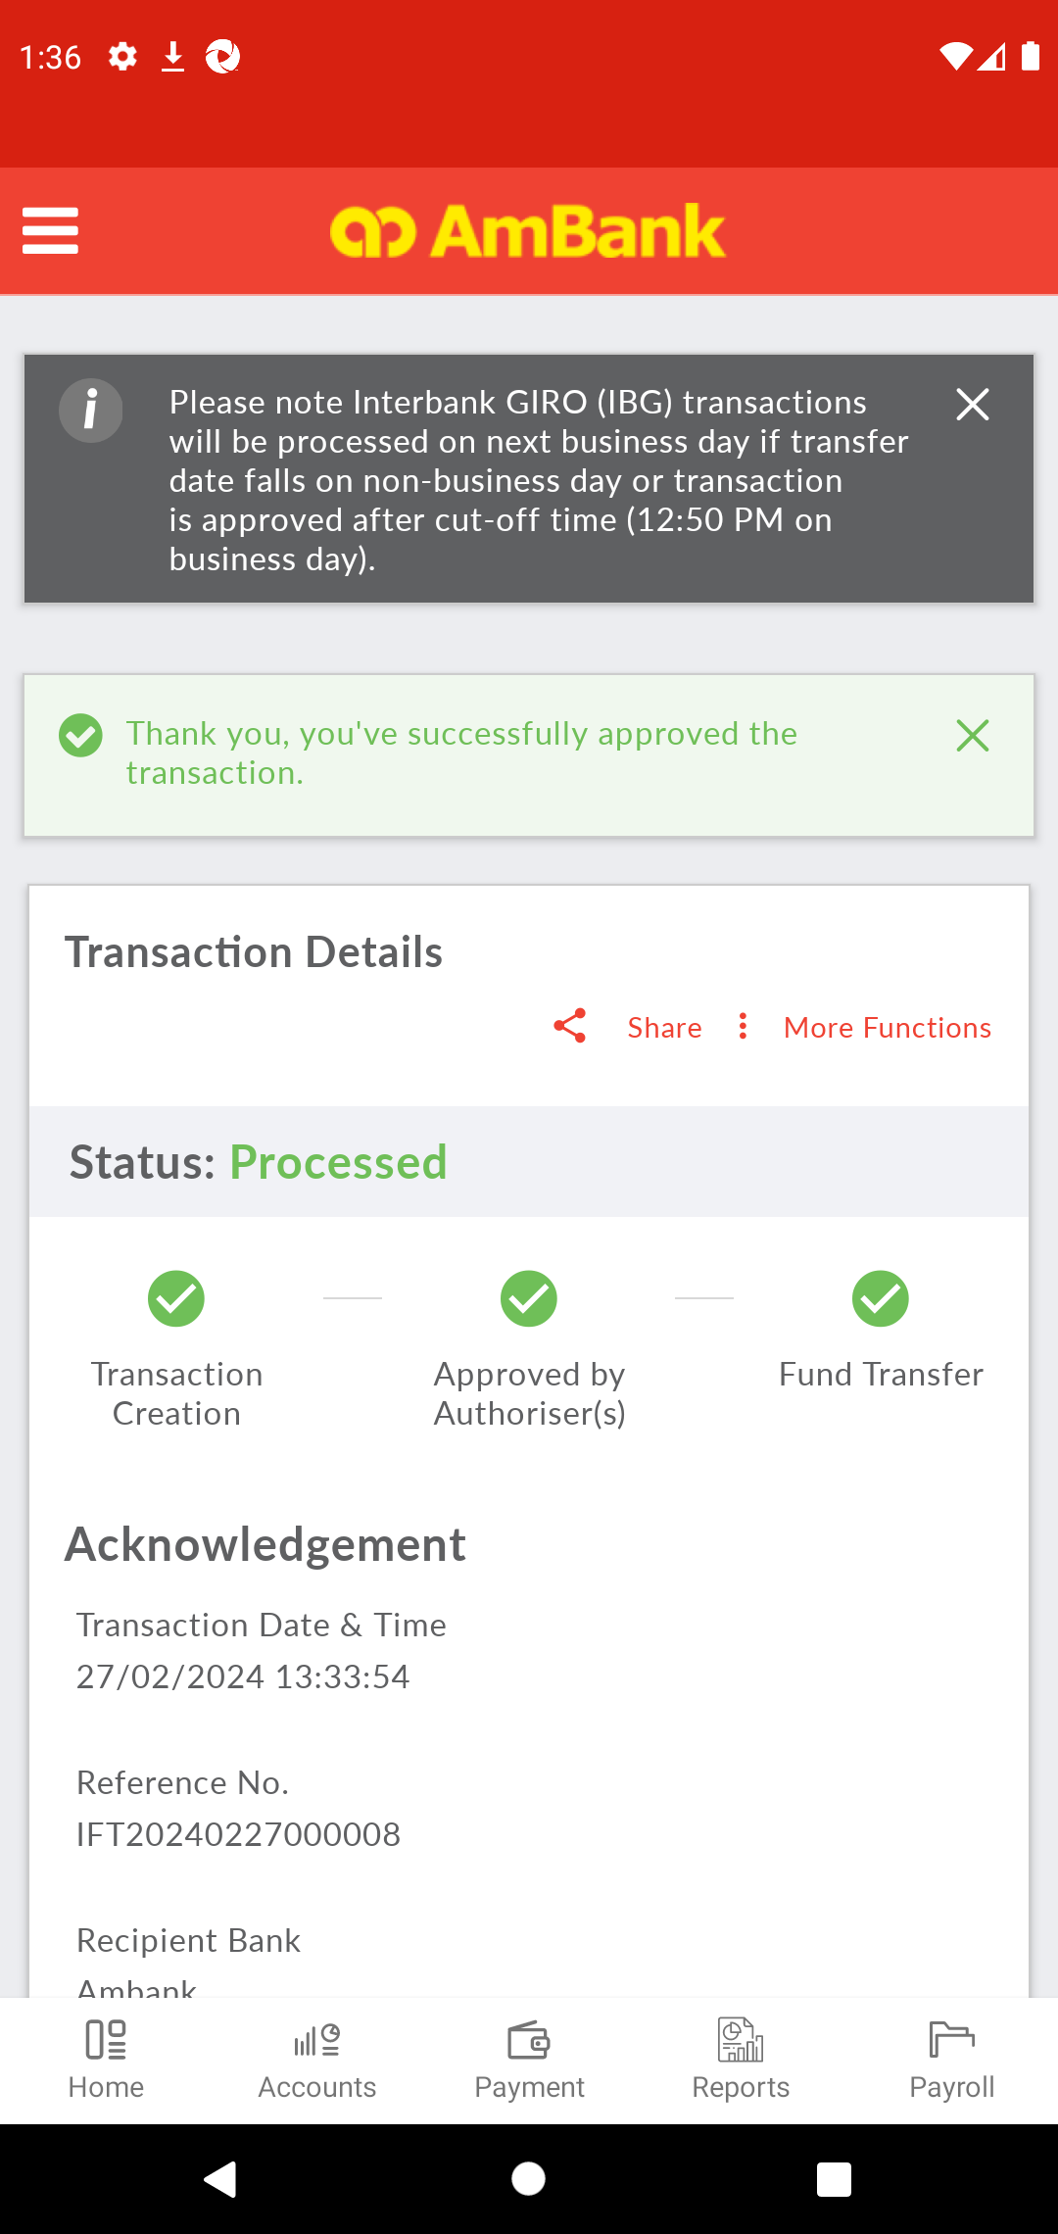  
  
**Test Step 91(PASS) :** [Multiple Approval] Click [More Functions]  
  
  
**Test Step 92(PASS) :** [Multiple Approval] Click [Download Advice]  
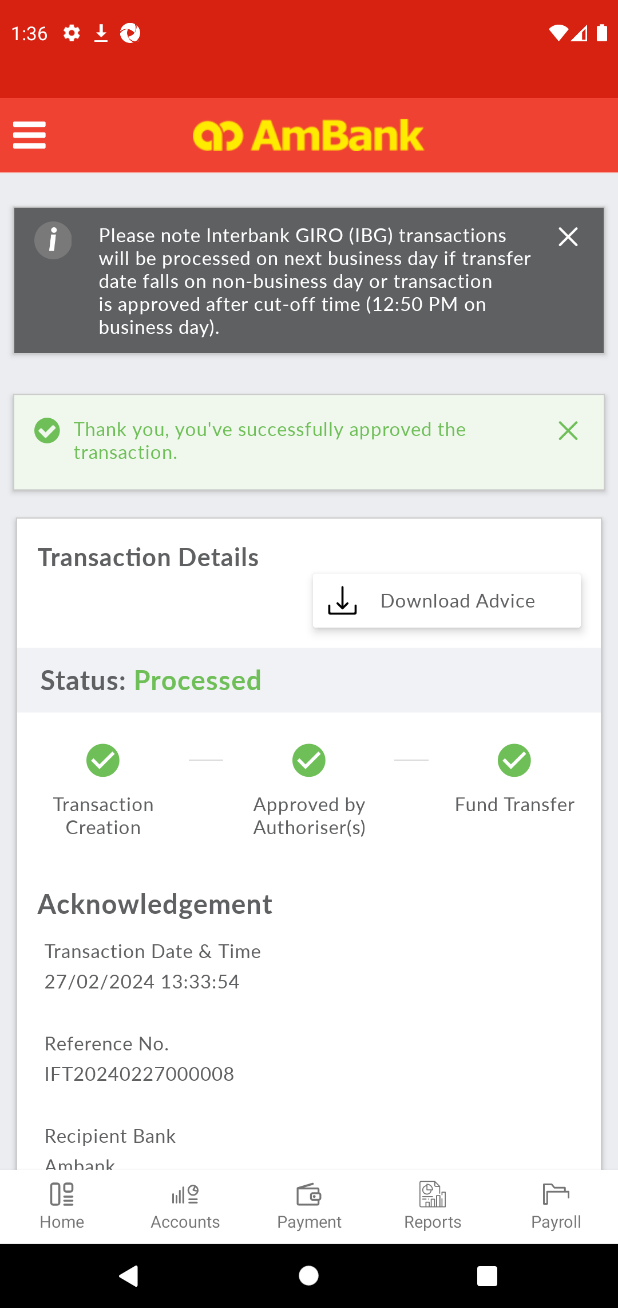  
  
**Test Step 93(PASS) :** [PDF] Back to CFO  
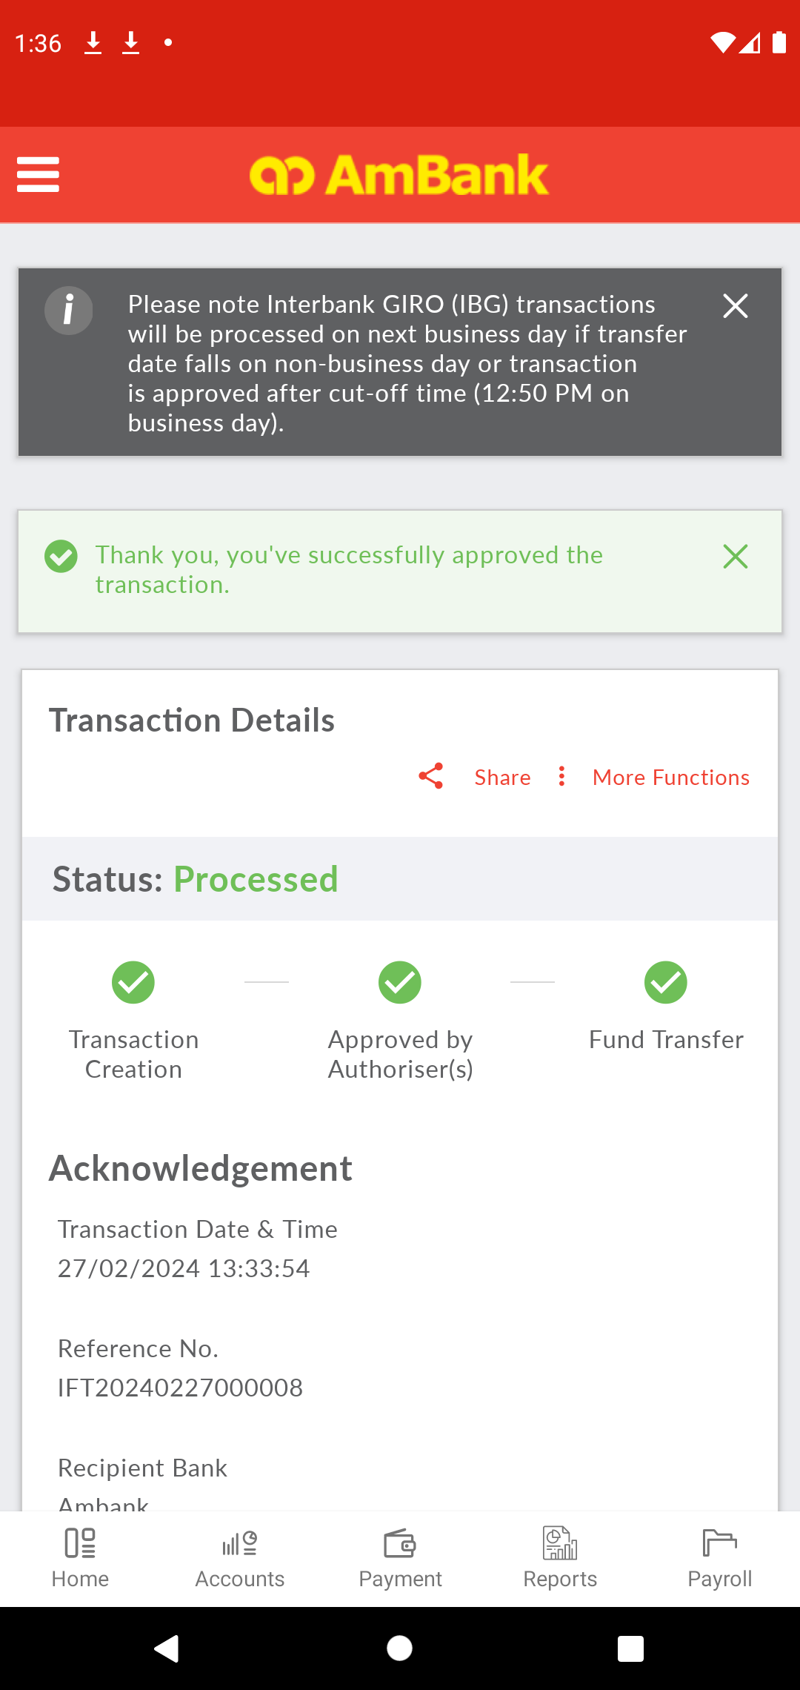  
  
**Test Step 94(PASS) :** [Notification] Display Push Notication  
  
  
**Test Step 95(PASS) :** Swipe Up To Downloaded Files  
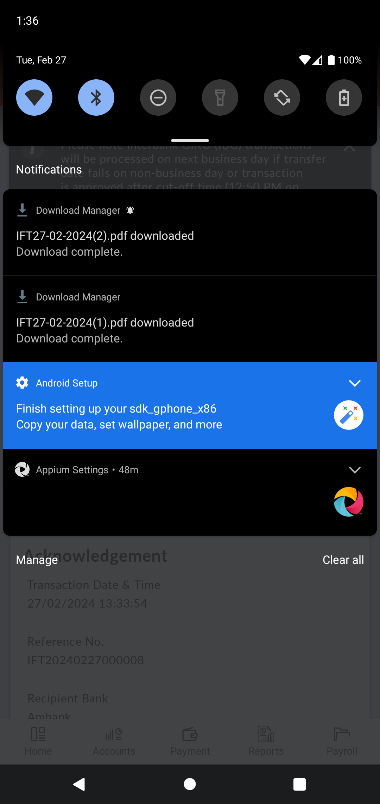  
  
**Test Step 96(PASS) :** [Notification] Click [Downloaded Files]  
  
  
**Test Step 97(PASS) :** SCREENSHOT  
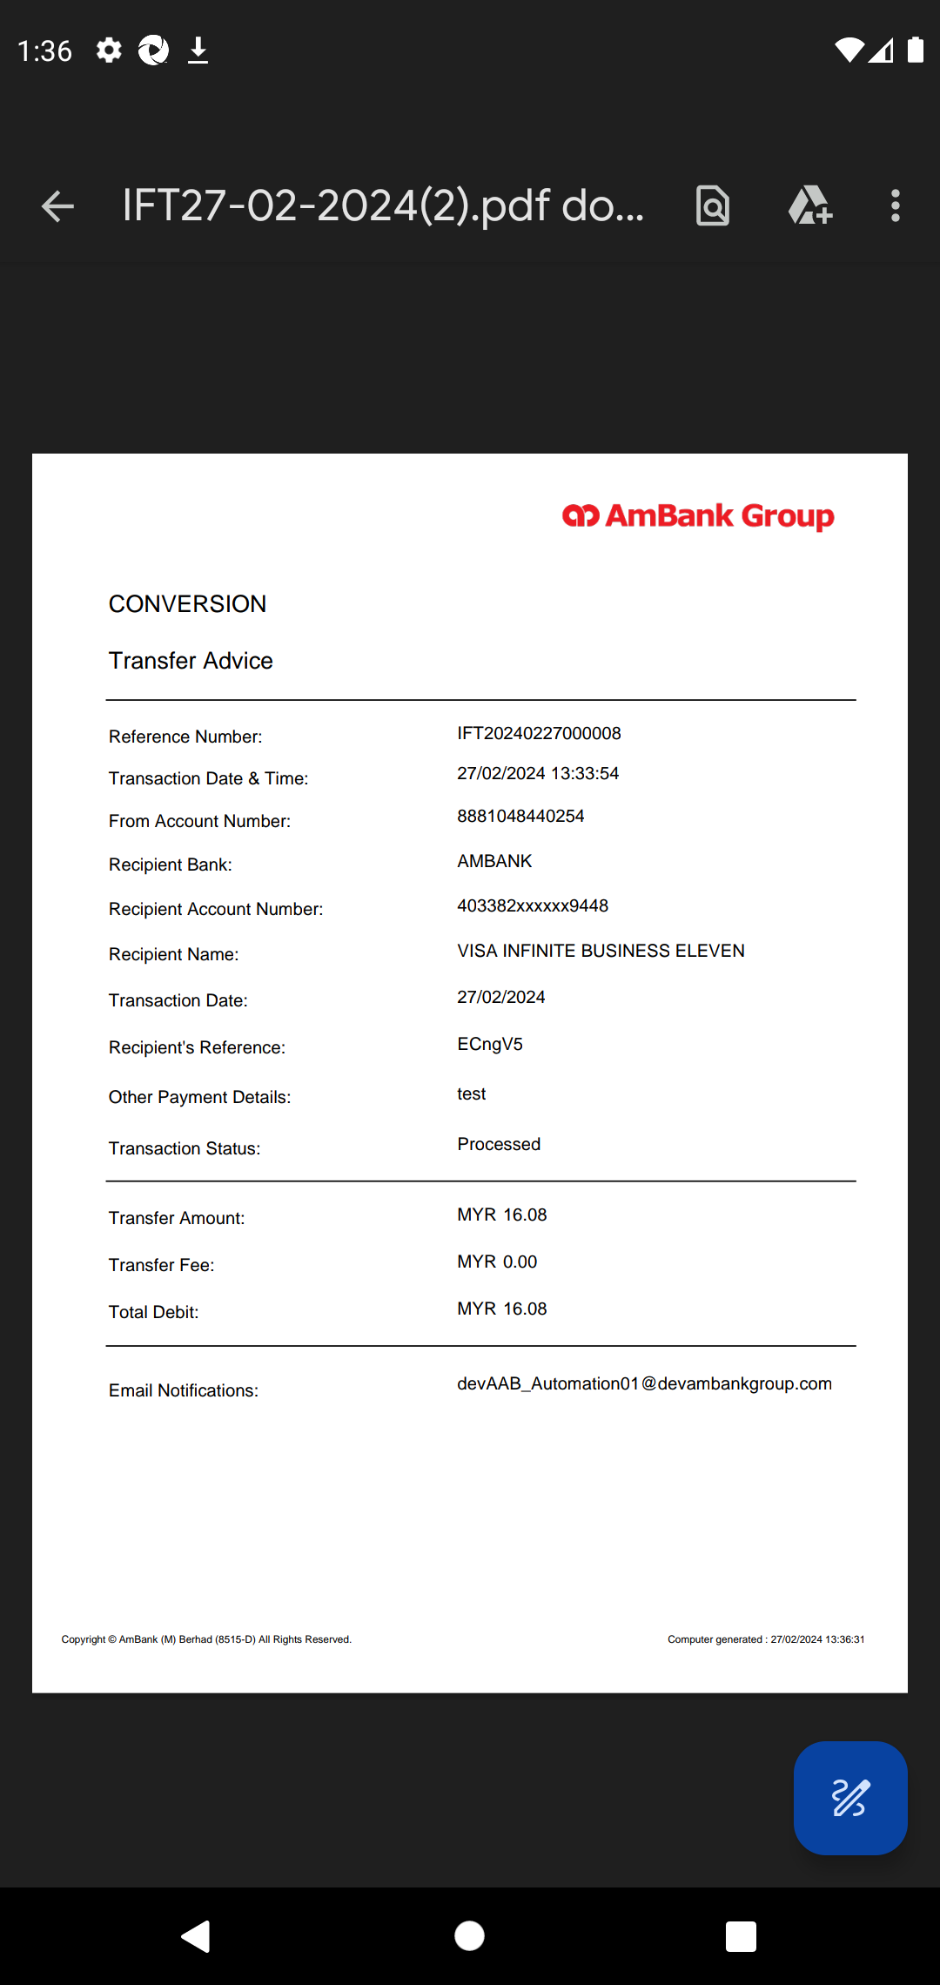  
  
**Test Step 98(PASS) :** [PDF] Back to CFO  
  
  
**Test Step 99(PASS) :** Swipe Up To Back to Payment Listing Button  
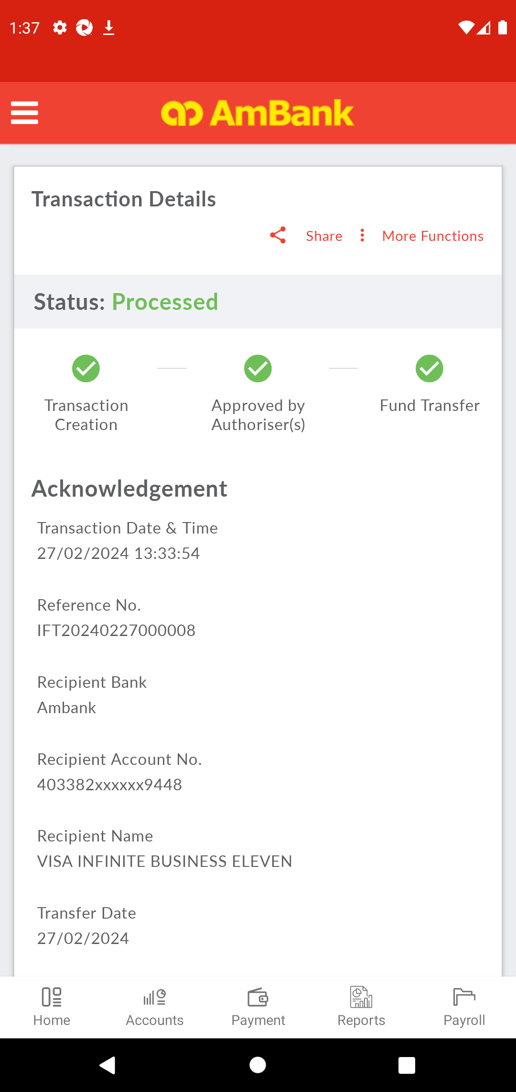  
  
**Test Step 100(PASS) :** [CFO] Click [Back to Payment Listing]  
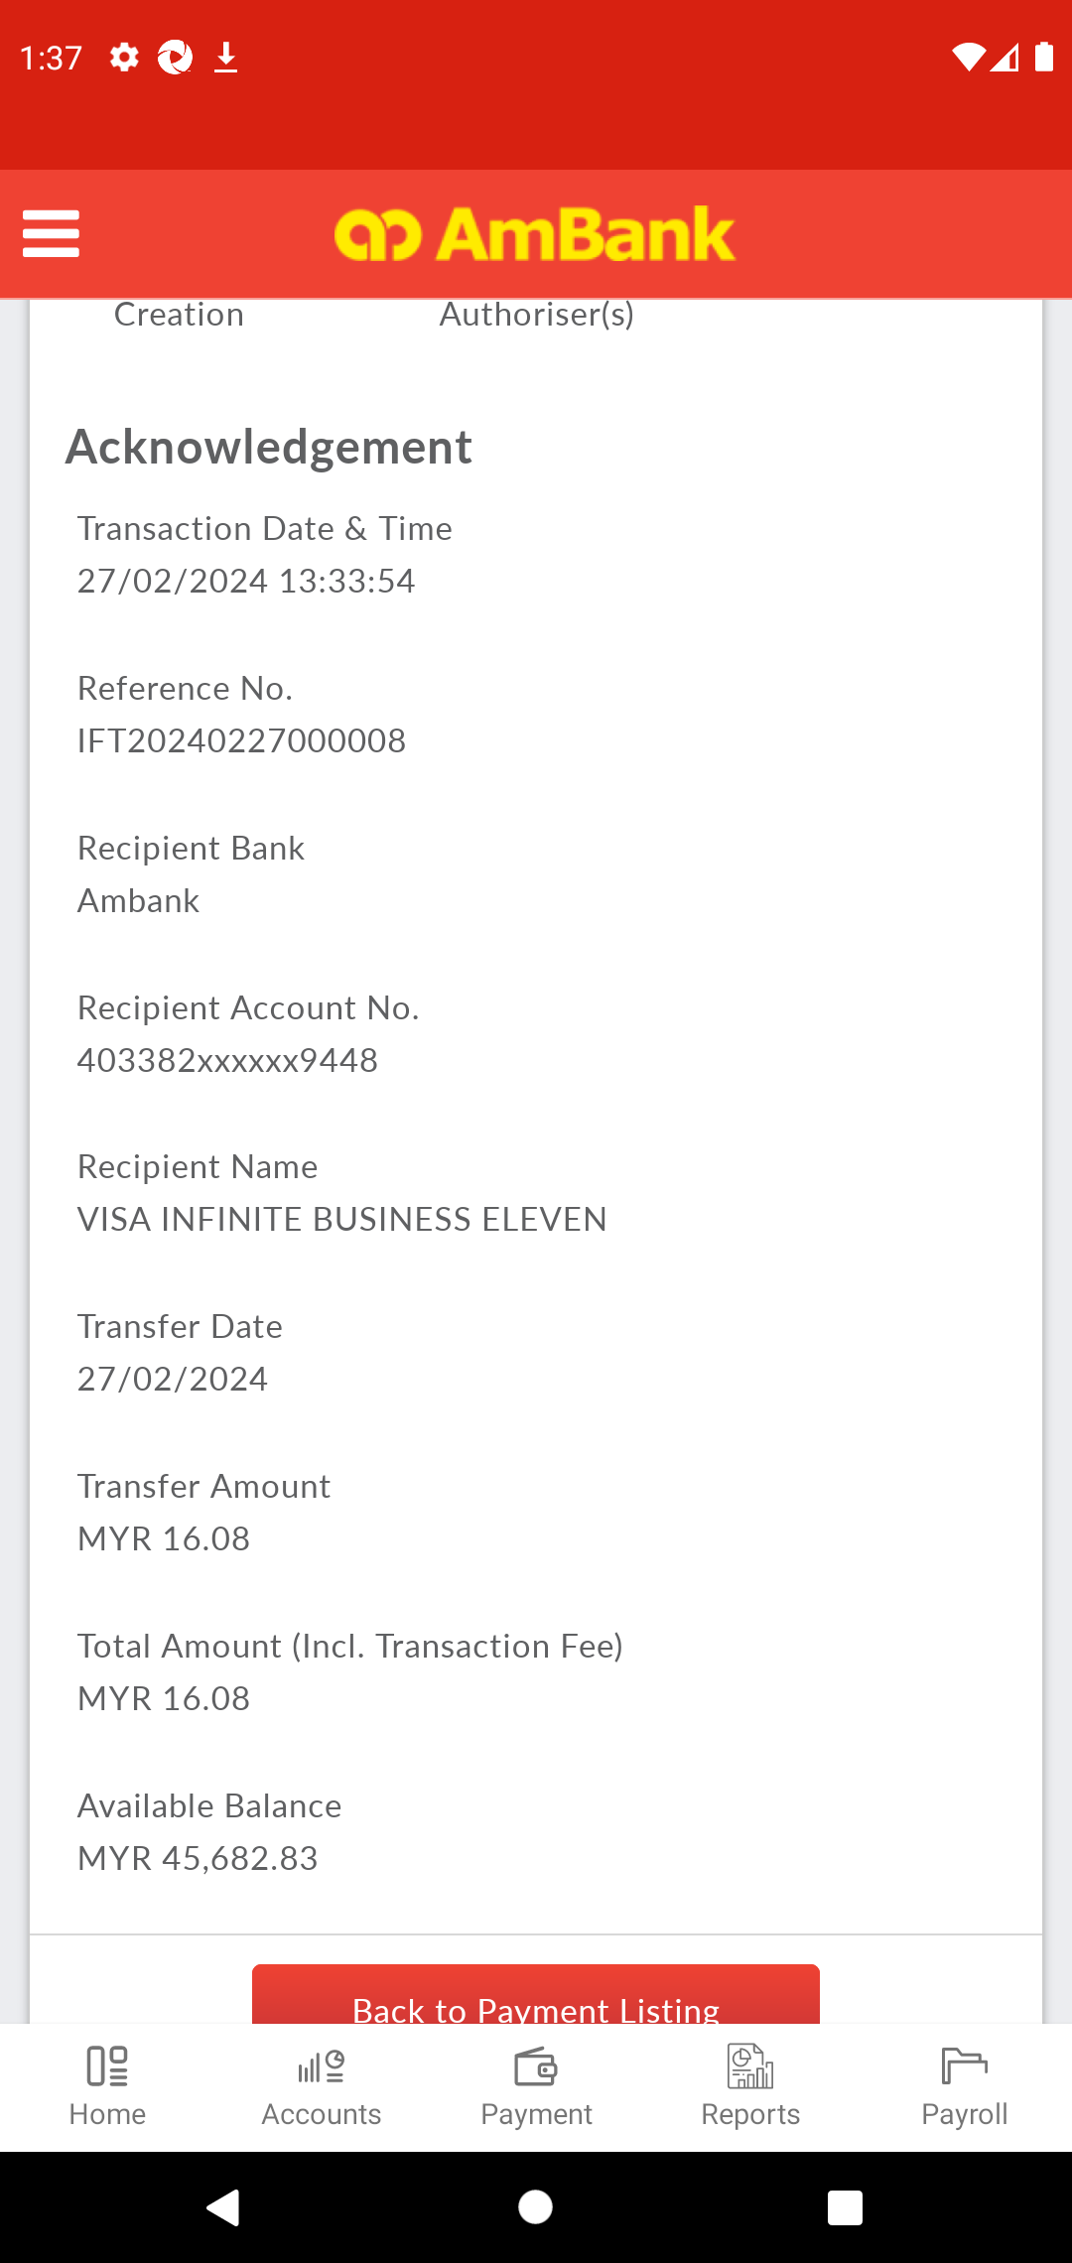  
  
**Test Step 101(PASS) :** [CFO] [Home] Click [Payment]  
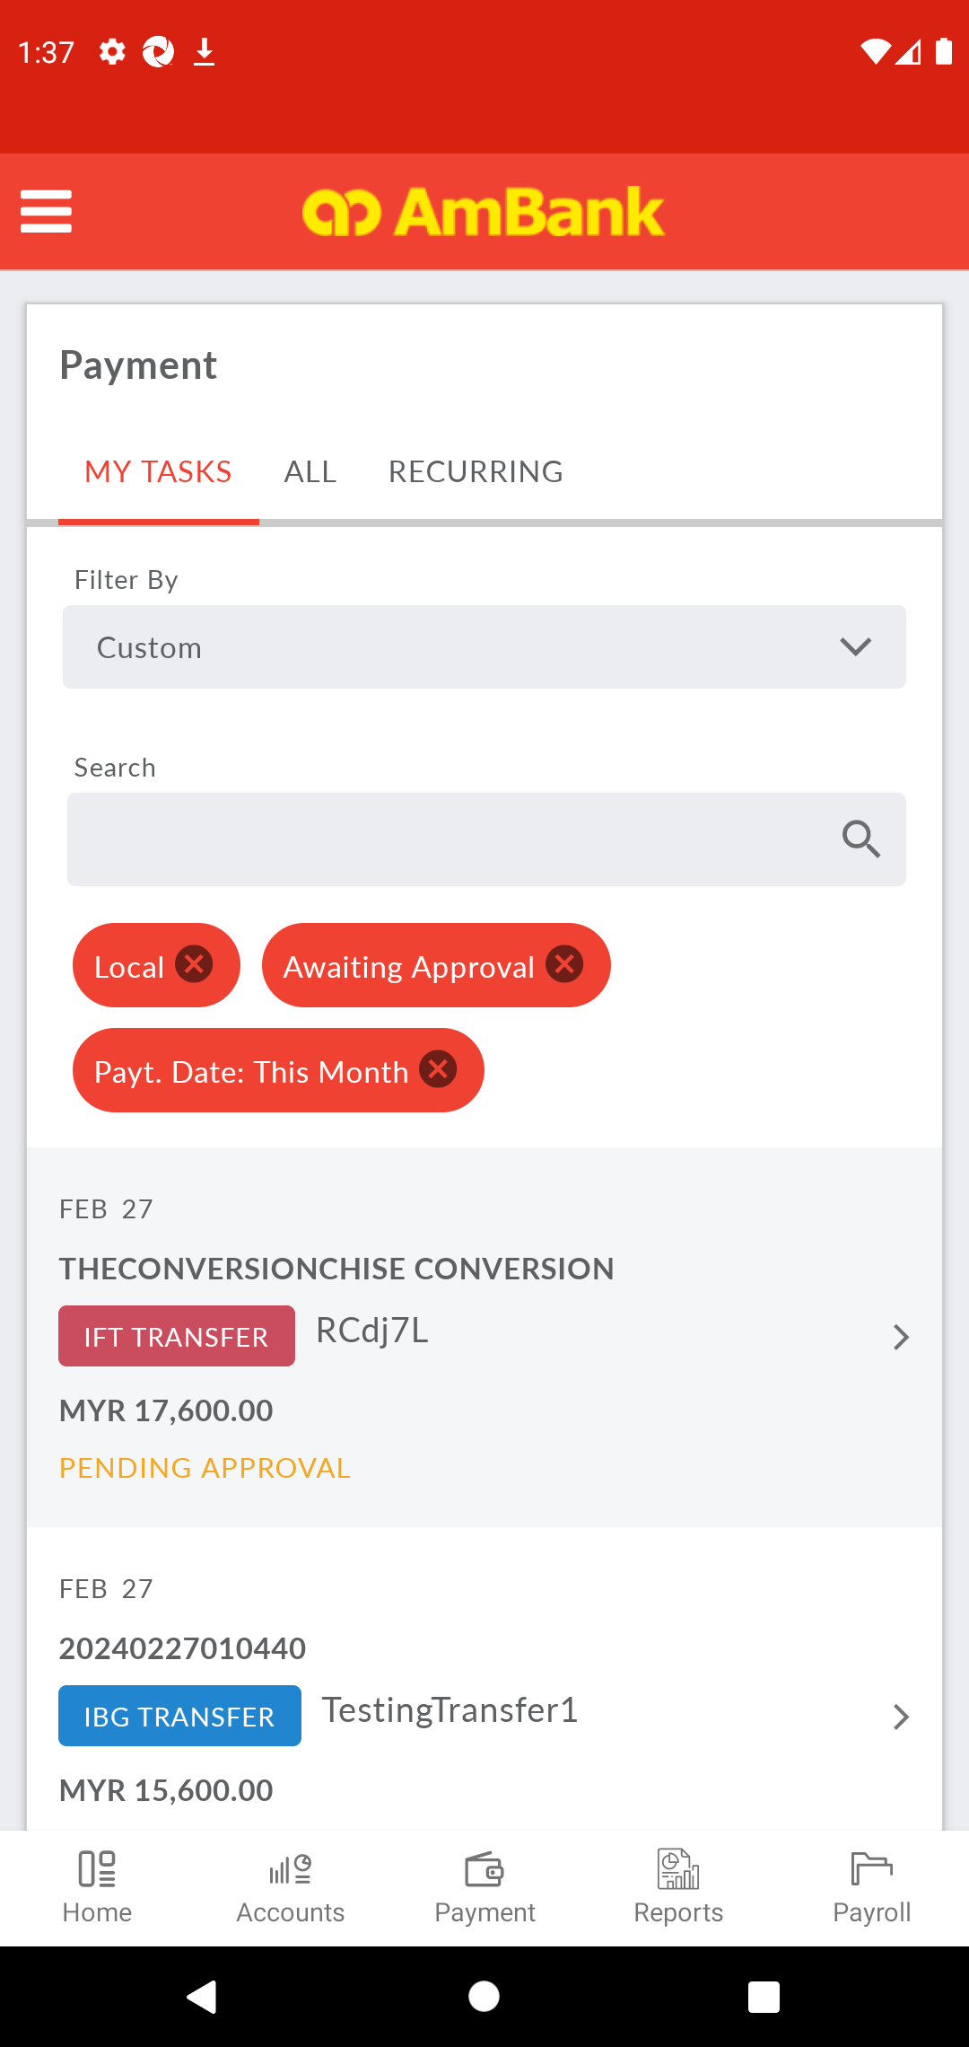  
  
**Test Step 102(PASS) :** [CFO] [Home] Click [All]  
  
  
**Test Step 103(PASS) :** [CFO] [Home] Click [All Transactions]  
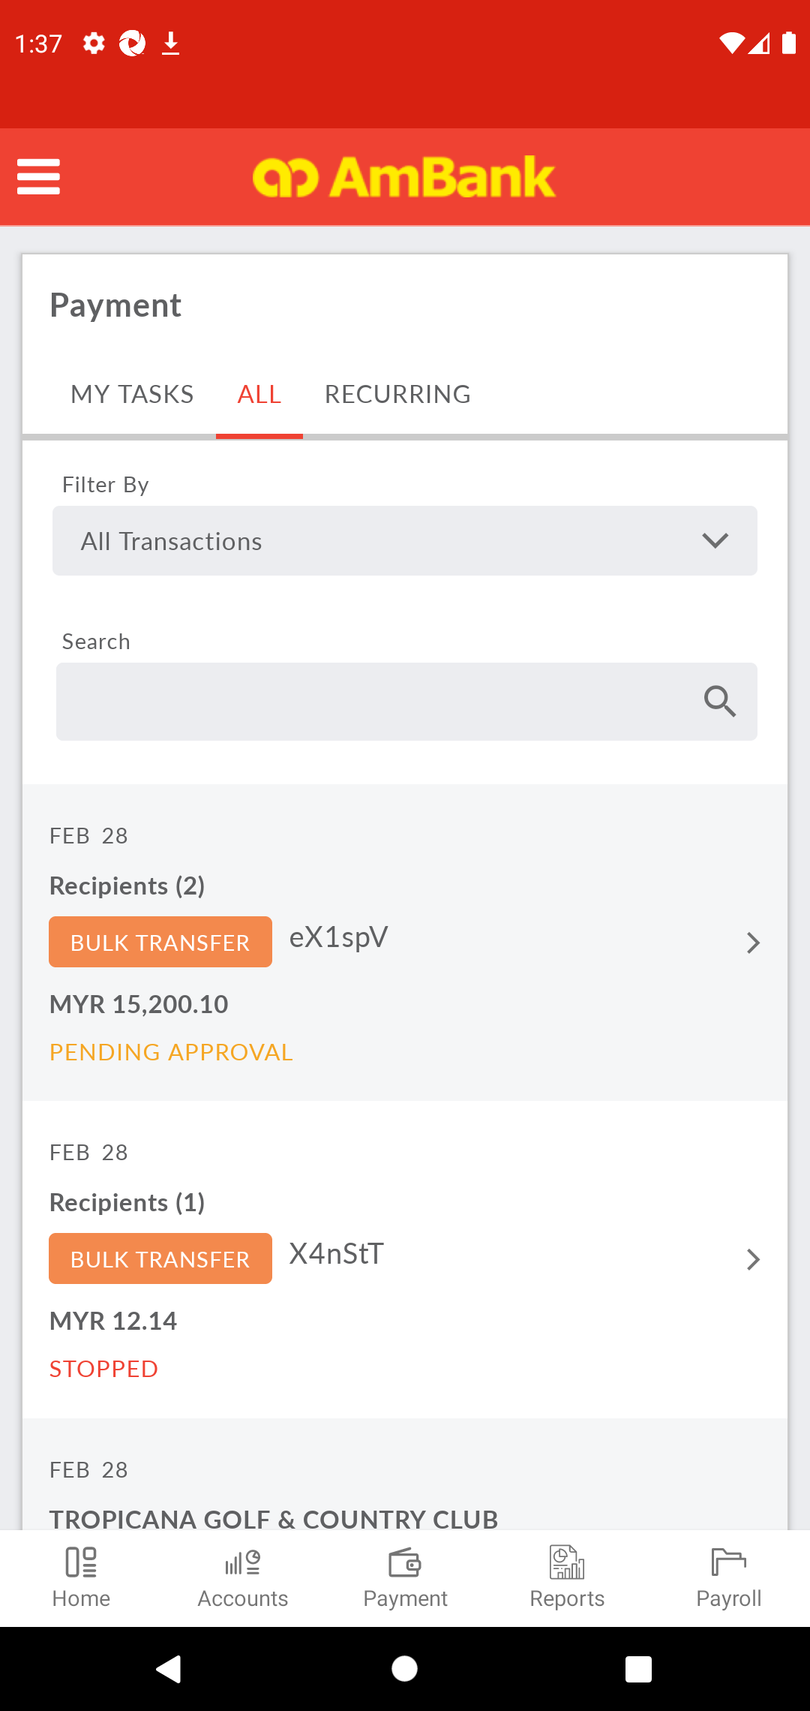  
  
**Test Step 104(PASS) :** [CFO] [Home] Click [Transaction Date]  
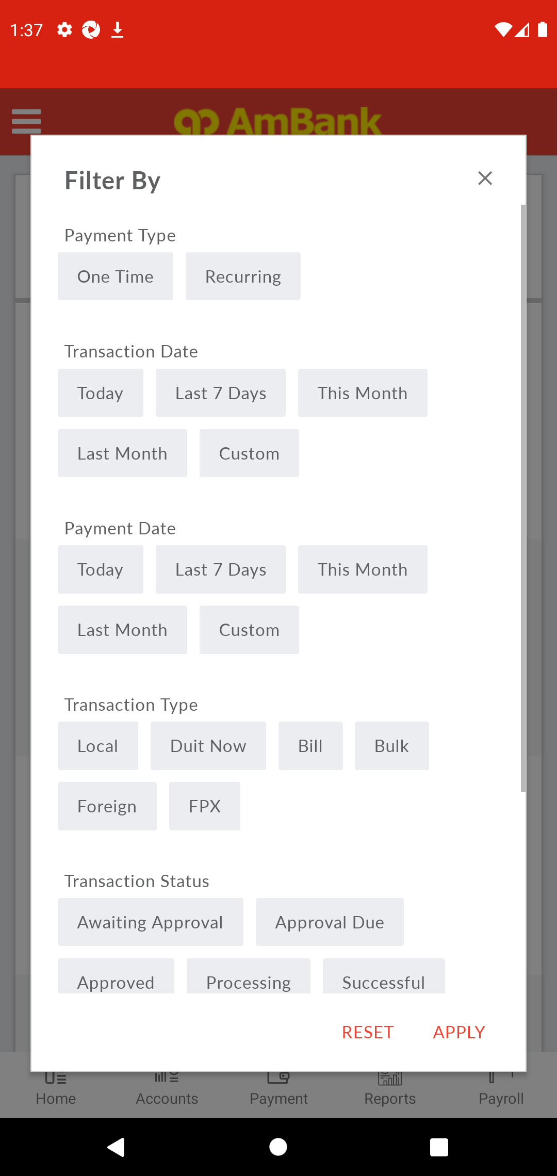  
  
**Test Step 105(PASS) :** [CFO] [Home] Click [Transaction Type]  
  
  
**Test Step 106(PASS) :** Swipe Up To Successful  
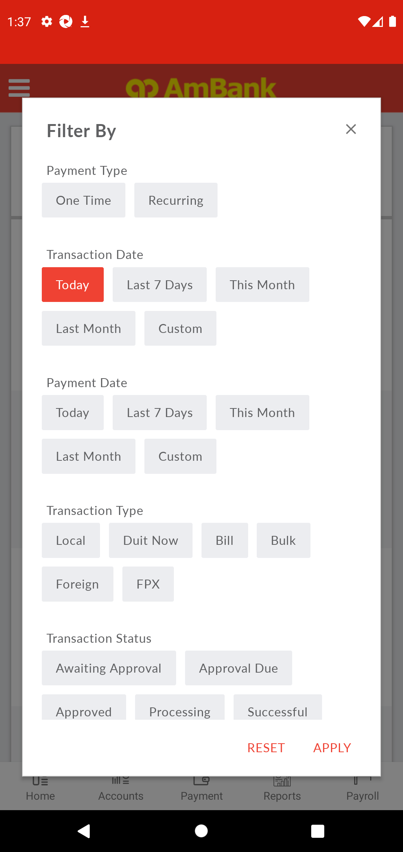  
  
**Test Step 107(PASS) :** [CFO] [Home] Click [Approval Due]  
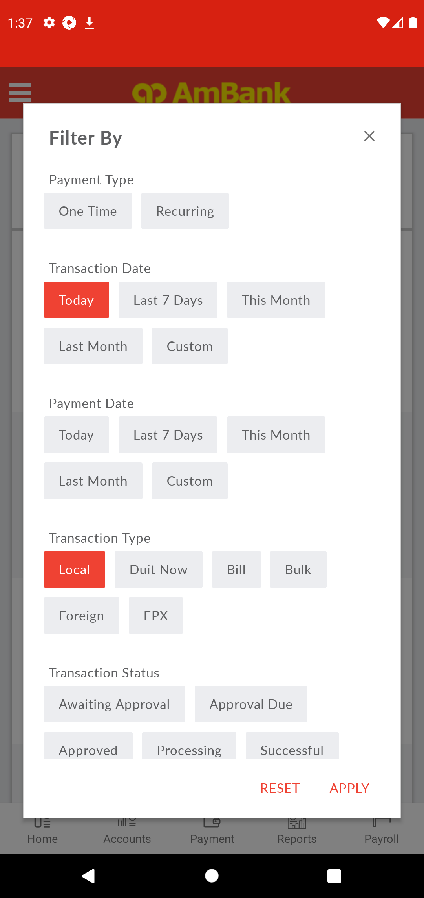  
  
**Test Step 108(PASS) :** [CFO] [Home] Click [Apply]  
  
  
**Test Step 109(PASS) :** Swipe Up To Transaction  
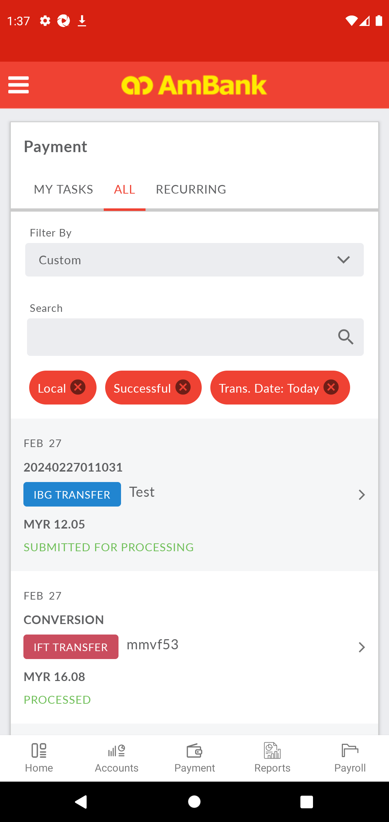  
  
**Test Step 110(PASS) :** [Local Transfer] Click [Transaction]  
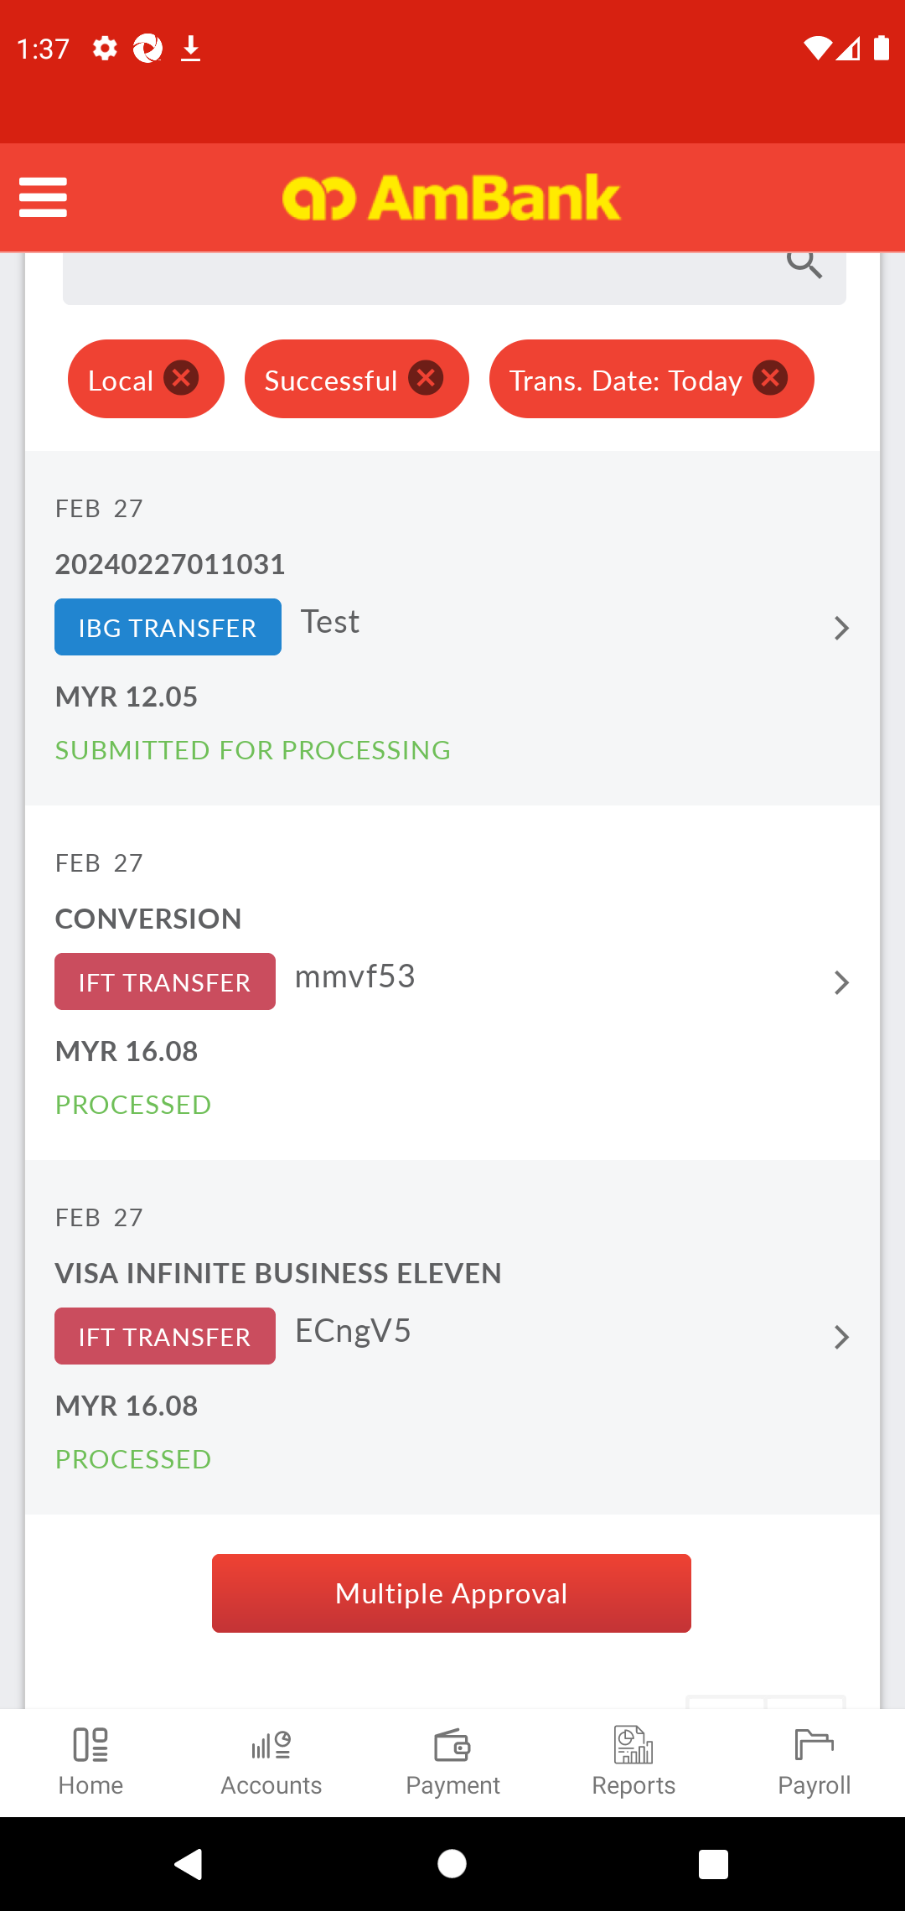  
  
**Test Step 111(PASS) :** [Local Transfer] Verify [Status]  
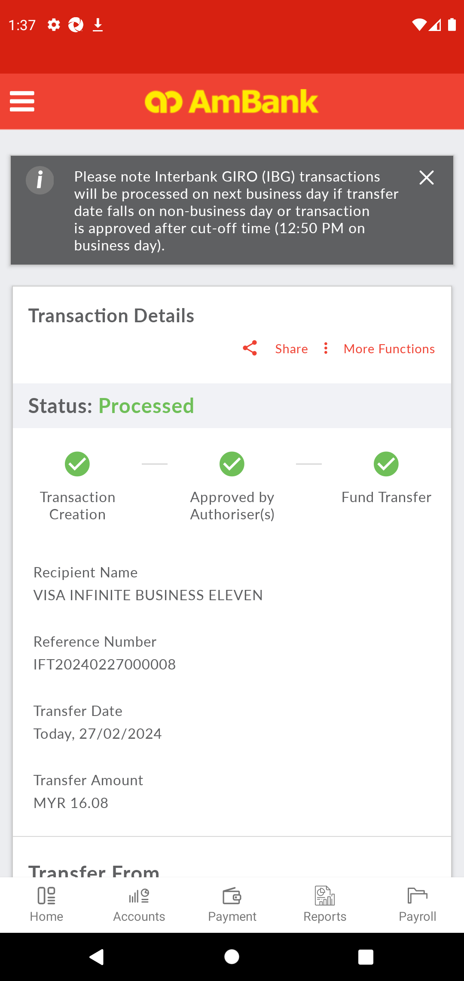  
  
**Test Step 112(PASS) :** Swipe Up To Masked Account Number Button  
  
  
**Test Step 113(PASS) :** [Local Transfer] Verify [Masked Account Number]  
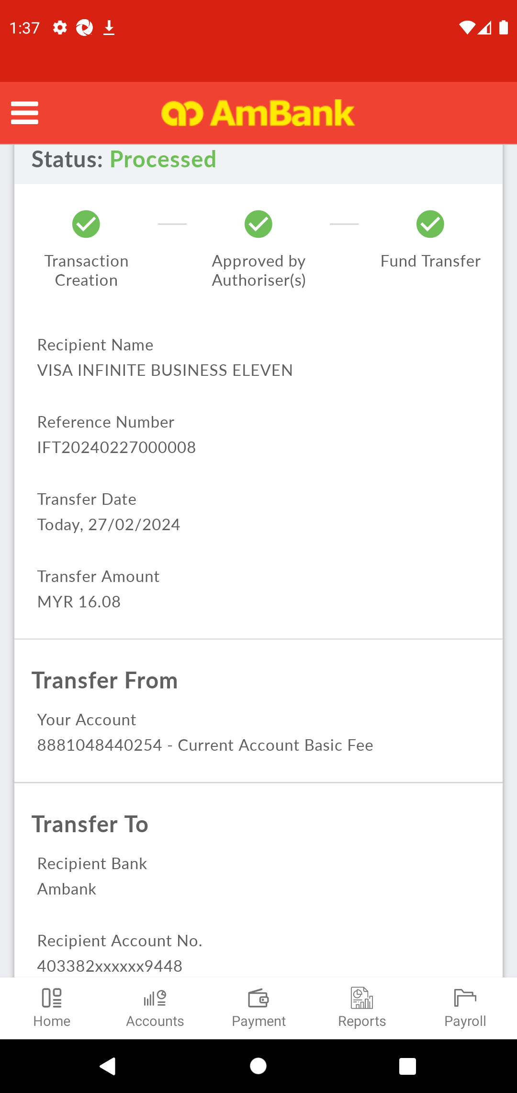  
  
**Test Step 114(PASS) :** [CFO] Click [Accounts]  
  
  
**Test Step 115(PASS) :** [CFO] Select [Accounts]  
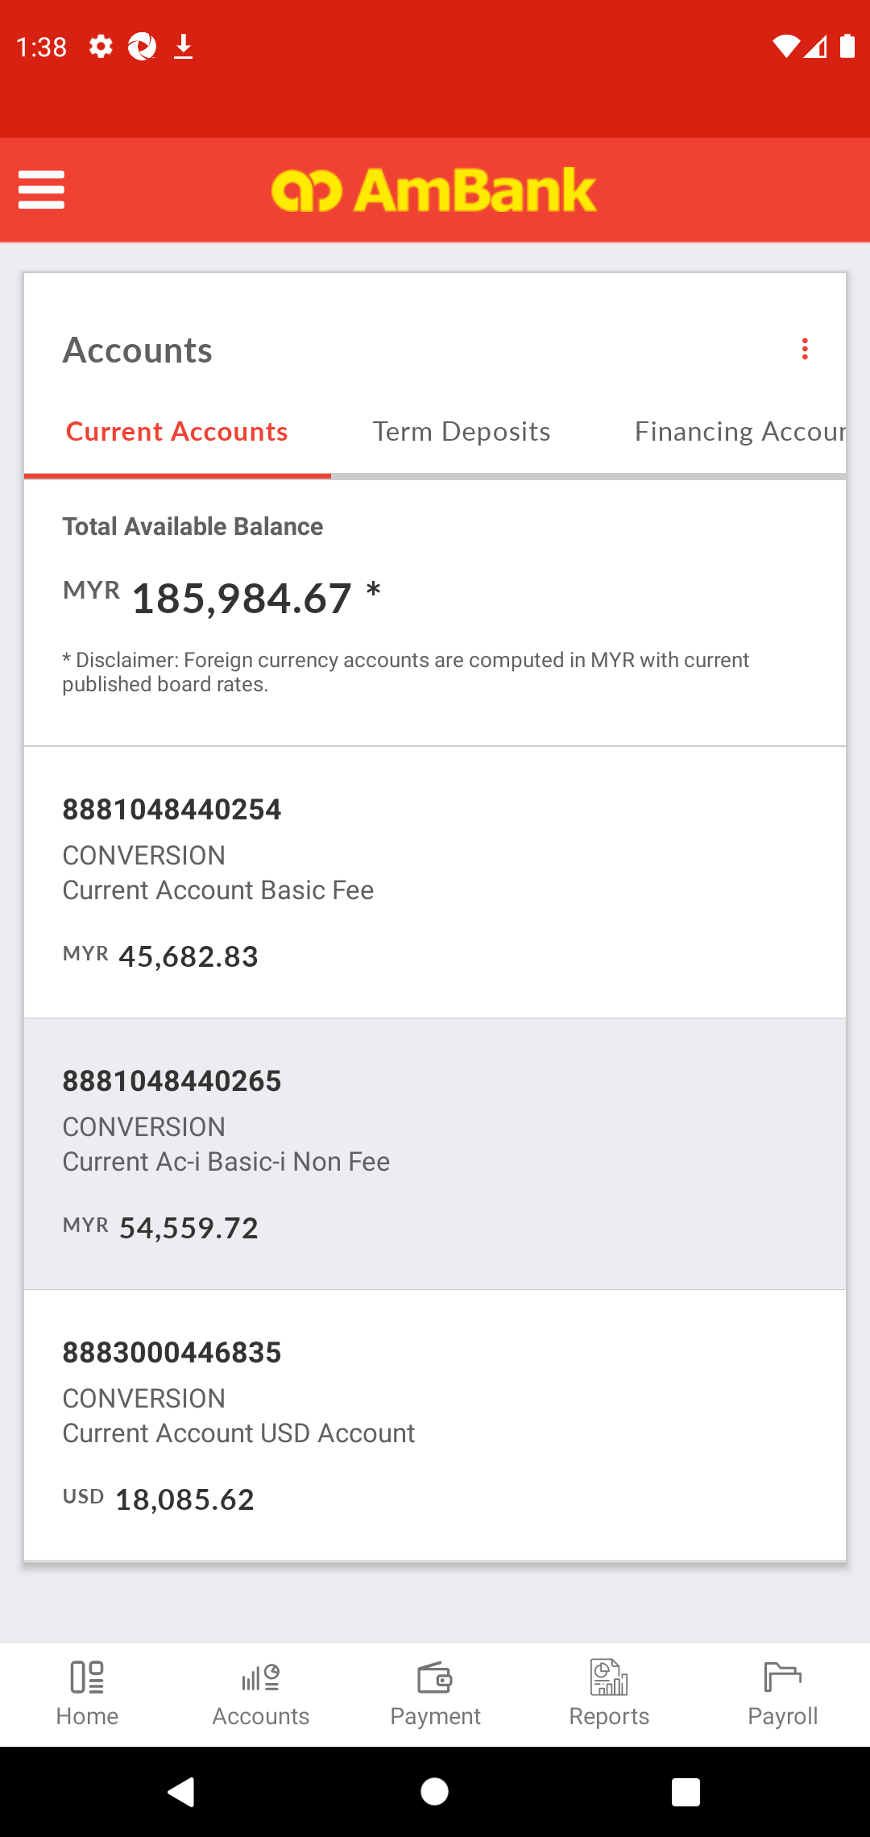  
  
**Test Step 116(PASS) :** Swipe Up To Transaction  
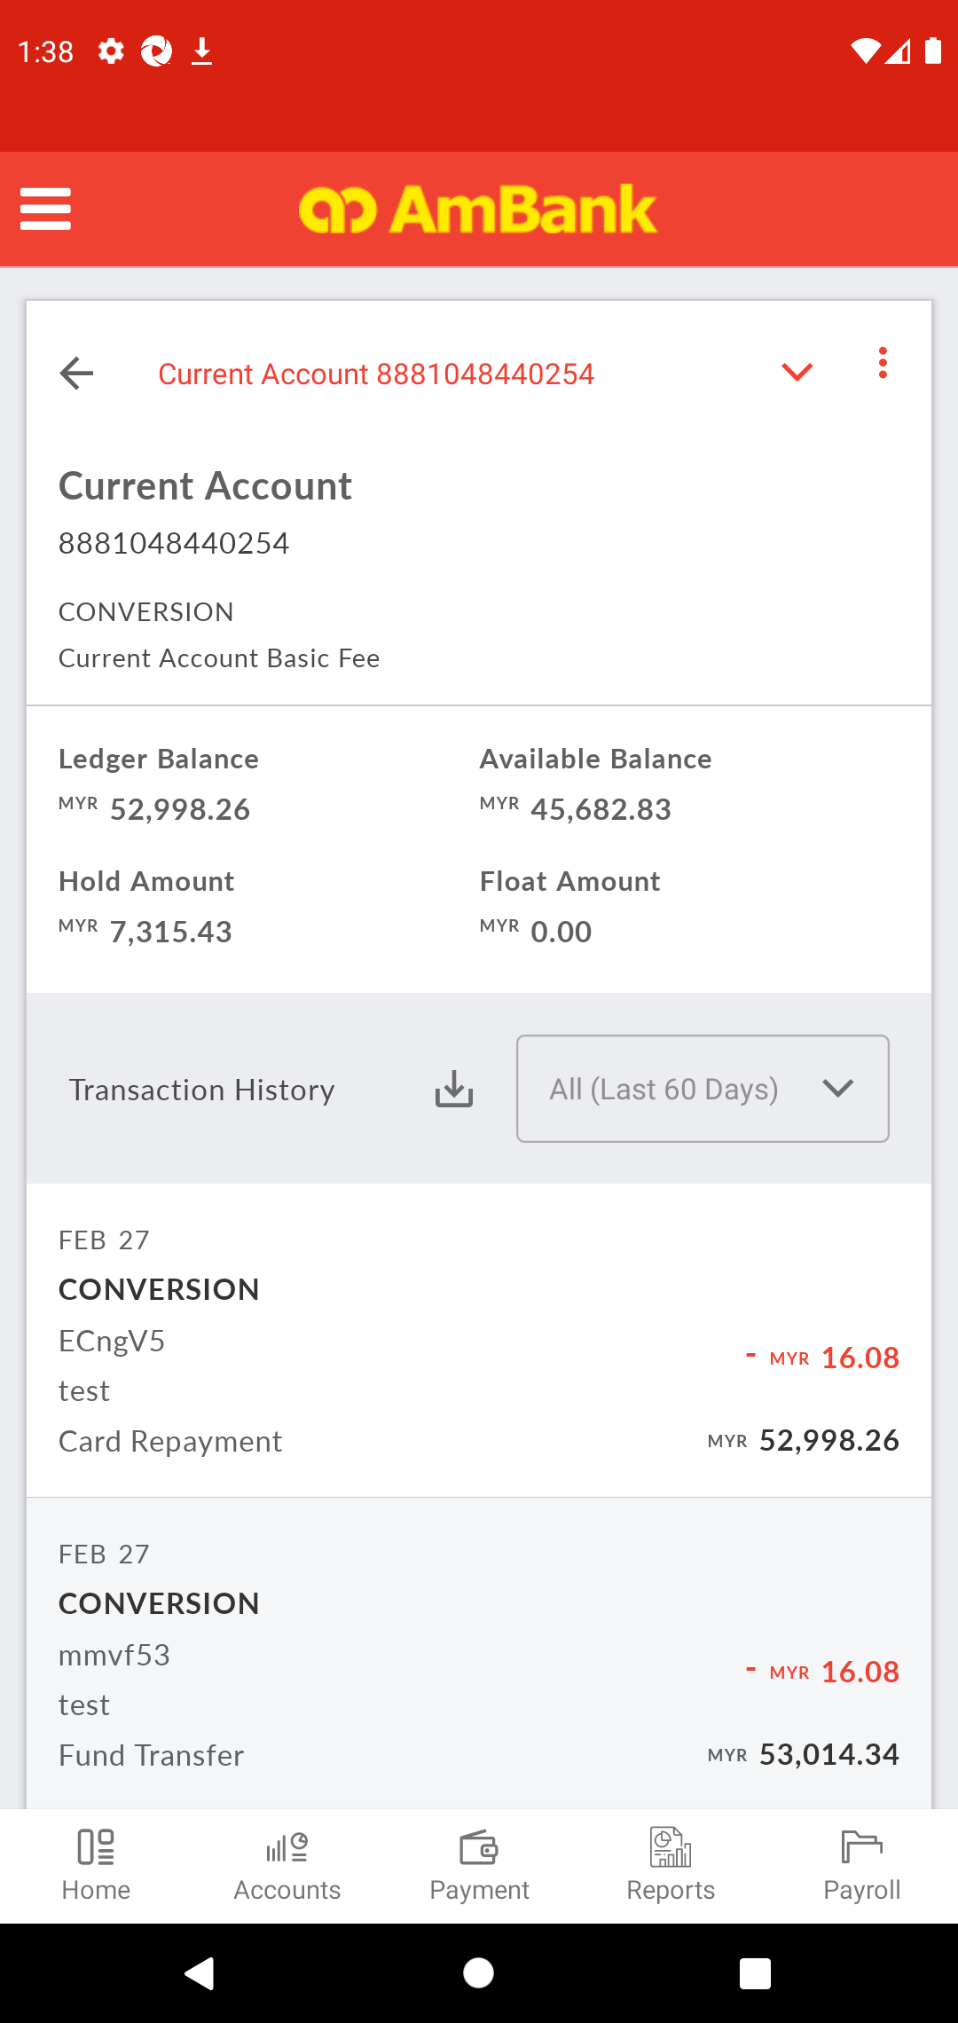  
  
**Test Step 117(PASS) :** [CFO] Verify [Balance]  
  
  
**Test Step 118(PASS) :** [CFO] [Verify] [Transaction Type]  
  
  
**Test Step 119(PASS) :** [CFO] Click [Menu]  
  
  
**Test Step 120(PASS) :** [CFO] Click [Logout]  
  
  
**Test Step 121(PASS) :** [BBO] Input [Username]  
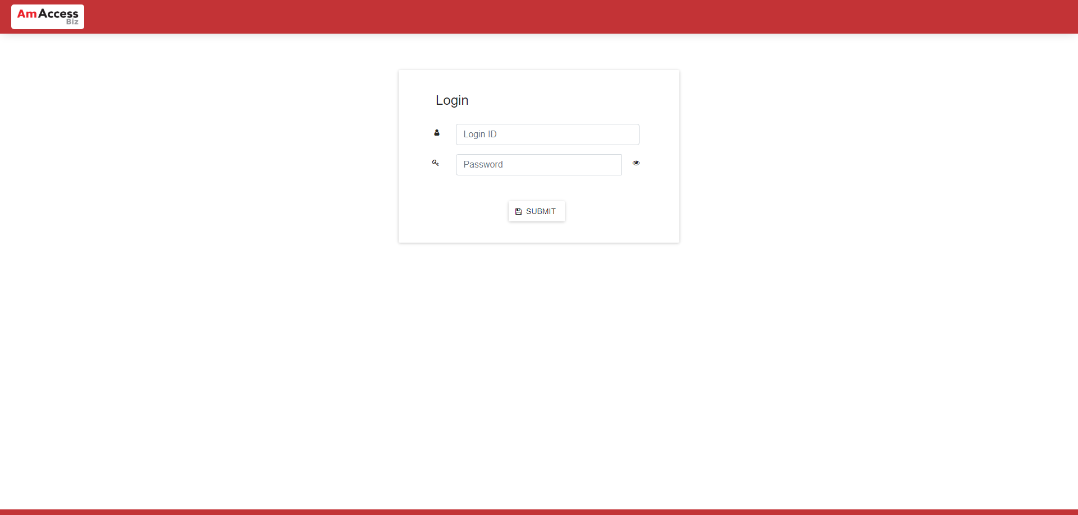  
  
**Test Step 122(PASS) :** [BBO] Input [Password]  
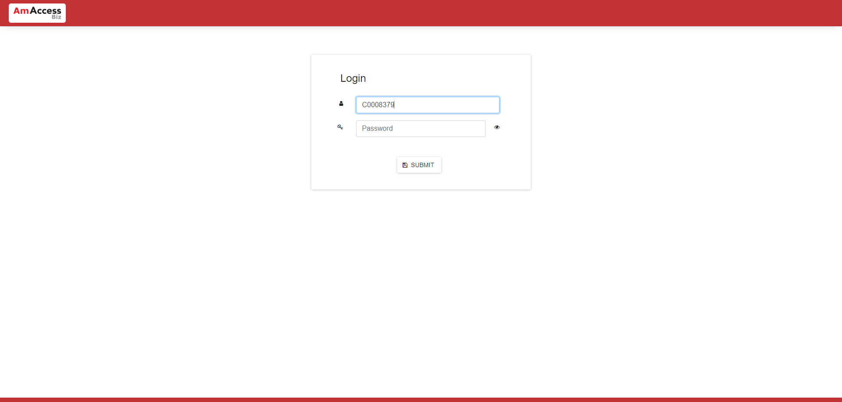  
  
**Test Step 123(PASS) :** [BBO] Click [Submit]  
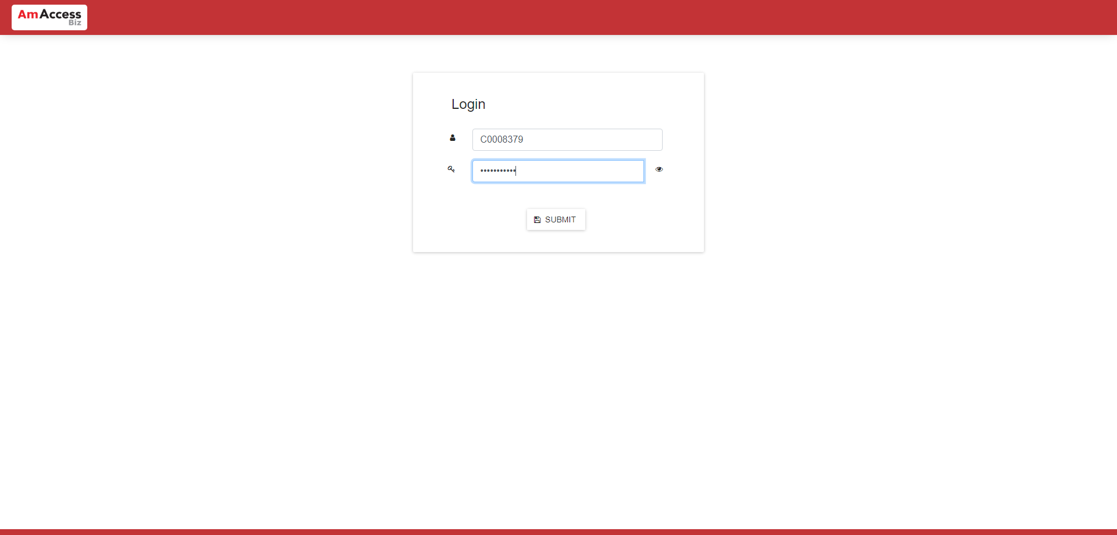  
  
**Test Step 124(PASS) :** [BBO] Click [Reports]  
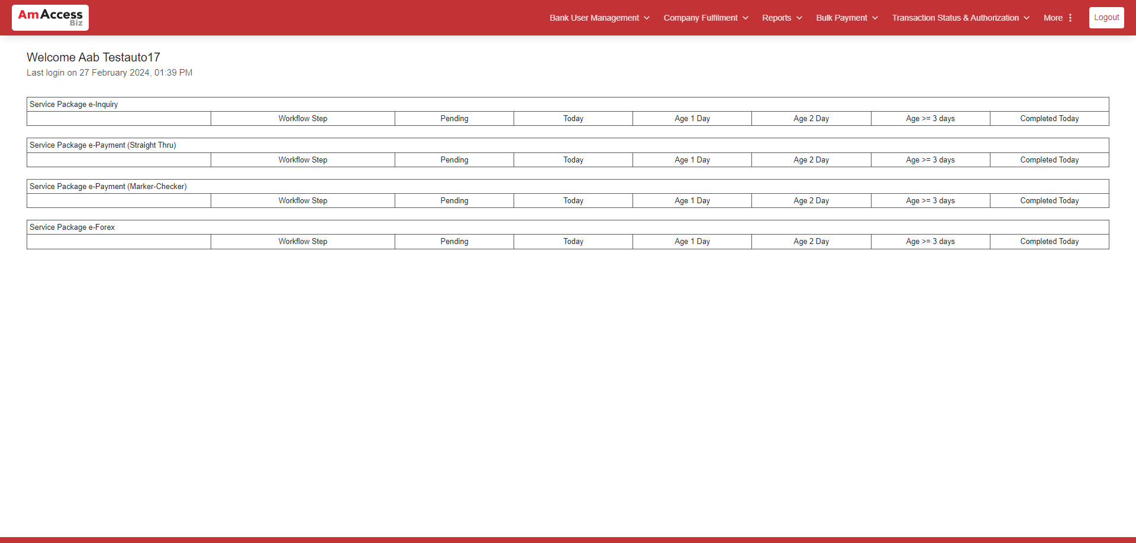  
  
**Test Step 125(PASS) :** [BBO] Click [Transaction Detail Report New]  
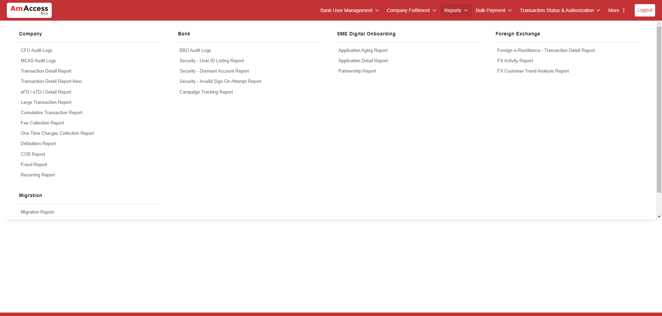  
  
**Test Step 126(PASS) :** [BBO] Input [CIF Number]  
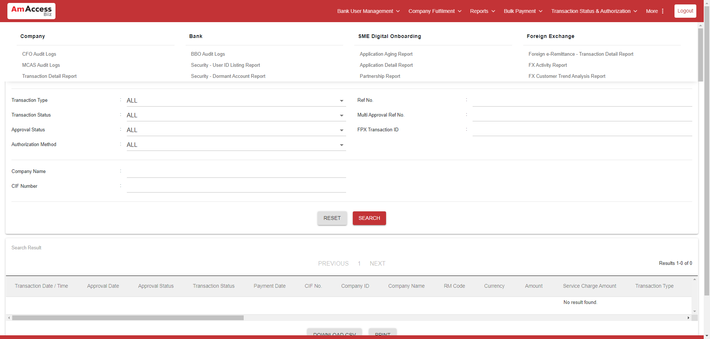  
  
**Test Step 127(PASS) :** [BBO] Input [Ref No.]  
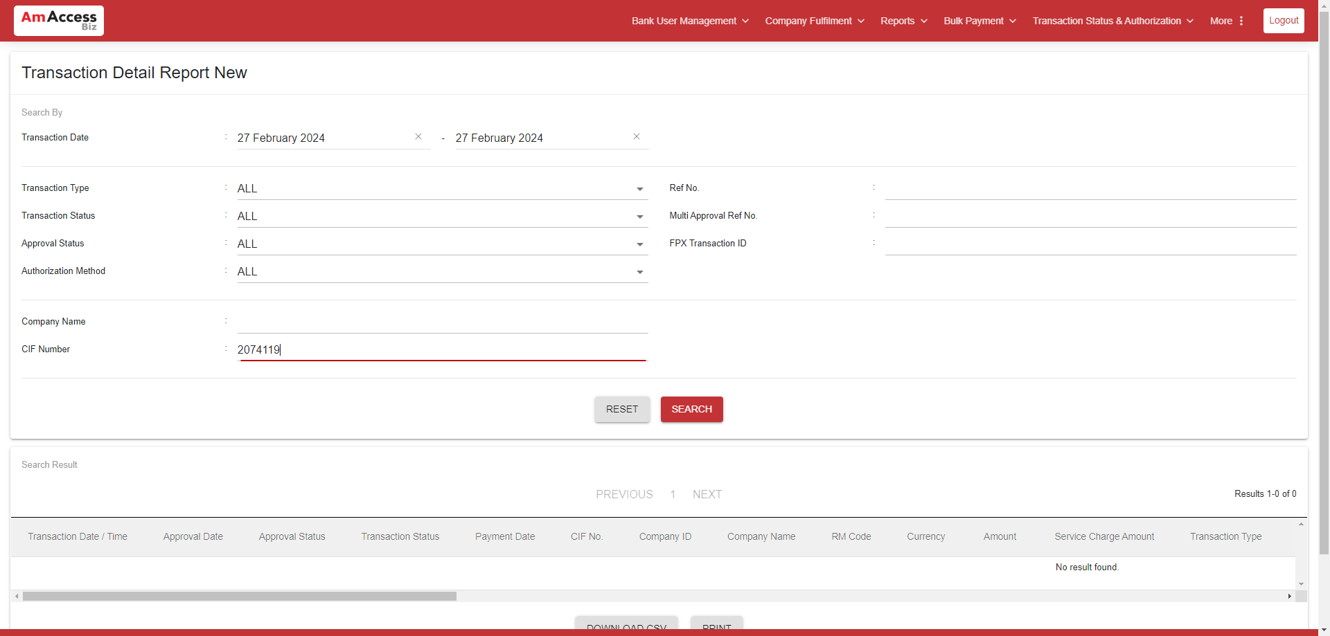  
  
**Test Step 128(PASS) :** [BBO] Click [Search]  
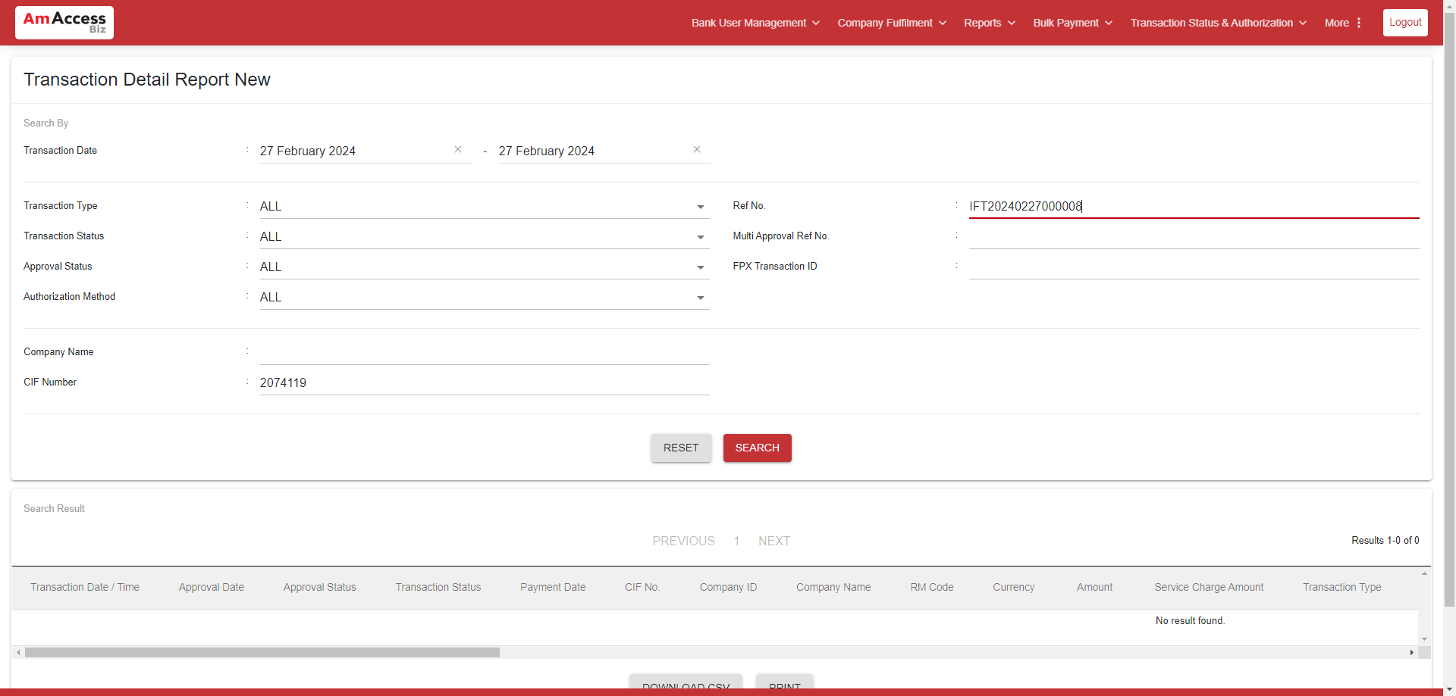  
  
**Test Step 129(PASS) :** PAGEDOWN  
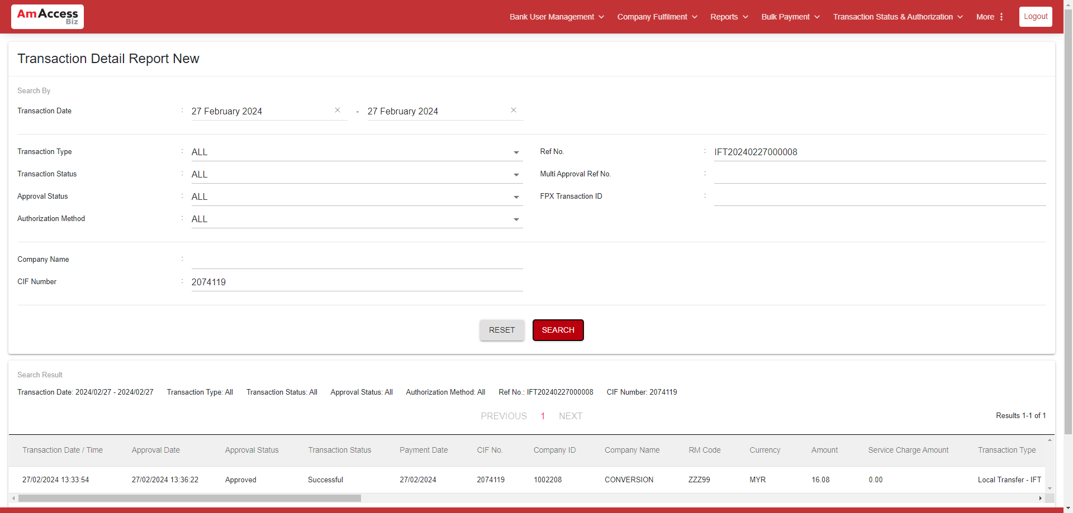  
  
**Test Step 130(PASS) :** [BBO] Verify [Transaction Type]  
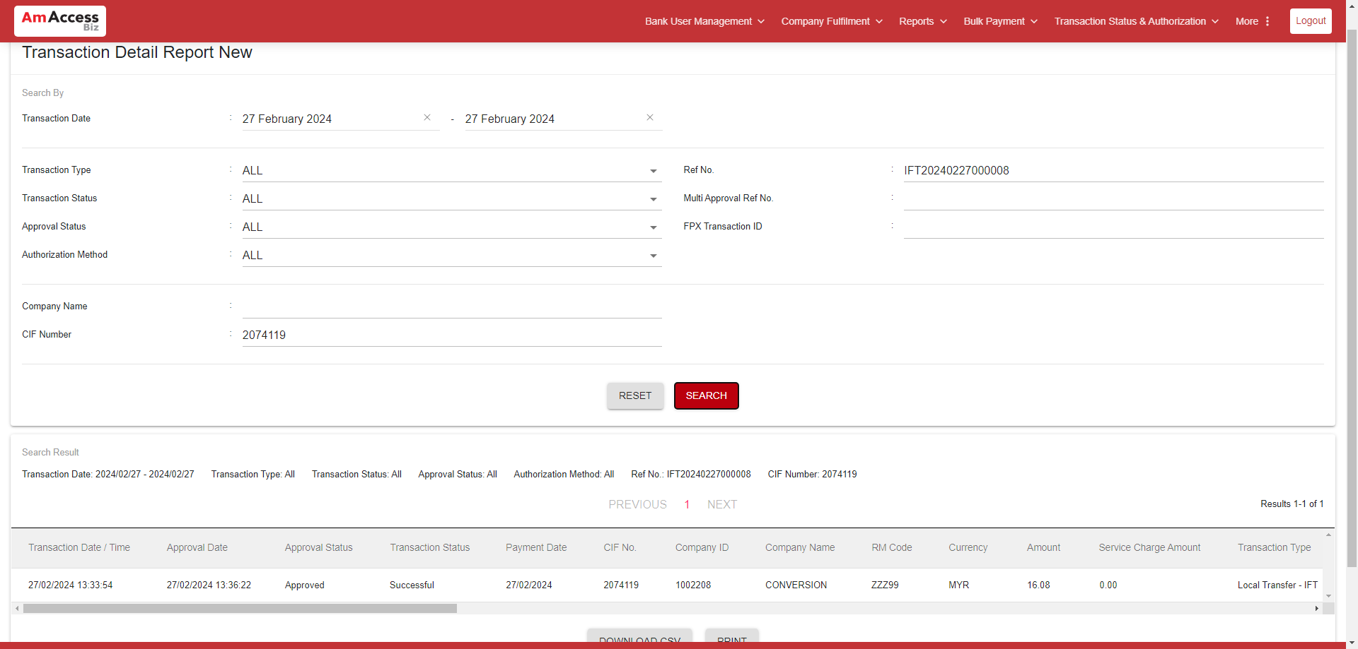  
  
**Test Step 131(PASS) :** [BBO] Verify [Transaction]  
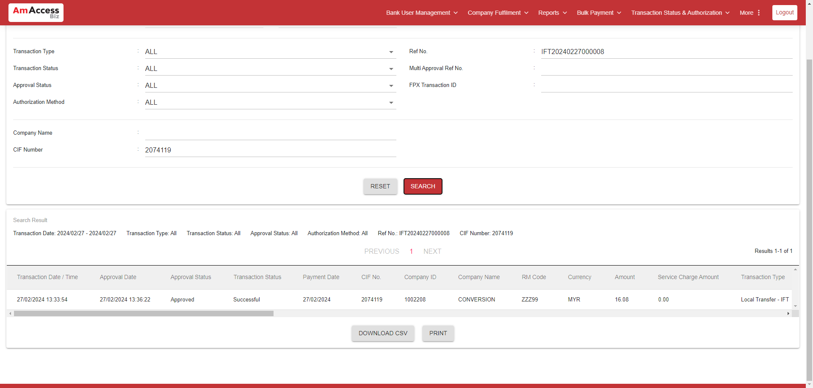  
  
**Test Step 132(FAIL) :** [BBO] Verify [ Recipient AccNo. / Proxy / Biller Code / QR ID ]  
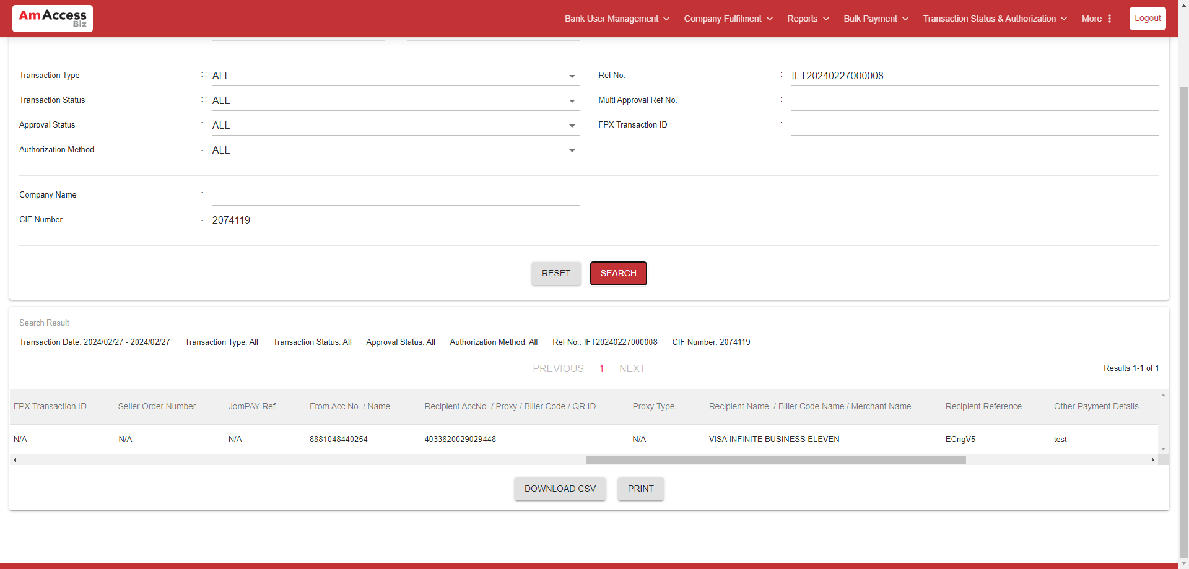  
  
**---------------------------------------- The End ----------------------------------------**